TICR DCEA Homework 5 – DUE Thursday, February 17, 2022 at 3:15 PM
Markov

Objectives:
- To apply Markov analysis to your CEA or another topic.

QUESTIONS – contact Elliot Marseille enmarseille@comcast.net or skype elliotmarseille1 and Albert Young albert.young@ucsf.edu

Procedure for Homework Assignment: *** Slightly different than usual ***
In this section, you will complete either HW 5A or HW 5B (submit one only). There is no mammography assignment.
5A. Apply Markov analysis to your own DCEA or to another topic of your choosing.
5B. Build and analyze a simple Markov cost-effectiveness model for cancer treatment using TreeAge.
If you are working on your OWN project (3-credit track only), keep refining your project. You may turn in a preliminary final project report by March 12. Your mentor will then send a provisional grade and issues to resolve to improve the analysis and increase your project grade.

HW 5A (choose either this or HW 5B below)

Steps:

- Define health states for the health condition you have been modeling … or if the situationyou are modeling is not amenable to Markov (e.g., short term outcomes), pick another condition of interest to you for the purposes of this assignment.

- Portray the health states using the Markov Excel template posted and reviewed in lecture. Read the “Orientation” text box in Orientation worksheet.
- Or, use the TreeAge program.
- With the template, you have 8 states you can portray. Plus you can assign health and cost “tolls” to state entry (e.g., the cost of a diagnosis).

- To develop a Markov, start with a “No intervention” version.First copy the worksheet called “Markov Nat Hx Sypheg” to the same Excel workbook or to the workbook with your project. Rename the sheet appropriate for your analysis.
- Then fill in the grey cells. (Non-grey cells are calculated.) This includes:
  - disease name and intervention status (J-N2 and J-N3)
  - disease state names (cells B9-B15)
  - QALYs (or DALYs [see note below]) per cycle by state (row 19)
  - the costs per cycle by state (row 20)
  - health and financial “toll” or “cost” on state entry (rows 21 and 22), if any, or set to zeros.
  - Transition probabilities (rows 9-15)
  - Cycle length, discount rate, # cycles counted (rows 2, 3, 27, respectively, can likely leave unchanged)
  - You can see the background mortality in R-V20 and leave as is or change – this correlates to the B in K9-13, which can be changed by health state if needed
- Repeat for an“Intervention” version – copy to a “no intervention” worksheet, rename, and modify as needed to present intervention timing / effects / costs.
- If you’re linking the Markov sheets to your project decision tree (as in the template), make sure to:
  - Specify and link state numbers from tree to Markov sheets (pink cells in the template)
  - Link the health outcome and costs sums (N25 and O25) back to the relevant parts of your tree (green cells)
- Report the QALYs/DALYs and costs expected with and without the intervention. Write a short explanation – how does the intervention change the QALYs and costs? If you are doing Markov modeling on a different topic than your project, provide a brief background of the disease or problem and intervention. (If incorporating into your own project you should have done this already.)
- Provide a few notes on the potential advantages and disadvantages of a Markov for your topic.

- Extra credit: Create a simple Markov graphic (transition matrix, bubble diagram, etc) to represent your states and transitions.

HW 5B (choose either this or HW 5A above)
Problem
Treatment 1, the standard treatment for an indolent cancer, costs $10,000 annually. A new treatment, Treatment 2, costs $15,000 annually but reduces the risk of progression to advanced cancer from 15% to 12% annually. The cost of treating advanced cancer is $50,000 annually. Two percent and 30% of those with indolent and advanced cancer, respectively, will die each year. See below for the complete transition matrices. Living with indolent and advanced cancer is associated with 0.95 and 0.7 QALYs each year, respectively. Given these assumptions, what is the cost-effectiveness of each treatment over 20 years?

Note the variables that have been pre-defined under the root node. You should use only use all of these named variables for the assignment. No new variables need to be defined, except for cIndolent and pIndolentToAdvanced for the Tx 2 node in question 8 below.

Transition matrix for Treatment 1
 | Indolent cancer | Advanced cancer | Death
Indolent cancer | 0.83 | 0.15 | 0.02
Advanced cancer | 0 | 0.70 | 0.30
Death | 0 | 0 | 1

Transition matrix for Treatment 2
 | Indolent cancer | Advanced cancer | Death
Indolent cancer | 0.86 | 0.12 | 0.02
Advanced cancer | 0 | 0.70 | 0.30
Death | 0 | 0 | 1

Creating the model
We have started the decision tree and defined the input variables in DCEA21_HW5_Markov.trex. You can define variables using the Variable Properties tab or by right clicking a node > Define Variable. Most variables are defined under the root node, but those that will vary by treatment will be defined separately for each treatment node.

General
- Set Willingness to pay of 50000 through Tree > Tree Preferences > Calculation Method > Cost-Effectiveness > Cost-Eff Params (WTP)
- Set global discounting to 0.03 for cost and also 0.03 for effectiveness through Tree > Tree Preferences > Payoffs > Discounting.
- Enter 1 in the box for Markov cycle length (in years).

Treatment 1
- Convert the Tx 1 node to a Markov node and add 3 branches, labeled Indolent cancer, Advanced cancer, and Dead, respectively. To define the initial distribution of states, enter 1, 0, and 0 for their respective probabilities (100% of the cohort starts with indolent cancer).
- Convert the Dead node to a terminal node.
- Add three branches to the Indolent cancer node labeled Stay here, Progress to advanced cancer, and Die, respectively. Enter the corresponding probability values, making sure to use the pre-defined variables. You may use the # symbol, which TreeAge automatically calculates as the complement so the total probability sums to 1. Convert each of these 3 nodes to terminal nodes (for each, a Jump State dialog should appear, and you should select the appropriate state).
- Analogously to step 6, add branches for the Advanced cancer chance node.
- Assign costs and effectiveness by selecting the Tx 1 node > Markov Info > Health States, as shown below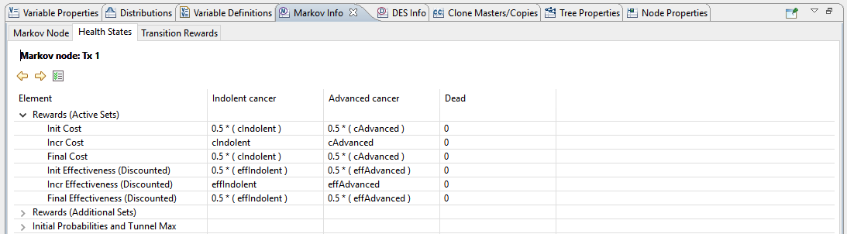

Treatment 2
As only two variables have different values, rather than build the entire tree again for the Tx 2 node, it is possible to copy the tree we built for Tx 1.
- Define cIndolent and pIndolentToAdvanced for the Tx 2 node.
- Select the Tx 1 node (the Markov node) and select Subtree > Create Clone Master. Enter a name, e.g. “Markov.”
- Convert the Tx 2 node to a Markov node.
- Right click the Tx 2 node and select Subtree > Attach Clone

Analysis
- Select Analysis > Roll Back to roll back the tree. The most cost-effective path will become highlighted in green.

You may double-check your tree with the solution below.
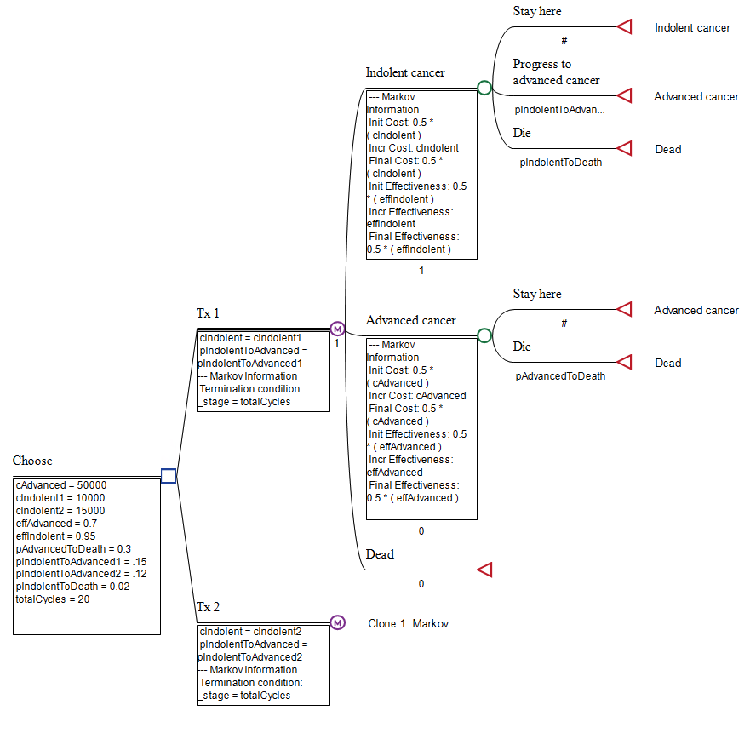
Questions
- Why might one choose to use a Markov model for cost-effectiveness analysis?

- What does it mean for willingness to pay to be set to 50,000 in this analysis?

- What is the cost per QALY for treatment 1?

- What is the cost per QALY for treatment 2?

- What is the incremental cost-effectiveness ratio (ICER)?

- Select Analysis > Roll Back to undo the roll back. Next select the Tx 1 Markov node and then Analysis > Markov Cohort > Basic Report.
  - At the end of 20 years, what proportion of the initial cohort is in each state?

  - What is the total cost accrued over the 20 years? How much of this was due to treating indolent cancer and how much was due to treating advanced cancer?

- While still viewing the Basic Report, plot the probability of being in each state by year (stage) via Charts – State Prob. on the Actions on the right sidebar. Copy the plot here.

- Repeat question 6 for treatment 2.

- Create a state transition diagram by selecting the Tx 1 Markov node > right click > Convert to STD. Copy the plot here.

- Modify one or more of the input variables of your choosing. How does this affect the ICER? (Optional: You can systematically vary input parameters using a tornado diagram if you wish to try this—more on sensitivity analysis next week.)

If you use DALYs, put “1” in cell K19 for Death, and adjust the # cycles counted (cell O27) to include up to the row that represents normal life expectancy for your population.

