Directed Acyclic Graphs (DAGs)

Key Words
Backdoor criterion
Causality
Colliders and collider bias
Conditioning
Confounding
D-separation
Paths
Measurement bias
Selection bias

Objectives
- Understand how to draw and use DAGs and related terminology.
- Apply DAGs to common problems in epidemiology.
- Recognize the limitations of DAGs.

Assigned Readings

Required:
- Chapter 6.1-6.3, Hernán & Robins, Causal Inference Book, online
- Chapter 7.1-7.4, Hernán & Robins, Causal Inference Book, online
- Chapter 8.1-8.3, Hernán & Robins, Causal Inference Book, online
- Chapter 9.1-9.3, Hernán & Robins, Causal Inference Book, online

Optional:
- Chapters 6.4-6.6, 7.5-7.6, and 8.4-8.5, Hernán & Robins, Causal Inference Book, online
- Chapter 12, Rothman, Greenland, & Lash 3rd Edition
- Digitale JC, Martin JN, Glymour MM. Tutorial on directed acyclic graphs. J Clin Epidemiol. In Press. https://pubmed-ncbi-nlm-nih-gov.ucsf.idm.oclc.org/34371103/.
- Hernán MA, Hernández-Díaz S, Robins JM. A structural approach to selection bias. Epidemiology. 2004 Sep 1;15(5):615-25. (This was a very influential paper that reconceptualized how we think about selection bias). https://www.ncbi.nlm.nih.gov/pubmed/15308962
- VanderWeele TJ, Hernán MA. Results on differential and dependent measurement error of the exposure and the outcome using signed directed acyclic graphs. American journal of epidemiology. 2012 May 8;175(12):1303-10. https://www.ncbi.nlm.nih.gov/pubmed/22569106

Assignment
Read Hernán MA, Zhang SM, Rueda-deCastro AM, Colditz GA, Speizer FE, Ascherio A. Cigarette smoking and the incidence of Parkinson’s disease in two prospective studies. Ann Neurol. 2001 Dec;50(6):780-6. PMID: 11761476.

The assigned article discusses several potential explanations for the association found between Parkinson’s disease and cigarette smoking. Aim for drawing the simplest possible DAGs given the presented scenarios. You might find DAGitty (http://www.dagitty.net/) helpful for drawing DAGs.

- In the first column of page 784, a paragraph begins with “The key question is whether this strong inverse association reflects a truly protective effect of smoking on the risk of developing PD.” Draw a causal DAG that is consistent with the explanation given in this paragraph. Please label your DAG and explain briefly. (3 points)

- At the bottom of the first column of page 784, a paragraph begins with “The information bias…” Draw a causal DAG that is consistent with the explanation given in this paragraph. Please label your DAG and explain briefly. (3 points)

- In the second column of page 784, a paragraph begins with “There are a number of variations of the hypothesis that selection bias…” Draw a causal DAG that is consistent with the explanation given in this paragraph. Please label your DAG and explain briefly. (3 points)

- In the first column of page 785, a paragraph begins with “Confounding…” Draw a causal DAG that is consistent with the explanations given in this paragraph. Please label your DAG and explain briefly. Note that you need not include more than one measured factor that confounds the relationship between smoking and Parkinson’s disease. (3 points)

- In the first column of page 785, a paragraph begins with “There are also several versions of the argument claiming the existence of a causal effect of PD on smoking behavior...” Draw a causal DAG that is consistent with the explanation given in this paragraph. Please label your DAG and explain briefly. (3 points)

- For each of the paragraphs referred to in Q1-Q5, discuss whether the authors’ explanations can be ruled out because of the study design and explain your reasoning briefly. For those explanations that cannot be ruled out, propose what might be a better study design to help evaluate (or rule out) the alternative explanation (i.e., one that would allow ruling them out in case they are not the true explanation). Note: There are 5 parts for this question. Please number as 6a-6e, corresponding to Q1-Q5 scenarios. (10 points)

- Consider the following hypothetical participant in the Nurses’ Health Study: Woman, age 63 at time of analysis, smoked 2 packs per day for 14 years between the ages of 16 and 30. Note that pack-years are calculated by multiplying the number of packs smoked per day by the number of years a person has smoked.

  - Indicate to which exposure category this individual is contributing data in Table 1 and in Table 2 and state what her estimated relative risks would be according to each Table. (For the purposes of this question, you may assume that the results are unbiased and reflect “truth” in the world) (2 points)

  - In your own words, specify and compare the different research questions under investigation in these two tables. (2 points)

  - Do you consider 'pack-years' of smoking (as examined in Table 2) to fulfill the consistency criterion for identifiability? Why or why not? Explain briefly. (2 points)

- Use a DAG to depict the following study designs using all provided information. In addition to the arrows indicated by each prompt, include any additional arrows that you would expect to connect the relevant variables. If bias is present, please identify the specific bias and explain how this may influence your study.

- In an observational study of the effect of antiretroviral therapy (ART) on the development of AIDS, participants were assessed every year at clinic visits with CD4 counts. ART is believed to reduce the likelihood of developing AIDS by increasing CD4 counts. In this setting, ART is not given to every attendee of the clinic, and sicker individuals (i.e., those with lower CD4 counts) are more likely to receive ART. Investigators had previously noted that patients of higher socioeconomic status had higher rates of follow-up. At the end of the study, patients who were lost to follow-up were excluded from the analysis and a relationship between ART and SES was found, although researchers believe this may have been due to participants receiving ART being sicker and attrition differing by SES. (6 points)

- In a study examining the association between physical activity and heart disease, investigators chose to study a group of firefighters. It is known that individuals who choose to become firefighters have an affinity for physical activity. Furthermore, it is also known that those with parents of high socioeconomic status are less likely to become firefighters and less likely to develop heart disease. (6 points)

- Consider the two 2×2 tables below. They were generated from a prospective study to estimate the average causal effect of treatment A on the risk of outcome Y. A pre-treatment variable L was also measured. We know for sure that either (i) A and Y have no common causes or (ii) the only common cause of A and Y is L.

 | L=0 |  |  | L=1
 | Y=1 | Y=0 |  | Y=1 | Y=0
A=1 | 60 | 40 |  | 120 | 80
A=0 | 40 | 160 |  | 56 | 224

- Which of the two explanations is consistent with the provided data? I.e., does the variable L confound the effect of A on Y? Why or why not? Please show your work and explain in a few sentences. (3 pts)

- Draw a DAG, consistent with the data, that represents L, A, and Y and explain briefly. (2 pts)

- For each of the following pairs of causal structures, describe how you would evaluate which structure best represents your data. (E.g., What associations (or lack thereof) would you test? In testing the association between two variables, would you condition on any other variables?) Be sure to comment on the differences you would expect to see between the two causal structures after implementing your strategy. You can assume that you have perfect measures of all four variables. (Hint: Refer to the “Quizlets” the DAGs lecture slides.)

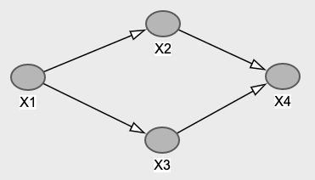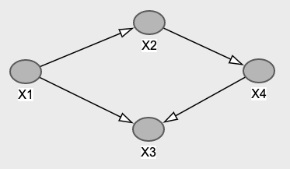

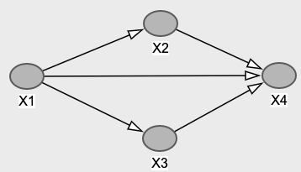

c.

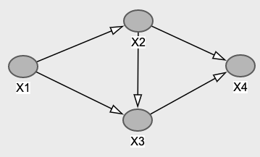

Total: 54 points

