HOW TO PULL DIABETES COHORT DATA USING SQL PRESTO CLI VIA INFORMATION COMMONS

- Download the diagnoses_by_encounter_PRESTO CLI SQL query.txt file from MS Teams to your desktop
- Prior to uploading files to information commons, you must have the following .sh files on your desktop
  - upload_data_toIC.sh
  - download_data_fromIC.sh
  - More information is found here: https://wiki.library.ucsf.edu/pages/viewpage.action?spaceKey=IC&title=Storing+and+Loading+Data
- Open your terminal and use the following command:
  - sh / <enter your file path> /upload_data_toIC.sh
  - If the command is executed your terminal should display the following items (below)
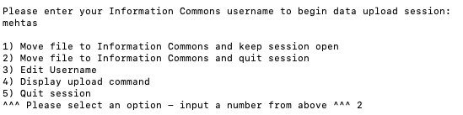
- Enter your information commons username to begin the upload process
- Enter “2” on your terminal and click and drag the diagnoses_by_encounter_PRESTO CLI SQL query.txt file into the terminal window.
- The terminal window will display the following message to ensure a success upload session
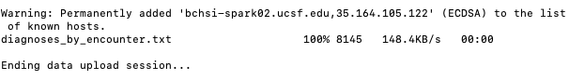
- Open a new terminal window and connect to the information commons (IC) cluster
  - sh connect_to_cluster.sh
- After connecting to IC, use the “ls” command to view the files in the folder
  - You should see diagnosis_by_encounter.txt file containing your SQL query
- Connect to PRESTO CLI using the following command:
  - presto-cli --catalog hive --schema rdb --file diagnoses_by_encounter.txt diagnosis_data
  - The syntax of the command is: presto-cli --catalog hive --schema rdb --file <your-sql-query-file-name>.txt <output-file-name>
- After running step 9, use the “ls” command to view the files in the folder. You should see your output file name containing your data
- Disconnect from IC and end this terminal window
- Open a new terminal window and use the following command:
  - sh / <enter your file path> /download_data_fromIC.sh
- Enter your IC username to begin the process and select option 2 “download file from information commons and quit session”
- Input the name of the file that you wish to download (e.g. “test.csv”)
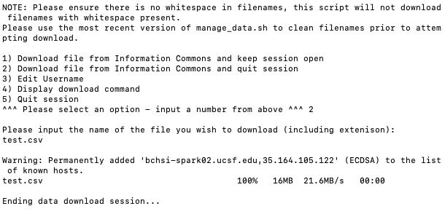
- The test.csv file containing the data should be on your desktop

