Labs 1 & 2

Establish Access and Perform Introductory Queries

Description
The purpose of this lab is to establish and confirm access to the research analytic environments and data sources that will be necessary to complete all lab sessions and course final project. You will also perform some basic queries and create a summary table and figure.
Part 1 is focused on establishing access. Start this process at least 1 week before the first day of class, as it can take a while for necessary approvals, account creation, and troubleshooting. In Part 2 you will be working with data. You can wait to start this section until class begins—we will give you class time to work on it.

Objectives
- Create account for Research Analysis Environment (RAE) and log-in
- Create account for De-Identified Data Warehouse (DeID CDW)
- Access course code on Git – OPTIONAL (all content will also be on the CLE)
- Connect to DeID from SQL Server Management Studio or your statistical program of choice (R or STATA) from RAE
- Execute a series of simple SQL queries (adapted from examples)
- Start to outline your research project, specify the target population, design a computable phenotype (version 1) to capture a sample of patients at UCSF in your target population.

Resources
- UCSF Research Analysis Environment Account Request: https://it.ucsf.edu/service/rae
- UCSF De-Identified Data Warehouse Account Request: https://ars.ucsf.edu/de-identified-clinical-data-warehouse
- De-ID Data Warehouse Knowledge Base (https://wiki.library.ucsf.edu/display/DCDKB/DeID+Clinical+Data+Knowledge+Base)
- The De-ID Data Team maintains shared code examples for querying the DeID DW. Instructions to access: https://wiki.library.ucsf.edu/display/DCDKB/DEID+CDW+and+DEID+OMOP+on+UCSF+GitHub
- File for R and Stata Code for this course will be available in CLE and Git at: https://git.ucsf.edu/Anobel-Odisho/epi231.

PART 1

Important Notes
- Access to many of these resources is limited to users on the UCSF network. You will either need to be using a wired connection, connect to the UCSFwpa wireless network, or connect to VPN.
- The domain/username you use for RAE and the DeID CDW must be the same. The domain is the first part of your login required for some UCSF resources, such as UCSFM\Username. Some of you may have a UCSFMC account, a SOM account, and/or a CAMPUS account. It doesn’t matter which you use, but you must request access to RAE and DeID CDW with the same accounts.

Obtain Access to Research Analysis Environment

Complete Account Request

Confirm ability to log in

UCSF's Research Analysis Environment (RAE) is a secure data hosting and compute service for UCSF students, researchers and their internal or external collaborators. Formerly known as MyResearch, RAE provides compute, storage, and tools in a secure, compliant platform. Access to this environment requires you to be on VPN and remotely launch software. From RAE you will be able to access the UCSF De-ID CDW.

Register for a RAE account by following this link: https://it.ucsf.edu/service/rae, and complete the Account Request Form. A video walkthrough available on CLE will walk you through the account set up.

Note: This usually takes 2-3 days to process, so please do this ahead of time.

To manage files in RAE, you can use your same RAE credentials to log in to mytransfer.ucsf.edu. You can transfer files into and out of your RAE workspace here.

Obtain Access to the UCSF De-Identified Clinical Data Warehouse (CDW)

Complete Training Courses (https://training.ucsf.edu)

HIPAA 101 - Privacy and Security for New Ucsf Faculty, Staff, Trainees, Students and Volunteers

UC Cyber Security Awareness Fundamentals

Your Responsibilities While Working with Clinical Data

Request Access to De-ID CDW

Review the DE-ID User Friendly (UF) Data Dictionary

The De-ID CDW is a de-identified database copy of high-value EHR data. Therefore, this data is not subject to HIPAA restrictions on research use and does not require IRB approval or an honest broker intermediary.

Follow the instructions on this site to obtain access to the De-ID Data Warehouse:
https://wiki.library.ucsf.edu/display/DCDKB/How+to+Request+Access+to+DEID+CDW+and+OMOP

You must also complete 3 training courses (HIPAA, Cybersecurity, Responsibilities with Clinical Data) prior to being granted access to the De-ID CDW. If you have not yet completed these, you will receive an email with instructions. NOTE: Once you have completed the training courses, it can take 1-3 days for the updates to be processed.

One of the primary information resources is the De-ID CDW Knowledge Base, maintained by the Academic Research Systems team on the UCSF Wiki (https://wiki.library.ucsf.edu/display/DCDKB/DeID+Clinical+Data+Knowledge+Base). This will initially seem overwhelming and potentially too detailed for the purposes of this course, but can be a useful resource.

DeID User Documentation can be found at https://mytransfer.ucsf.edu/index.php/apps/files/?dir=/DE-IDCDW_UserDocs&fileid=24342338#/ (need RAE account to access).
- Prior to our first session, make sure you can access the De-ID Data Dictionary (User Friendly Schema) at this link: https://wiki.library.ucsf.edu/display/DCDKB/Download+Notice

- Access SQL Manager- you will use SQL manager to view the DeID CDW.
Steps to access SLQ Manager:

Once you have access to RAE, you will have a window that looks like this:
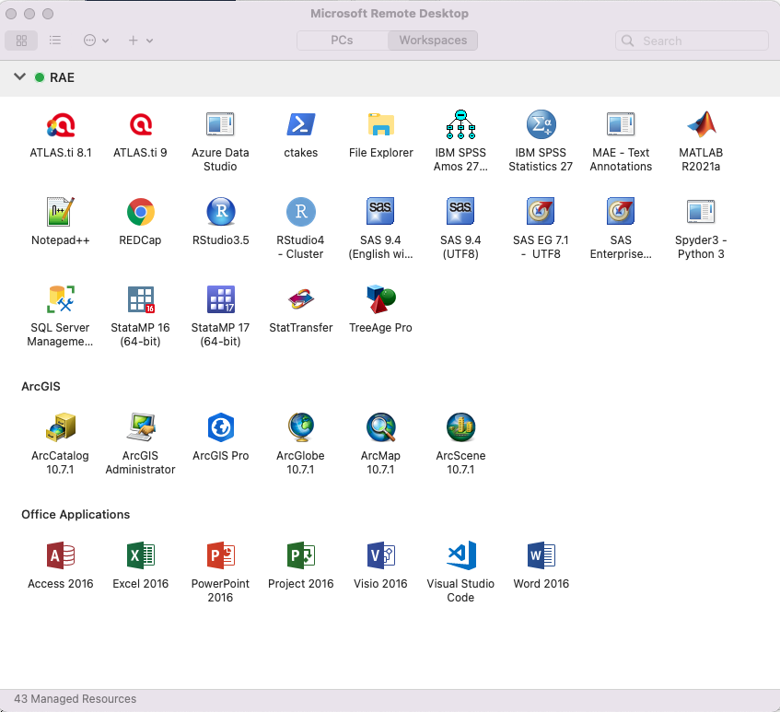
- Click on SQL Server Management
- Follow these steps to get connect to the DeID CDW through SQL Server Management: https://wiki.library.ucsf.edu/display/DCDKB/1.+Connecting+to+the+DEID+CDW%2C+OMOP+DB%2C+and+the+Limited+Data+Set

Note, the SQL Server Management platform is the best way to view the structure of the tables in the DeID CDW. You will query the data primarily in SQL Server Management and copy your query to R or STATA, whichever coding language you choose to use for this class.

- Access to UCSF Git - OPTIONAL
- Request access to git.ucsf.edu and confirm ability to log in
- Confirm access to course repository on git.ucsf.edu

Git is a system that allows you to share and collaborate on source code. At UCSF, we have our own git server (git.ucsf.edu) that allows us to share code securely. For this course, if you chose to use git, you will only be expected use very basic Git functions, such as copying code. You will not be expected to commit any changes, create branches, manage pull requests or merge code.

The code for the course will be posted to the CLE and also to git.ucsf.edu at the following address:
https://git.ucsf.edu/Anobel-Odisho/epi231 . If you like using git or want to learn, this can be a good intro. Otherwise, using CLE to download course code requires less technical background.

There are many ways to obtain the code from Git for your own use.

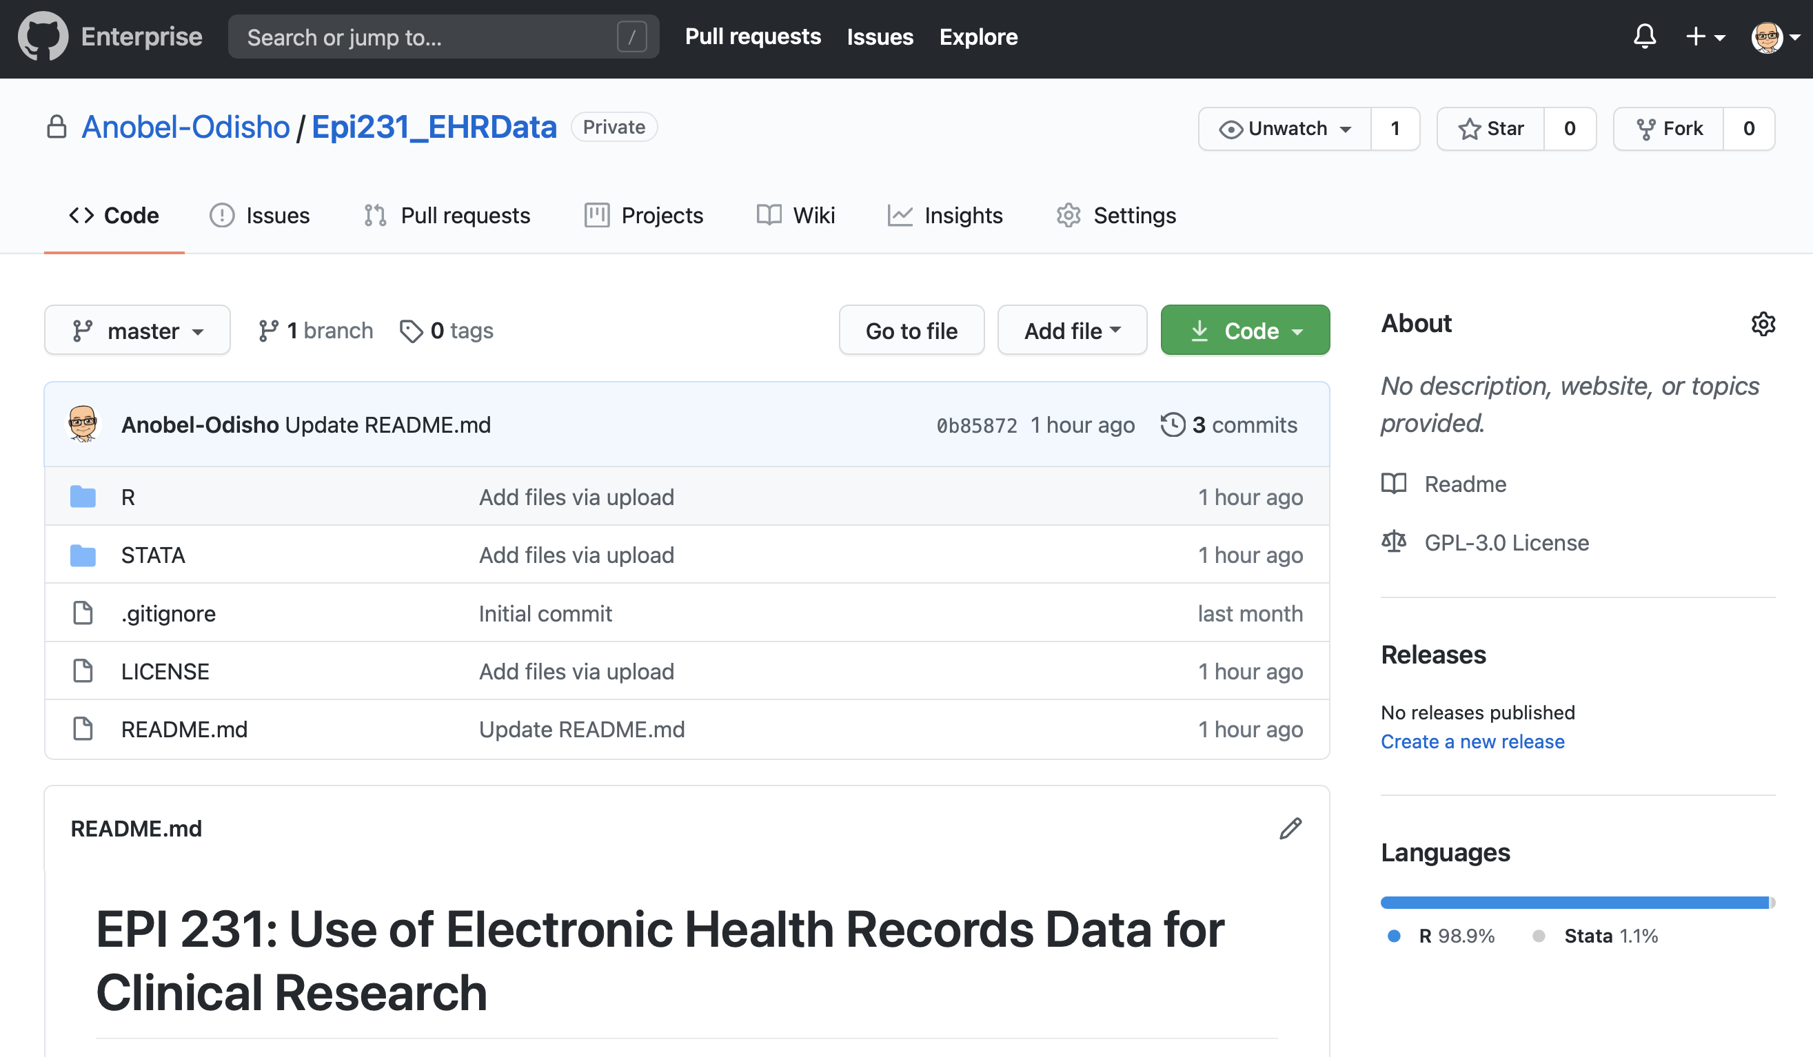

- The technologically simplest way is to go to the repository web page and download the code by clicking on the green CODE button. You can download the entire repository as a ZIP file and then transfer that to your RAE folder using MyTransfer. Anytime the code changes, you will need to download it again and manually transfer to RAE. Using this requires the least knowledge and comfort with Git. This is the recommended approach.
- Optional: These are only recommended to students already comfortable with Git.
  - Clone the repository. You can configure R Studio to “checkout” the code right into RAE. You must first create a remote access token for authentication (detailed instructions here; note where it says “employee ID”, it’s your UCID, which you have even if you’re a student rather than an employee. You can find your UCID here.) Then, open a new project in RStudio with version control (video walkthrough on CLE). This is “right” way to work with Git version control in RStudio, but requires comfort with Git (or a willingness to learn and troubleshoot). Synchronizing with updates in the main project while not losing any of your own work is also tricky. It is only recommended for those comfortable with Git.
  - You can also FORK the repository by clicking the Fork button on the top right of the Git webpage. This makes an exact copy of the entire repository in your own personal account, which you can modify without restriction. However, in order to keep your fork up to date with the original project, you must be comfortable with configuring a remote branch and syncing (described here). This adds onto the complexity of option (b).

