1. Did your group make any general observations about the data structure or distribution?
While the database is clean and there are very few missing values (only ~270 Race values missing), on closer inspection some of the variables were found to have options such as “None,” i.e., the data was effectively missing. One such example is the A1c variable, which would be expected to be predictive of readmission, but the vast majority of participants are coded as ‘None,’ and as a result the variable appears to be minimally predictive when examined in the ‘Rank’ widget. (Of note, the need to measure A1c is hospital patients is among the conclusions of the paper.)

In the ‘Distributions’ widget, no single variable stands out as particularly different between the <30d and >30d readmission groups. The Number of Diagnoses and Insulin variables look slightly different, but based on the ‘Rank’ widget, neither appears to be a strong predictor.

2. What models did you consider and why?
We considered logistic regression, with several lasso regularization parameters, since it is a simple classifier. To see if bagging improved prediction, we considered Random Forest, and tuned the number of trees. We also included AdaBoost to see if boosting improved prediction. Of these, logistic regression performed best, so we tried to stacking, including logistic regression as both a learner and the aggregate, with random forest and SVM as additional learners. The AUC was still in the 0.7 range, so we tried SVM and kNN methods, but with worse results. We also tried a neural network, but it would not run.

3. What validation scheme did you settle on?
Because of the large N in this sample (15.4K), we did not use cross-validation. We opted for a simple 70/30 split of the Training file (i.e., training and validation, testing data provided as separate file).

4. How did you make your modeling approaches and evaluation reproducible?
We selected the options for replicable sampling in all widgets that involved randomization, namely: ‘Data Sampler,’ ‘Random Forest,’ ‘Neural Network,’ and ‘AdaBoost’.

5. Was there variability in AUC among candidate models?
There was little variation in the AUC among candidate models, ranging from 0.689 to 0.742 for our validation data set. Variation among other metrics (e.g., recall) was similarly limited.

6. What was your winning model and its performance for AUC?
The winning model was the Stack, with logistic regression as the aggregate learner, and logistic regression/SVM/Random Forest as the input learners. The AUC on the training data was 0.790, and 0.742 on the validation data. In the final testing data, the AUC was 0.743.

7. Describe EXACTLY the hyperparameter values you used for your winning model. If possible, take a screen shot in Orange.

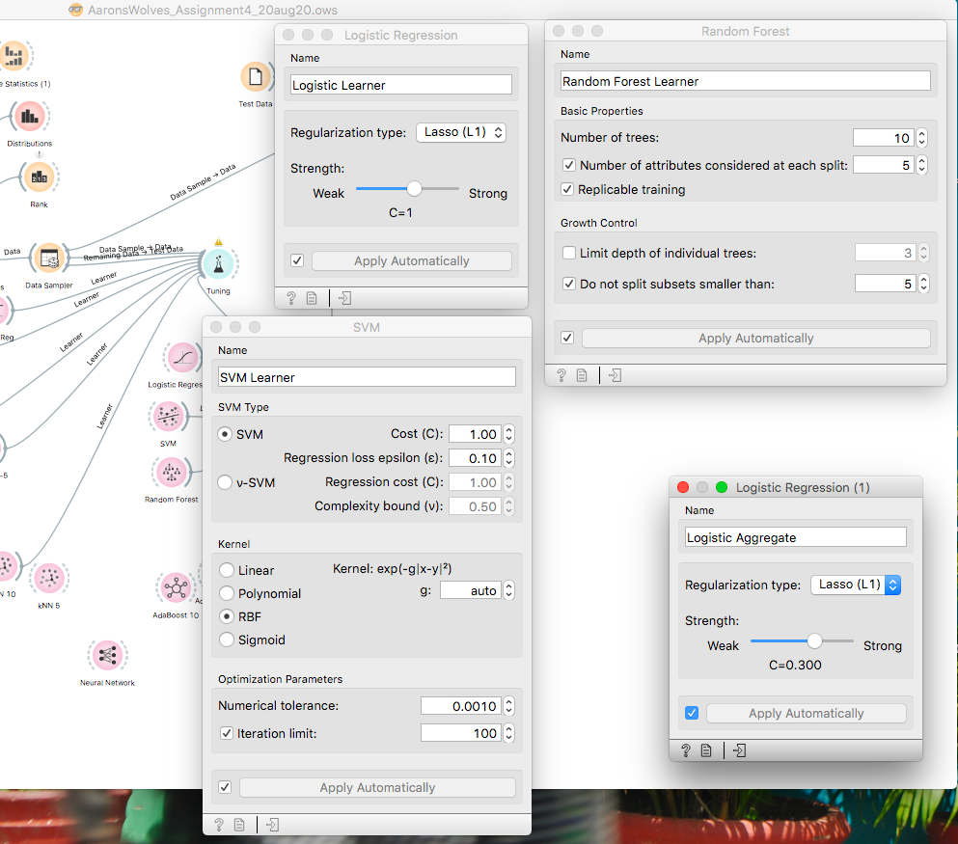

8. Use a confusion matrix to characterize how your winning model got predictions wrong.
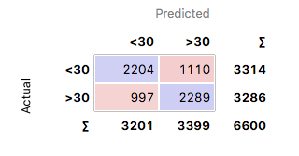

It misclassified about 1/3 of patients in both categories.

