5M PHONE/ZOOM PRENATAL VISIT CHARTING

During chart review for term people look at notes and make sure they did not deliver or that they were not seen in triage for r/o labor etc.

Chart review for a tele-visit is much the same. You can look at labs, previous notes, encounters etc.

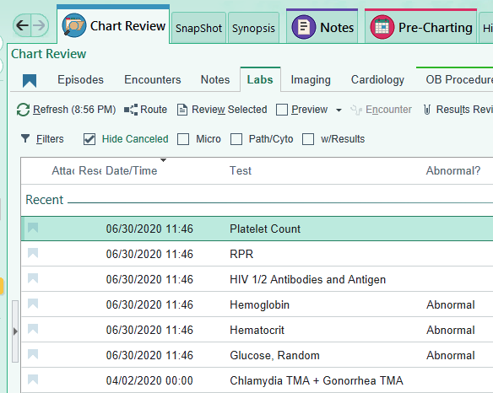

You can do pre-charting and add problems from labs or ultrasounds or triage visits etc. Order labs for that day or vaccines… (and remember the handy order sets for third tri labs etc)


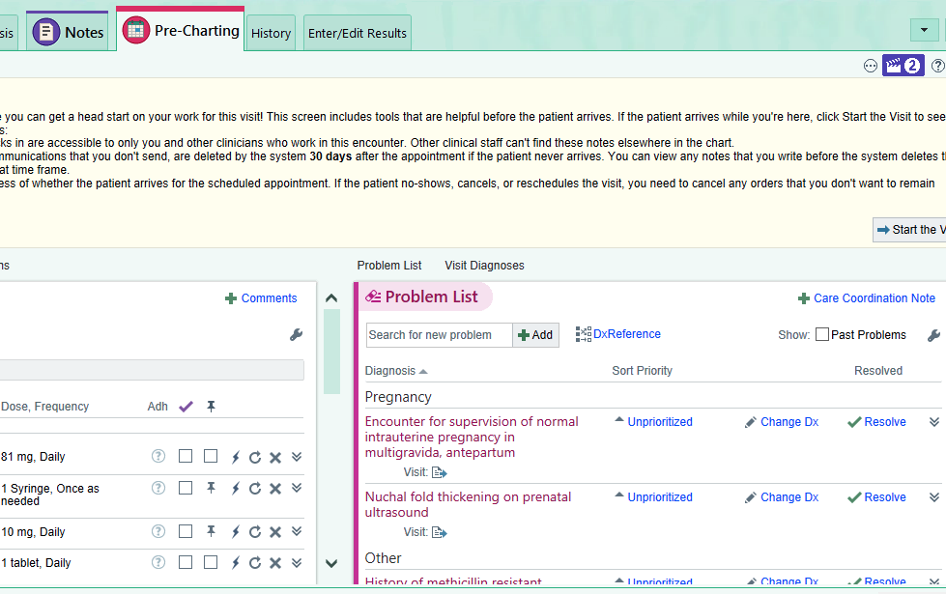

Visits should be pre-set as phone visits with this view. Calls are outgoing. If the patient answers the phone you “start the visit”. I usually ask first thing if they want to use the phone or do zoom. I have my ZOOM room number handy.

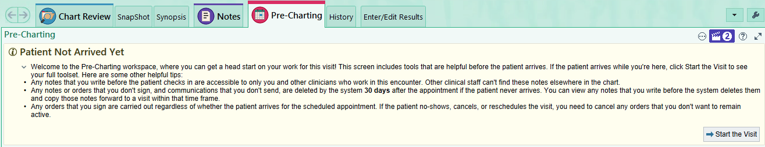
Once you are on the phone check “outgoing” call and fill in the boxes

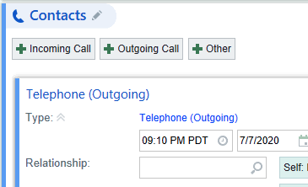

Any problem that you discuss be sure to “move” that problem with the arrow into your note. So for example if they have anemia and you talk about that. If someone needs and rx your preceptor will have to write it, please make sure that you identify the pharmacy they want to use. The main problem for all pregnant patients will be the normal pregnancy one.
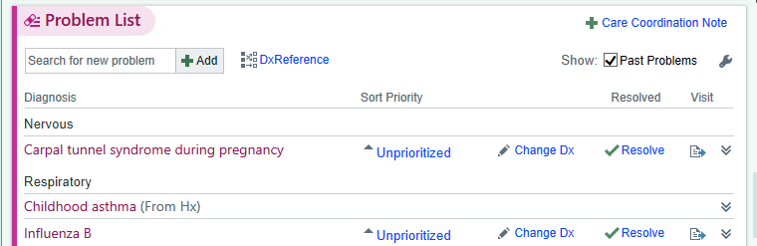
Always check a diagnosis and it will always be normal pregnancy or encounter for postpartum visit.
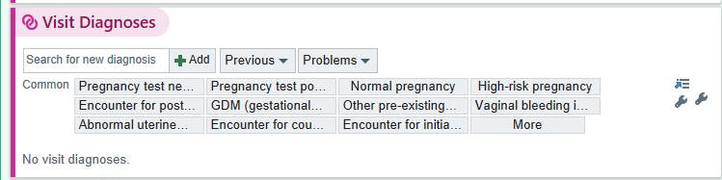

Mark your follow up and say if it will be tele visit or in person

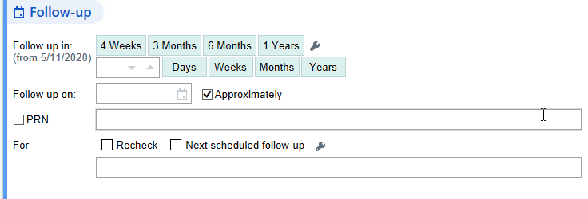

When you are ready to write your note check if it is a tele-video or tele-phone Initial, F/U or postpartum. The note will auto populate. It will pull in any problems and whatever you wrote that you have “arrowed” over. Remember to update your OB-checklist before writing your note. You can also “refresh”
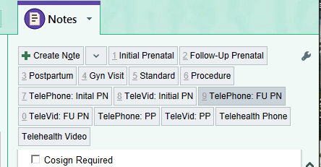

If someone needs resources (nutritionist or MSW or H.Ed) send a message using this mail function. Referral to OB pych or HROB talk to your preceptor.

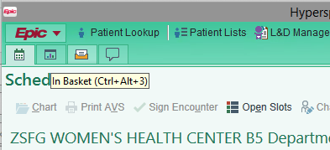

Ceci is the Health Educator and also the person for breast pumps. See resource list for other resources and how to order.