How to Post Assignments
Assignments should be uploaded to the Online Discussion forum by 5pm PST on Tuesday each week. There are no exceptions to the due dates so that faculty and peers can review your work.
- Click Add a new discussion topic
- Enter a few words describing your assignment in the Subject Box
- Type or paste your assignment in the Message Box. Please include a one-sentence description of your project at the start of each assignment. This will help remind everyone what you're working on. Using the same sentence each week is fine.
- To add an attachment, click on the "Advanced" link.
- Click Post to Forum
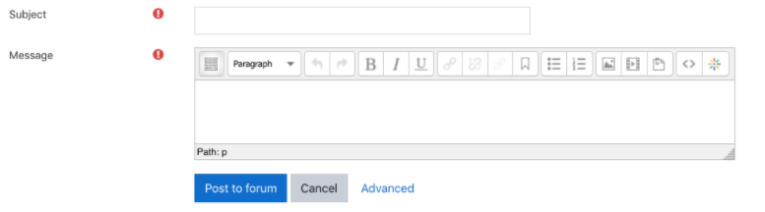
READ and REPLY to other participants' work:
- Click the SUBJECT of the post (not the person's name)
- Click the Reply link at the bottom right of the Message Box
- Type your feedback and click Post to Forum

Peer Feedback
Each week your small group leader will ask you to read and comment two of your classmates’ homework assignments via the Assignment Forum. The goal of this exercise is for you to help each other learn through constructive feedback. Please choose assignments that have not yet received comments. Feel free to ask questions, offer suggestions and share your experiences with the week’s topic. Please post your feedback to the forum by Thursday 5pm PT. Since this deadline is only 48 hours after the homework assignment is due, we encourage everyone to submit homework assignments on time, i.e. by Tuesday 5pm PT.
Your small group leader will post feedback on your assignment on the Assignment Forum by Friday 5pm PT.

