Riana Jumamil
Section Leader: Scott Bauer, MD, MS
Protocol Feedback? Yes

Healthy community conditions and vaccine uptake during the COVID-19 Delta surge: an overview of San Francisco Bay Area
Riana Jumamil, MD; George Rutherford, MD

Abstract
During Summer 2021, the San Francisco (SF) Bay Area experienced a rise of hospitalizations and deaths from the Delta variant of SARS-CoV-2. Despite the availability of effective vaccines to help curb disease spread, large portions of the Bay Area remained unvaccinated. We propose a cross-sectional study on 248 Bay Area zip-code tabulation areas (ZCTAs) during the Delta surge to determine if healthy community conditions (defined by a low or high Vaccine Equity Metric [VEM]) are associated with an increased proportion of new vaccine doses among previously unvaccinated residents. VEM is an index score of community characteristics, including factors associated with life expectancy such as income, education, and having health insurance. Vaccination information is obtained from the California Immunization Registry (CAIR). ZCTA population estimates and demographic characteristics are obtained from the 2019 5-year American Community Survey (ACS). We will use a Wilcoxon test for primary analysis and a multivariate linear regression to control for possible cofounders.

Research Question:
Among San Francisco Bay Area zip codes, is a health equity index score associated with new COVID-19 vaccinations during the Delta variant surge?

Significance
Since Summer 2021, the Delta variant of SARS-CoV-2 has become the dominant strain in the United States (US).^{1,2} During this time, the Centers for Disease Control and Prevention (CDC) recognized the SF Bay Area as a “hot spot” with rapidly increasing COVID-19 cases, as well as hospitalizations and deaths.³ One reason for the rise in cases is that a significant proportion of the Bay Area remain unvaccinated, which is consistent with observations of higher burden of disease among communities with low vaccination rates.⁴

Vaccine uptake is greatly impacted by social determinants of health. Large national surveys have shown decreased vaccinations in those who are younger, with lower income, less education, and living in Republican-leaning states.^{9,8, 6} Other structural barriers to obtaining the vaccine include cost, convenience, and supply chain issues.^{10,11} Vaccine hesitancy is also prevalent among Black and Hispanic communities due to medical distrust, prior experience of racial discrimination, and fear of vaccine side effects.^{5–7, 8} These reasons highlight the need for multipronged public health efforts and investments. Examples include community and policy-level interventions, such as offering local or at-home vaccination programs, to address social/structural barriers in areas with low SES or poor transportation access.¹⁴ Pro-social messaging in various local languages are also evidence-based strategies to address COVID-19 vaccine hesitancy.¹³ One way to measure a community’s social determinants of health is through a VEM like the California Healthy Places Index (HPI), a health index score developed by the Public Health Alliance of Southern California (PHASC).¹² The HPI is a sum of weighted scores according to eight domains: economic, social, education, transportation, neighborhood, housing, clean environment, and healthcare (Figure 1); it has been validated against life expectancy at birth.

This study will contribute to current literature by investigating whether VEM/HPI is associated with new vaccine doses among previously unvaccinated Bay Area residents since the Delta surge. Due to the dynamic nature of the COVID-19 pandemic, prior studies have not examined vaccine uptake during this wave of the pandemic. Moreover, there have not been many studies in the San Francisco Bay Area, a relatively small geographic area with great sociodemographic diversity. Although several counties have a much higher overall vaccination rate than the national average of 64%, there are large discrepancies between certain areas. This study can help elucidate the influence of social determinants of health on those discrepancies.

Methods

Overview of design:
This study will be a cross-sectional study. We will conduct secondary data analysis on the CAIR database run by the California Department of Public Health (CDPH). Specifically, we will look at the percent of first COVID vaccine doses among Bay Area zip codes on July 6, 2021, right before the Delta surge, and estimate the proportion of unvaccinated residents. We will then explore whether a high or low VEM score predicts the percent increase in new vaccine doses among previously unvaccinated residents since July 6 (data as of September 28, 2021). In order to estimate the prevalence of residents vaccinated, total population estimates and demographic characteristics are obtained from the 2019 five-year American Community Survey.

An alternative study design would be a mixed-methods study using community-based participatory research. This could involve a lengthy qualitative interview of community members and stakeholders (ie. Healthcare workers in local hospitals or government officials) in each Bay Area neighborhood. The interview would elucidate reasons for getting or not getting a COVID-19 vaccine, and whether announcement of the Delta variant had affected one’s decision. Common themes of the qualitative interview could then be converted into categorical variables used in statistical analyses, which could also be analyzed by sociodemographic characteristics, such as race/ethnicity, age, and socioeconomic status. Conducting such a study would be very time-intensive and expensive. It would require recruitment of participants and new data collection, which is impossible without sufficient funding and staff. Secondary analysis of an existing database, such as the CDPH’s vaccination database, is much more feasible.

Study subjects:
The target population will be all vaccine-eligible residents living in the SF Bay Area. The accessible sample population for the study include SF Bay Area zip code tabulation areas (ZCTAs). We will use several databases to estimate ZCTA population estimates. The CAIR database includes most immunization records of Bay Area residents, but does not include vaccine doses administered by the Veterans Health Administration, Indian Health Service, Department of Defense, and the Federal Bureau of Prisons. Self-reported demographic data from the 2019 five-year American Community Survey and the National Center for Health Statistics are limited to residents who responded to these surveys. The recruitment and selection criteria of these data sources allows our study to be generalizable to vaccine-eligible residents of the SF Bay Area.

Inclusion criteria are ZCTAs in the Bay Area, which includes Alameda, Contra Costa, Marin, Napa, San Francisco, San Mateo, Santa Clara, Solano, and Sonoma counties. Data will include household residents who are 12 years old or older (for whom COVID-19 vaccines were approved for). Exclusion criteria will include ZCTAs that do not have a calculated VEM, and ZCTAs who have no change in vaccination rate since 100% of the area was vaccinated by July 6.

Measurements:
The main predictor variable will be VEM (dichotomous variable), which is which is divided into above (high VEM) and below (low VEM) the median VEM distributed among all California ZCTAs. VEM include HPI scores developed by the PHASC and imputed scores developed by the CDPH for ZCTAs that did not have an HPI score. ZCTAs without an HPI score included those with a population <1,500 or where more than 50% of the population resides in group quarters.

The primary outcome is the percent increase in unvaccinated residents on July 6 who received at least one COVID-19 vaccine dose three months later during the Delta surge (continuous skewed variable). The number of unvaccinated residents in each ZCTA is estimated by subtracting the proportion of population with at least one dose from 1, and multiplying it by the ACS estimated total population. The primary outcome is calculated by subtracting the number of unvaccinated residents on 9/28 (the most current date) from the number of unvaccinated residents on 7/6, and dividing by the number of vaccinated residents on 7/6 (see below). The secondary outcome is percent of residents with at least 1 vaccine dose during the Delta surge. Data has already been collected to an existing database. Therefore, I will be unable to reduce random and systematic error in my measurements of predictor and outcome.

$$\# Unvaccinated=\left(1-x\right)*y$$

Where x = proportion of the population with at least 1 dose and y= total population

$$\% increase in vaccination among A= \frac{A-B}{A} × 100$$

Where A = # Unvaccinated on 7/6 and B = # Unvaccinated on 9/28

An important questionnaire used in my study is the American Community Survey, from which total population estimates in each ZCTA are obtained. The ACS is the largest US annual survey administered by the US Census Bureau. Domains assessed include demographic characteristics (ie. Age and sex, race/ethnicity), social characteristics (ie. Citizenship, educational attainment, educational attainment), economic characteristics (ie. Employment status, health insurance coverage, income), and housing characteristics (ie. Computer and internet use, value of home). Data estimates are collected into 1-year estimates for geographic areas with at least 65,000 people and 5-year estimates for areas with at least 20,000 people. ACS data is used to inform where to allocate more than $675 billion in federal spending, and where state and local governments invest in community resources. ACS data is also used for disaster response and recovery, research, and NGO and business decision-making.

An important consideration is that ZCTA data is only available as a compilation of 5-year estimates. The most recent data is from 2014-2019, and does not overlap with the current COVID pandemic from the end of 2019 to present-day 2021. Although the data is less current, the margins of error are smaller than 1-year estimates due to larger sample size. However, because of increased frequency of sampling, the estimates can be imprecise. Another consideration is that not all US residents are recorded in the ACS, and people experiencing homelessness are not included due to having no address. The US Census Bureau sends a survey to over 3.5 million addresses, with a national response rate of roughly over 90% in 2018 via internet, telephone, paper survey, or in some cases in-person interview. Each address in the US has a 1-in-40 chance of being selected, and the same address should not be selected in a 5-year period in order to create 5-year estimates.

Potential Confounders:
There are many potential confounders in my study, which may or may not be studied at the level of a ZCTA and/or have available information. These variables are not associated with VEM, which takes into account many social determinants of health in a community (see Figure 1). Eight variables that could be a confounder include the following (defined as a proportion of the ZCTA greater than the state’s median):
- Race/ethnicity
- Age
- Gender
- Non-US Citizen
- Political affiliation (unsure if measured on a ZCTA level)
- Multiple chronic diseases (not measured on a ZCTA level)
- Low density of vaccine sites (unsure if measured on a ZCTA level)
- Has a PCP (not measured on a ZCTA level)
Possible effect modifiers include:
- Unwillingness to vaccinate due to medical distrust, fear of side effects, or other reason (not measured on a ZCTA level)
- Inadequate positive vaccine marketing (not measured on a ZCTA level)

First, we will perform a bivariate analysis looking at the association between VEM and each of the following potential confounder variables: whether a ZCTA has a percent of White and Asian race less than state median of 50.9% (dichotomous), percent of age ≥ 65 years old greater than state median of 14.8% (dichotomous), percent of men greater than state median of 49.6% (dichotomous), and percent of non-US citizenship greater than state median of 12.4% (dichotomous). If there is a statistically significant or near significant association (p<0.1), then possible methods to cope with the likely confounders include:

- A statistical adjustment by calculating a multivariate linear regression model with various potential confounders.
- Stratification and only look at ZCTAs by subgroups according to the level of a potential confounder, such as similar population proportions of race/ethnicity, age, etc.

Stratification in this study would likely involve 3 or more potential confounders or strata, which is limited by the sample size needed for each stratum. Statistical adjustment would be the best plan in this study. In order to draw causal inference in my study (that is, VEM is associated with increase in COVID vaccine first doses among previously unvaccinated), there should be a strong statistical association while accounting for potential confounders. There should also be a consistent association between VEM (or another index score for a community’s wellbeing) and low vaccine uptake among current studies. Lastly, there should be a plausible mechanism for why this association exists, with evidence in current literature.

Statistical Issues
Research Hypotheses:
- High VEM ZCTAs are associated with a higher proportion of previously unvaccinated residents who received at least 1 vaccine dose during the Delta surge compared to Low VEM ZCTAs.
- High VEM ZCTAs have a higher percentage of residents with at least 1 vaccine dose compared to Low VEM ZCTAs.

Analysis Plan:
For my primary analysis, I will use a Wilcoxon test to analyze my dichotomous predictor (VEM) and continuous skewed outcome (proportion of unvaccinated who received at least 1 vaccine dose). For my secondary analysis, I will use a t-test to analyze my dichotomous predictor and continuous normal outcome (percent of residents with at least 1 dose).

Anticipated findings in the Results section: Compared to Low VEM ZCTAs, High VEM ZCTAs had a statistically significantly higher proportion of previously unvaccinated residents who received at least 1 vaccine dose during the Delta surge. High VEM ZCTAs had lower COVID-19 cases per 10,000 residents compared to Low VEM ZCTAs during the Delta surge.
Anticipated findings in the Conclusion section: In the SF Bay Area, communities with favorable sociodemographic conditions associated with high life expectancy have increased vaccination rates and fewer COVID-19 cases during the Delta surge compared to those with less favorable conditions.
Sample Size Estimates:
- Statistical Tests:
  - Wilcoxon
  - T-test
- Null Hypotheses:
  - There is no difference in proportion of previously unvaccinated residents who received at least 1 vaccine dose during the Delta surge between High and Low VEM ZCTAs.
  - There is no difference in percentage of residents with at least 1 vaccine dose between High and Low VEM ZCTAs.
- Alternative Hypotheses:
  - There is a difference in proportion of previously unvaccinated residents who received at least 1 vaccine dose during the Delta surge between High and Low VEM ZCTAs.
  - There is a difference in percentage of residents with at least 1 vaccine dose between High and Low VEM ZCTAs.
- Standardized Effect Size:
  - 0.096; Low VEM n = 41, High VEM n = 207, SD = 0.20
  - 0.058; SD = 0.37
- Alpha is 0.05. Two-tailed test.
- Beta is 0.20

Justification:
- I obtained the standard deviation of my outcome by calculating it with Microsoft Excel using my current dataset. I obtained estimated effect size using the T statistic and non-centrality parameter using an online calculator.

- I decided on a two-tailed statistical test, since the P value includes the probabilities of committing a type I error in either direction. For example, I will be better able to detect a statistically significant difference if High VEM ZCTAs were to be associated with higher or lower outcome. I decided on the power to be 80%, since that is the standard. I decided to also look at overall percentage of 1st vaccine dose among ZCTAs to see if it associated with my primary outcome, the proportion of previously unvaccinated who became vaccinated during the Delta surge.

Ethical Considerations
The ethical considerations of my study are minimal, given that all data has been de-identified and I am primarily looking at data at the population-level of ZCTAs.

References
1. Bolze A, Cirulli ET, Luo S, et al. SARS-CoV-2 variant Delta rapidly displaced variant Alpha in the United States and led to higher viral loads. medRxiv. Published online 2021.
2. Planas D, Veyer D, Baidaliuk A, et al. Reduced sensitivity of SARS-CoV-2 variant Delta to antibody neutralization. Nature. 2021;596(7871). doi:10.1038/s41586-021-03777-9
3. Kate Larsen. Bay Area lands on CDC’s emerging COVID hot spot list as cases surge among unvaccinated. Published online July 12, 2021.
4. Sacarny A, Daw JR. Inequities in COVID-19 Vaccination Rates in the 9 Largest US Cities. JAMA Health Forum. 2021;2(9):e212415-e212415. doi:10.1001/jamahealthforum.2021.2415
5. Gibson D, Agarwal S, Mba M, Meghani A, Limaye RJ, Labrique A. Title: COVID-19 Vaccine Acceptability and Inequity in the United States: Results from a nationally representative survey. medRxiv. Published online 2021.
6. Thunstrom L, Ashworth M, Finnoff D, Newbold S. Hesitancy Towards a COVID-19 Vaccine and Prospects for Herd Immunity. SSRN Electronic Journal. Published online 2020. doi:10.2139/ssrn.3593098
7. Savoia E, Piltch-Loeb R, Goldberg B, et al. Predictors of COVID-19 vaccine hesitancy: Socio-demographics, co-morbidity, and past experience of racial discrimination. Vaccines. 2021;9(7). doi:10.3390/vaccines9070767
8. Kim D. Associations of Race/Ethnicity and Other Demographic and Socioeconomic Factors with Vaccine Initiation and Intention During the COVID-19 Pandemic in the United States. medRxiv. Published online 2021.
9. Tram KH, Saeed S, Bradley C, et al. Deliberation, Dissent, and Distrust: Understanding Distinct Drivers of Coronavirus Disease 2019 Vaccine Hesitancy in the United States. Clinical Infectious Diseases. Published online 2021. doi:10.1093/cid/ciab633
10. Alam ST, Ahmed S, Ali SM, Sarker S, Kabir G, ul-Islam A. Challenges to COVID-19 vaccine supply chain: Implications for sustainable development goals. International Journal of Production Economics. 2021;239:108193. doi:https://doi.org/10.1016/j.ijpe.2021.108193
11. Fisk RJ. Barriers to vaccination for coronavirus disease 2019 (COVID-19) control: experience from the United States. Global Health Journal. 2021;5(1):51-55. doi:https://doi.org/10.1016/j.glohj.2021.02.005
12. Maizlish N, Delaney T, Dowling H, et al. California Healthy Places Index: Frames Matter. Public Health Reports. 2019;134(4):354-362. doi:10.1177/0033354919849882
13. Finney Rutten LJ, Zhu X, Leppin AL, et al. Evidence-Based Strategies for Clinical Organizations to Address COVID-19 Vaccine Hesitancy. Mayo Clinic Proceedings. 2021;96(3):699-707. doi:10.1016/j.mayocp.2020.12.024
14. Barry V, Dasgupta S, Weller DL, et al. Patterns in COVID-19 Vaccination Coverage, by Social Vulnerability and Urbanicity — United States, December 14, 2020–May 1, 2021. MMWR Morbidity and Mortality Weekly Report. 2021;70(22):818-824. doi:10.15585/mmwr.mm7022e1

Appendix
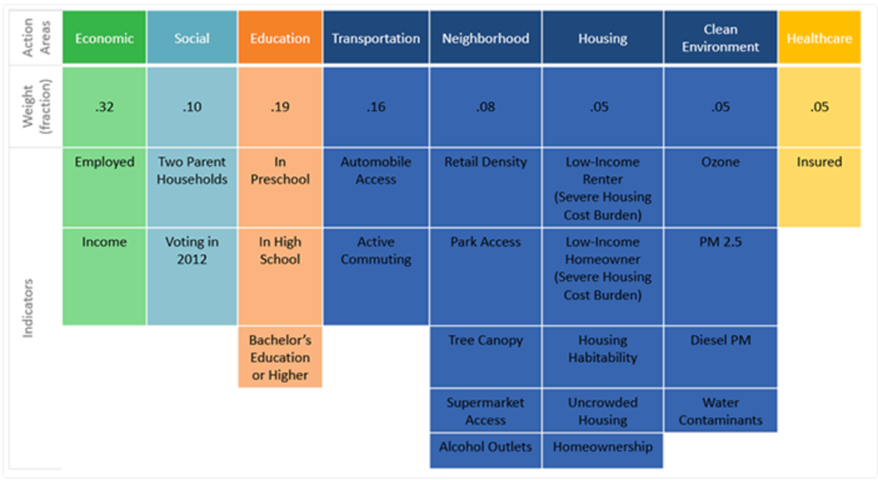
Figure 1. Community characteristics and weights combined into overall HPI score

A.
Vaccine Equity Metric
(Low/High)
% Increase in Vaccine Doses among Unvaccinated Residents

B.
Vaccine Equity Metric
(Low/High)
% Increase in Vaccine Doses among Unvaccinated Residents
Percent of ZCTA White Race is <36.3%
(Yes/No)

C.
Vaccine Equity Metric
(Low/High)
% Increase in Vaccine Doses among Unvaccinated Residents
Percent of ZCTA aged ≥65 years old is >14.8%
(Yes/No)

Figure 2. Directed Acyclic Graphs of Possible: A) Effect-Cause, B) Confounder, and C) Effect Modifier

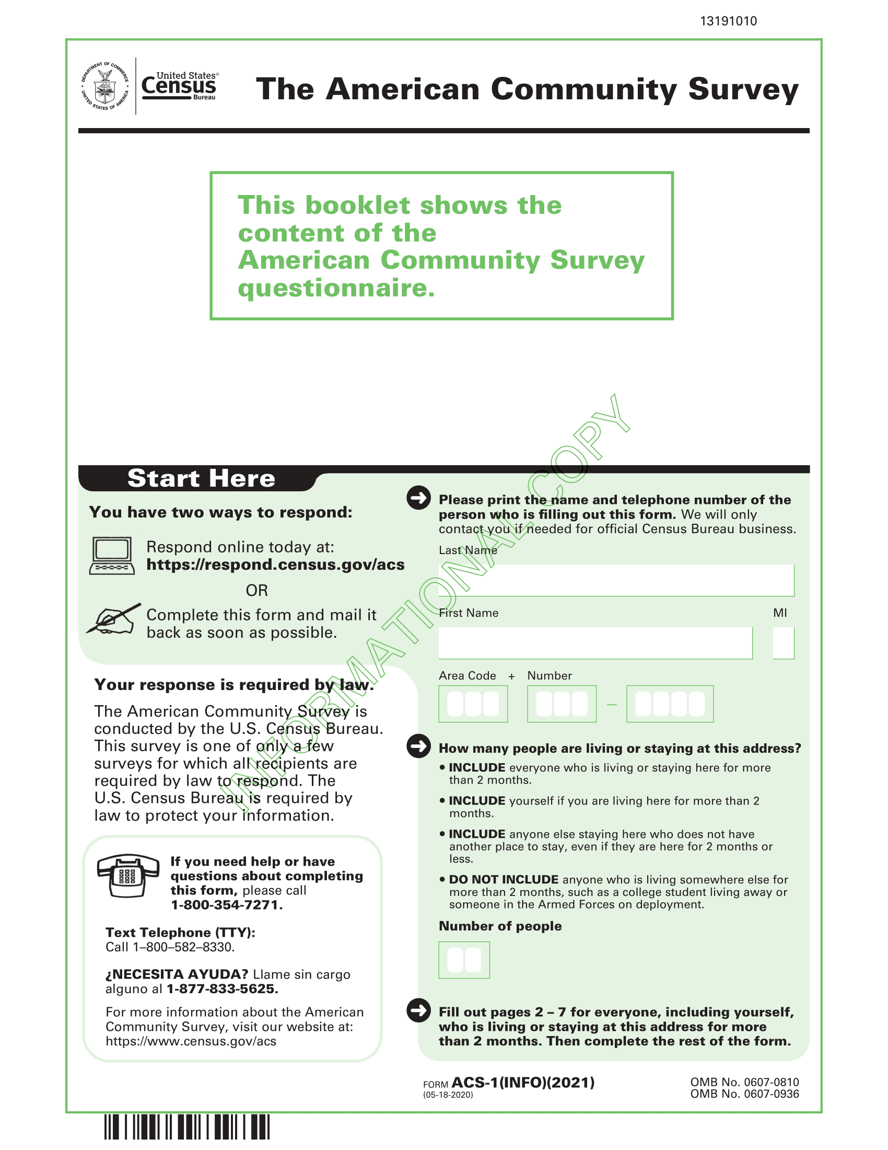
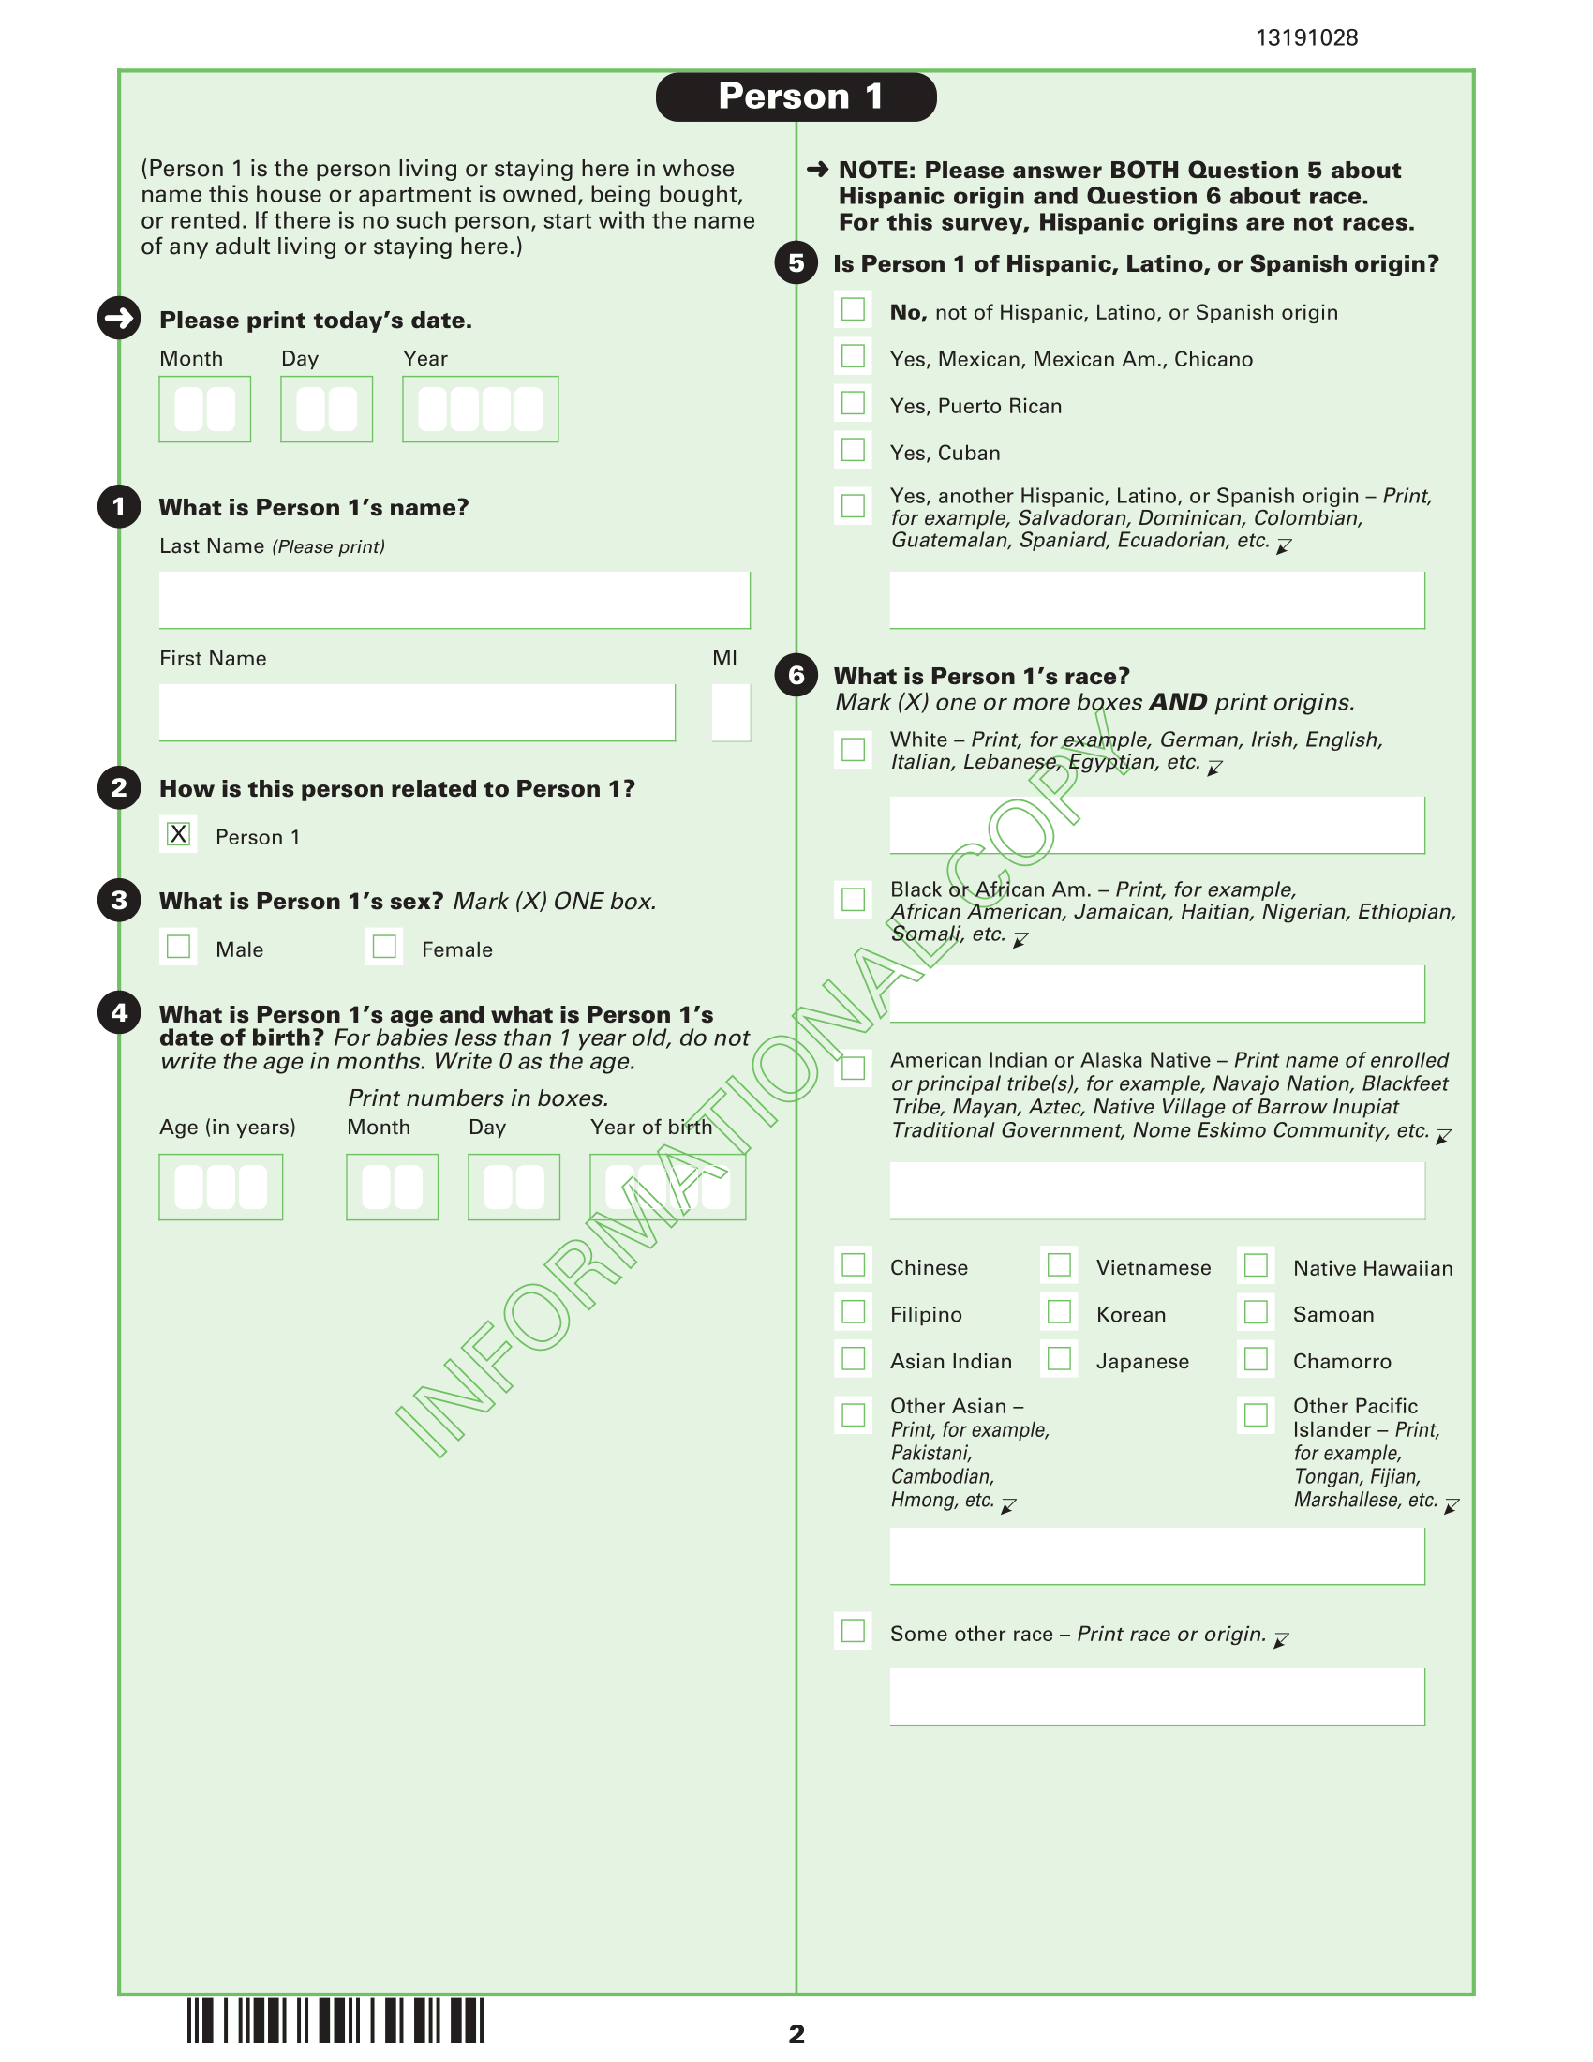
American Community Survey (abbreviated for relevance)

