Outline for today: This handout can be used as a worksheet and reference. The goal of today’s session and the handout is to leave you with a working version of EndNote.
What is it?
Setting up EndNote for Mac (Windows) Page 2
Setting up EndNote Web (a free, limited, online version of EndNote) Page 3
Using EndNote for Mac (Windows) Page 5-10
Adding references to EndNote
From PubMed
From Others:
(Web of Science, Embase, PsycINFO, CINAHL, GoogleScholar)
From PDFs (bottom of Page 10)
Adding citations and a reference list to a Microsoft Word document

What is it?
EndNote (EN) is the “industry standard” reference manager. It has been around for > 20 years. It has many competitors but stands out due to power, customizability, and ability to retrieve a set of full-text articles with one-click. It is a bit harder to master than others but basic functions are not difficult to learn or execute. We will focus on basic set up and use today.

This class uses EndNote version X8. Version X9 was released in August 1, 2018 by new owners Clarivate Analytics. If you own EndNote X6, X7, or X9 they are similar enough for this class to be useful. This class will be less useful for EndNote X5 (and older). The Mac and Windows versions are generally similar in X6 and X7; in X8 and X9 the versions are almost identical.

EN is available at: https://ucsf.onthehub.com/WebStore/Welcome.aspx for faculty and staff for $219, $99 for those with registered earlier versions. Students who are new to EndNote can purchase via EndNote for $113.95 https://endnote.com/interstitial. Try to stay within two versions of the current version to be able upgrade directly. That is, if you have EndNote X6 or X7 you can update easily to X8; if you have X4 or X5 it is more complicated.

If you do not have EndNote already and want to try it out there are two options:
1. Download a 30-day trial of the desktop version at http://endnote.com/downloads/30-day-trial . Note that it may take hours before you receive an automated email response. You must have this response to download and activate your trial.
2. EndNote Basic is a free, limited version of EndNote. It will import articles from databases and cite in Word. http://endnote.com/product-details/basic
EndNote desktop combines with EndNote Basic to facilitate sharing your work with others.
Setting up EndNote for Mac (Windows)
Set up your Library:
Create a new library when you open EndNote for the first time and name it something useful. The default is MyEndNoteLibrary. A frequently asked question is whether to put everything in multiple folders within one library or to create a separate library for each project. You will hear different opinions but generally I recommend one library with “groups” and “group sets”. Why? Organizational simplicity and sharing.

Each EndNote library is made of two components. If those components are not together in one folder EndNote will not function properly. The two components are a file (with suffix .enl) and a folder (with suffix .data). More libraries means more complexity; it becomes easier to separate the file and folder.
EndNote has tried to make this more fool-proof.
- .enlp is a library package that keeps both components together, choose this option when you create a new library (Mac)
- .enlx is a travelling or export package, choose this option when exporting.
As for sharing, you can only synchronize one of your desktop libraries with EndNote Basic. Sharing using EndNote Basic is harder with multiple libraries.

Set Preferences (probably already set on UCSF Computer Lab computers):
In the EndNote X8 menu (the Edit menu in Windows) click on Preferences…
Click on Find Full Text.
Check the PubMed LinkOut box
Open URL Path: http://ucelinks.cdlib.org:8888/sfx_local
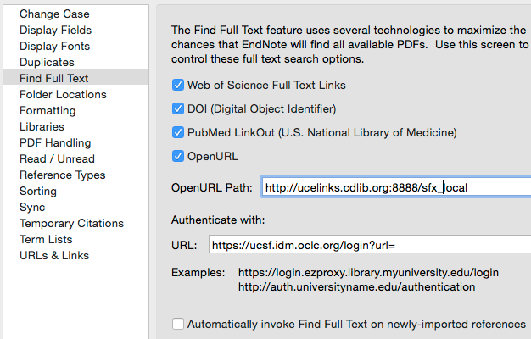

Authenticate with URL: https://ucsf.idm.oclc.org/login?url=
Will help you find full text if you are off campus and will bring up the MyAccess login.
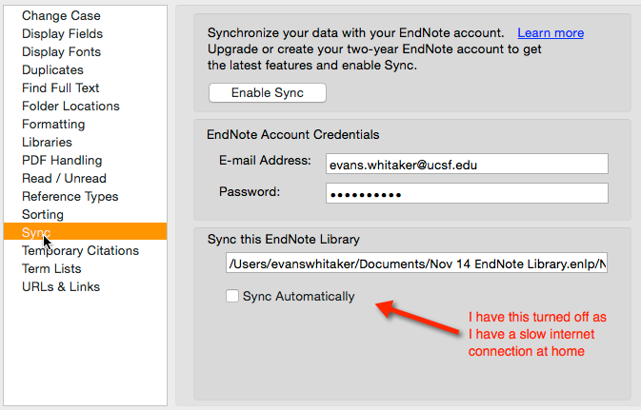
Set up EndNote Online (if you own EndNote you can set this up from within the program):
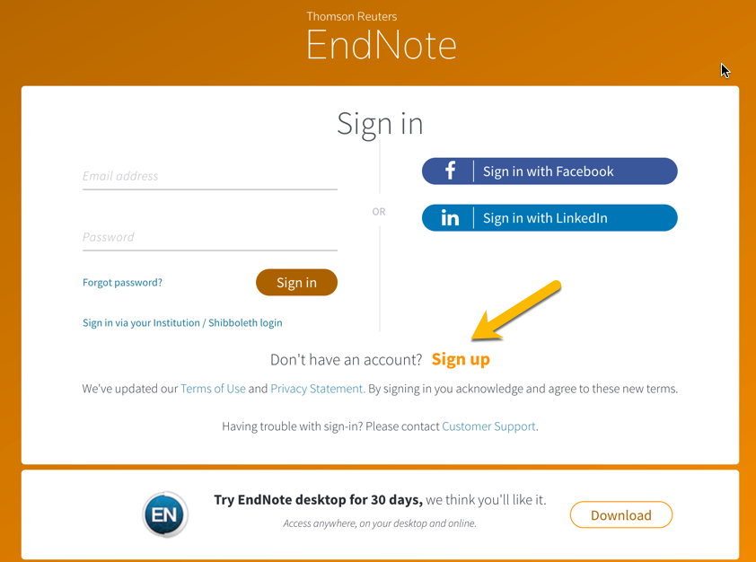

1.Go to https://www.myendnoteweb.com/
2. “Create a free account””Sign up”
3. Fill out the form.
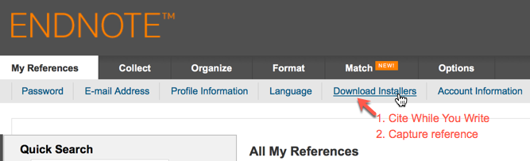
If working on your personal computer and you have Microsoft Word installed, download. CiteWhileYouWrite (CWYW). It is already installed on computers in the lab.

(CWYW is automatically installed with EndNote desktop. See image below.)

The orange arrow (see below) points to an interesting tool (Match) designed to help authors select a journal to which they might submit a manuscript!

EndNote has a Capture Reference bookmarklet. See figure just below. This allows you to store website references. It does not work perfectly but I am hopeful Clarivate will improve it.

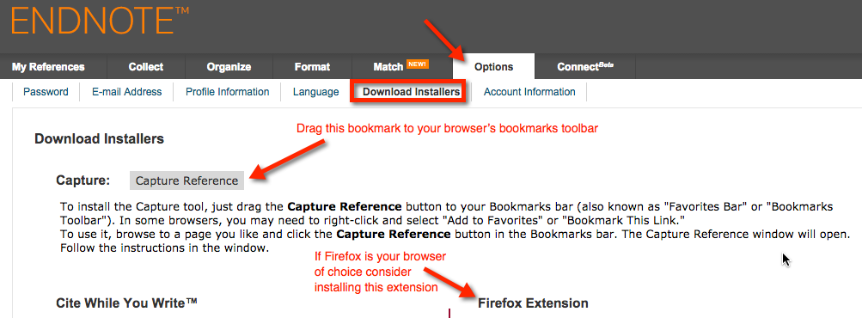
From Options Download Installers Drag Capture Reference to your bookmarks toolbar. Get Cite While You Write (CWYW) while you are at it if you have Microsoft Word

If you are going to use EndNote Web with EndNote Desktop set preferences (see figure at the top of page 3) by adding username and password to Sync portion of Preferences.
You can use either EndNote desktop or EndNote online to do the following parts of the class.

Using EndNote with Mac (Windows) to add references:
PubMed
1. Open PubMed.UCSF.edu from the UCSF Library home page (www.library.ucsf.edu, I suggest you bookmark this link).
2. Search in PubMed for anything you want.
3. Select a few results.

Note: Adding material to EndNote from PubMed is a three-step process.
First, create and download a small file from PubMed.
Second, import that file into EndNote.
Third, move the references from the Imported References folder
in EndNote to your folder of choice in EndNote.
Specific steps follow:

4. In PubMed choose Send to: Citation manager (see image below)
Then click Create File, a small file is downloaded to your computer.
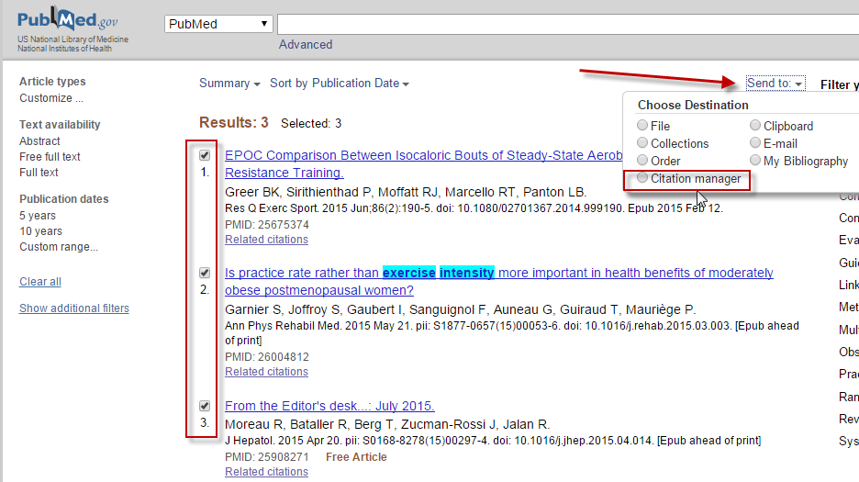

It is usually placed in the downloads folder. The suffix of this file is .nbib and unique to PubMed. You can download up to 200 citations at one time with Citation manager. If you have more than this you can move up 500 at a time using the Send to…File option. Here you will need to choose MEDLINE as the file type, this will create a small .txt file. In EndNote, choose FileImport and set import option as PubMed(NML)
5M. Mac
Choose Import…see image to right top of next page…
5W. (Windows)From the File menu in EndNote, choose Import…File
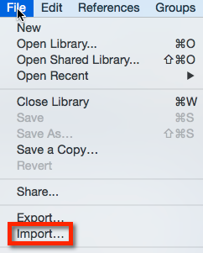
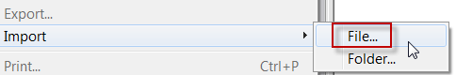
6. Locate the file (try downloads first).

7. Set import preferences to look like image below:
This is a key step to remember whenever
importing material into EndNote. Set import option (see below) to match the database or PDF you are
importing from!

Windows: Mac:

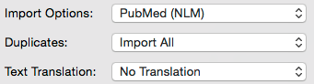
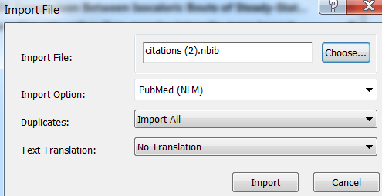

8. The citations will be moved into the Imported References folder in EndNote.
9. See image below:

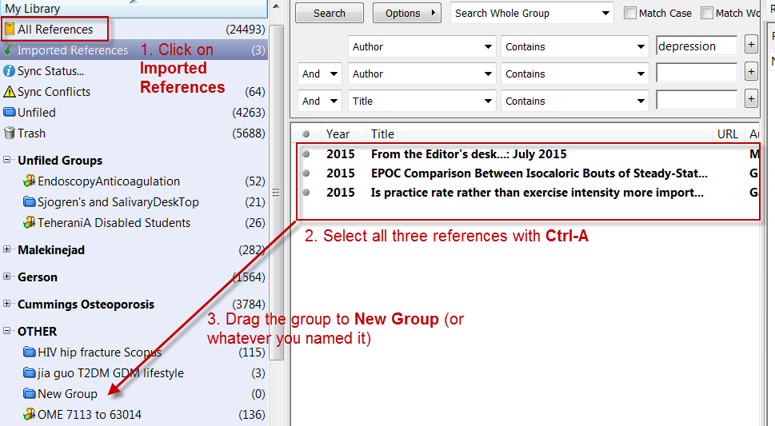
Now you have references from PubMed in a folder in EndNote.
You are probably thinking that is way too much work. The process is easier in other databases and GoogleScholar. We will look at these next…

Web of Science: Find this database by searching for Web of Science in the search box at library.ucsf.edu.
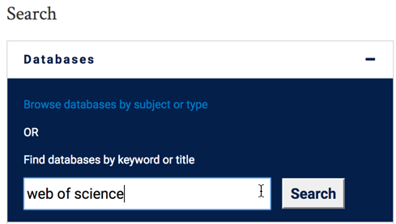
- Perform a search in Web of Science.
- Select articles you want by clicking on check box.
- Send to EndNote (either online or desktop – see image below
- A file is downloaded with a .ciw suffix
- Double-click on the downloaded file and you will be asked whether you wish to add it to EndNote desktop or EndNote online.
- Make your choice…
The rest is as discussed in PubMed section
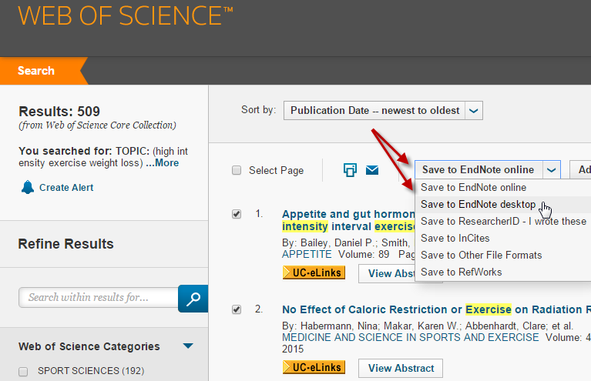

Embase:
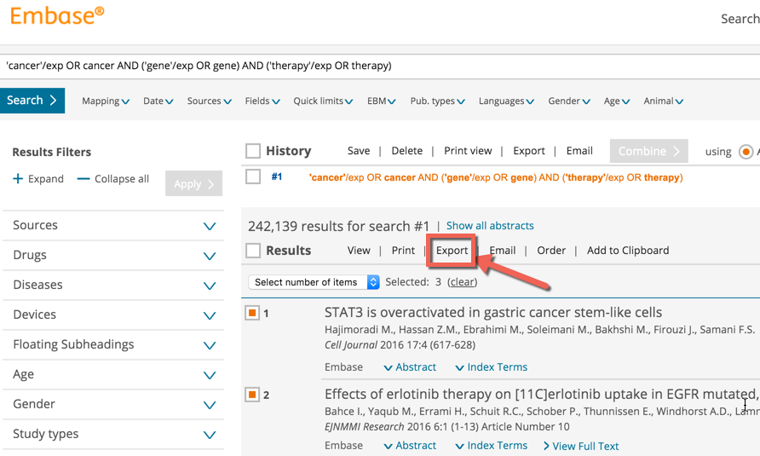
Moving material from Embase to EN is a multistep process like PM

1. Search Embase

2. Check boxes of what you want to export.

3. Click Export

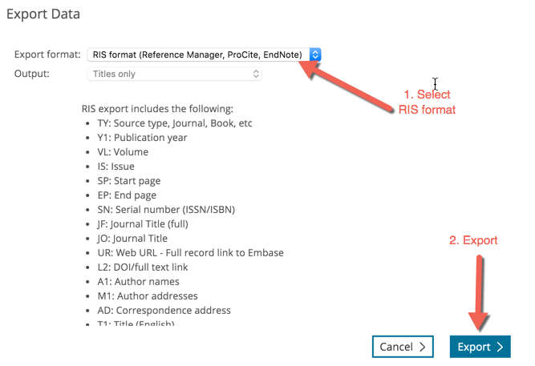
4. Select RIS file type.

5. Click Export

6. Download your file (see bottom of page)

7. Import into EndNote.

The process is similar to PubMed (see page 6)
except file type is Reference Manager (RIS) instead of PubMed (NLM).


Let’s try PsycINFO next:
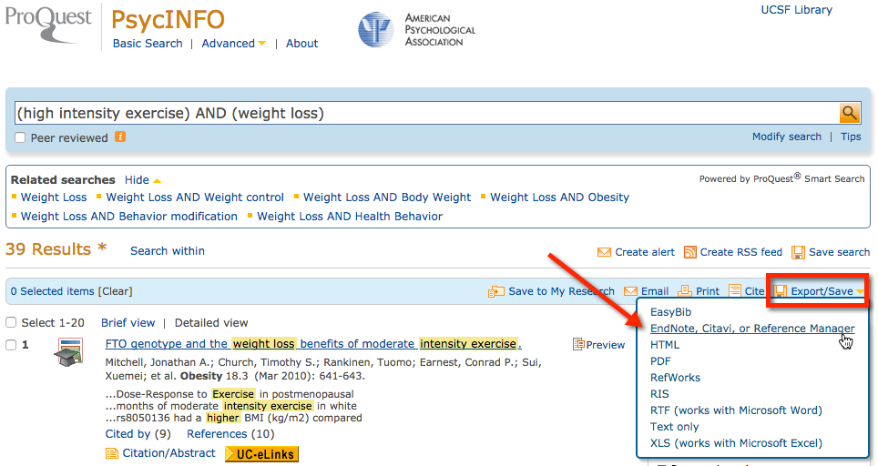
Sociological Abstracts, ERIC both look and act the same as PsycINFO.

CINAHL (Nursing and Allied Health database)
4 steps: Search, Add to folder, Export to EndNote (see the three screen shots below)
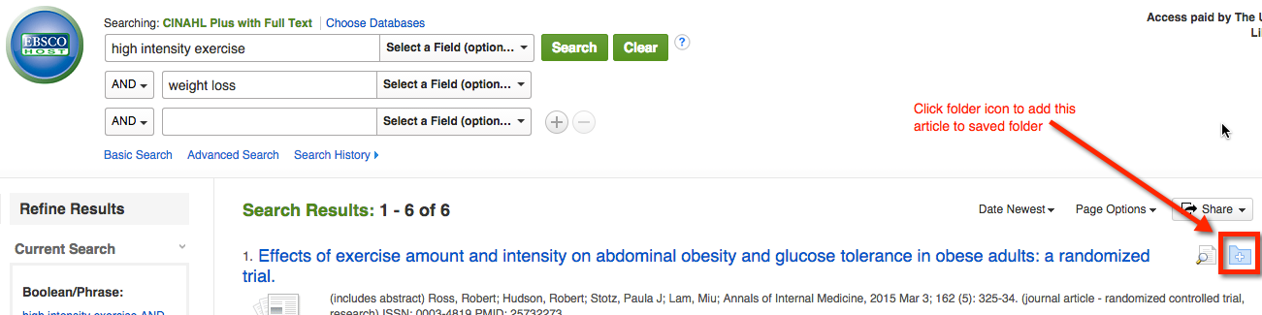

Step 1

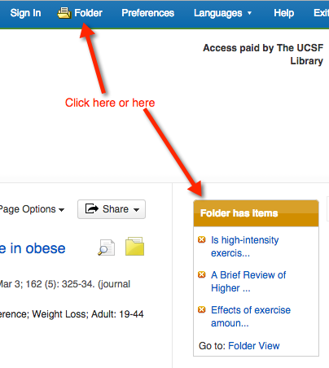

Step 2

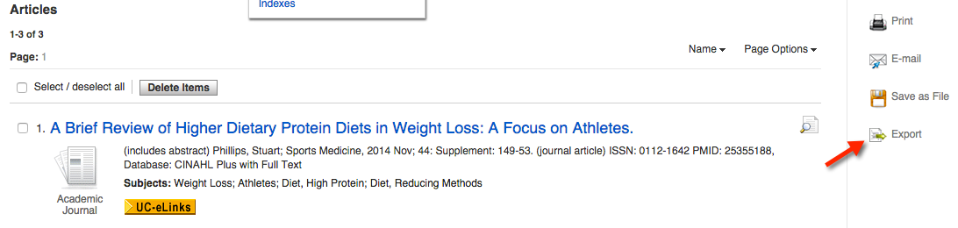
Step 3

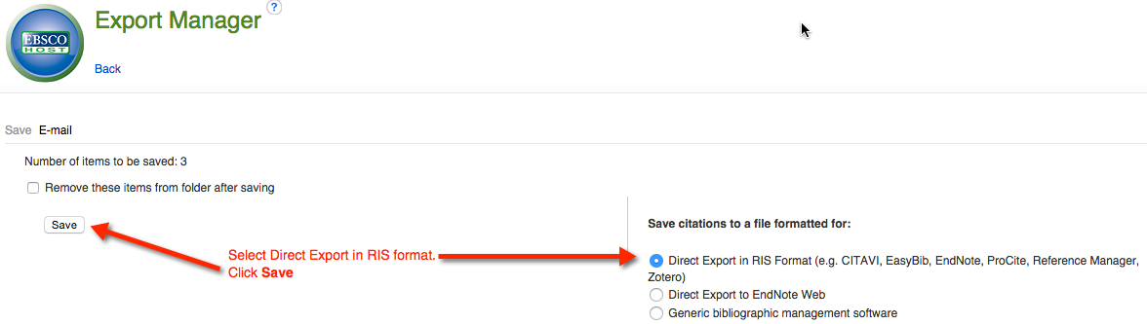

Step 4

Let’s try Google Scholar. Two steps to this one…
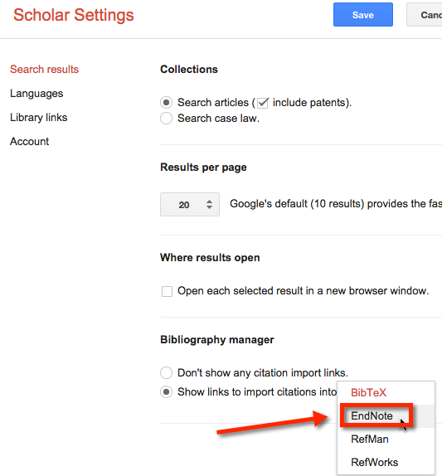
1. Set Preferences
a. Go to scholar.google.com
b. Click Settings
c. See picture to right. Select EndNote as your Bibliography manager

Now your search results will offer Import to EndNote with each result (see next image).

Note: I suggest you only add one reference at a time from GS to EndNote, trying to import more than one at a time does not work very well.
2. Import into EndNote (see image top of next page)
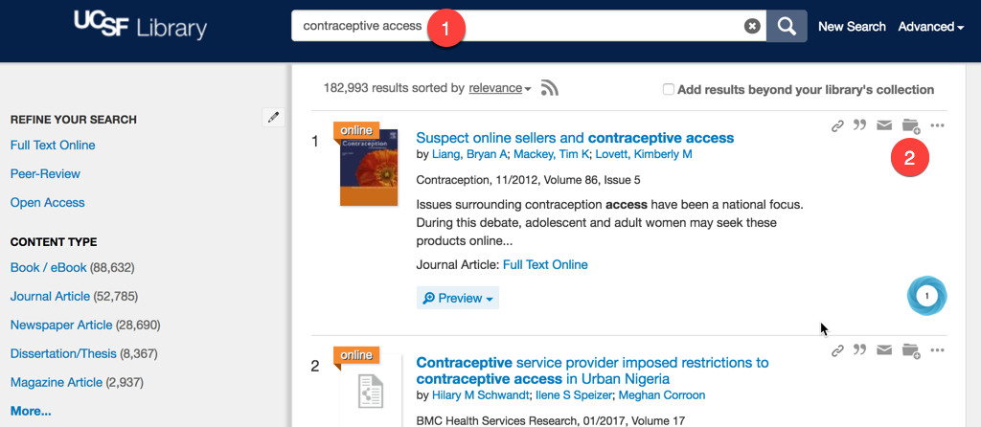
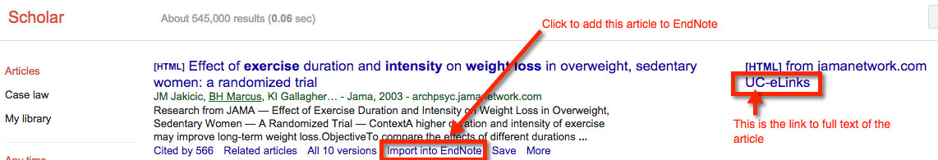
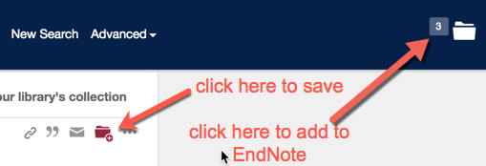
New UCSF Library Single Search (AKA Summon Search or Global Search) is a great place to start looking for information. It searches all UCSF Library content in one interface 1. Search.
2. Select articles you want to save by clicking on folder icon
Add to EndNote by opening folder see image to right and “export to EndNote”.

Getting PDFs for articles you have added to your EndNote libraries.
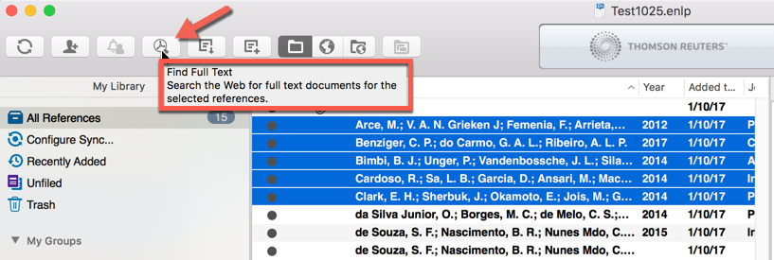
You can set the import to be automatic in preferences. OR you can highlight a set of articles in a library and “tell” EndNote to go fetch full text.

Adding PDFs to your library
Many of us end up with PDFs on our computer.
Can we add these to EndNote?
Mostly yes with desktop. When you import PDFs make sure you have the options set properly. More times than not EndNote does not get the metadata right.
No with online version.
With Mac desktop (Windows is similar but not exactly the same):
Within EndNote, go to File menuImportSet preferences at bottom of page to: PDF file or folder (if you want to bring in more than one PDF at a time put them all in a folder!).
Leave the other settings unchanged (see image below). Then Import.
EndNote will try to find the right information for title, authors, journal, year, volume, issue, pages. It does not always get it right so double-check your imported PDFs. Edit as necessary.
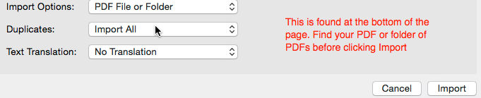

Let’s write a paper
1. Word for Mac 2011.
Verify installation of Cite While You Write (CWYW)
Open Microsoft Word. If you do not see the EndNote toolbar …
Go to the View menu of Word. Find Toolbars and make sure EndNote X7 is checked. If you do not see it there, you may need to reinstall it. See image next page.
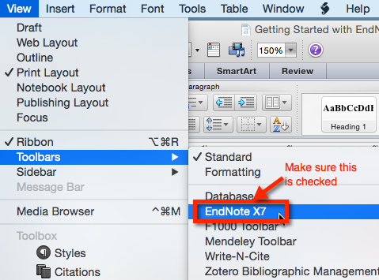

As you write your paper, click Citations to add a reference.

Notice: You can see the reference style.
It is JAMA in the example shown at the bottom of the last page. (JAMA is the same as AMA style)

When you are ready, you can click Bibliography and then Configure Bibliography to add your reference list to the end of your paper.

2. Word for Mac2016 and newer. You should see an EndNote tab in Word.

3. Windows. Verify installation of Cite While You Write (CWYW)
Open Microsoft Word
You should see an EndNote tab.


If not, you may need to reinstall or enable CWYW. To enable: In Word find the File menu, then Options, then Add-ins, then Word Add-ins, make sure both options are checked
Set your bibliographic format. AMA and APA 6th ed. are commonly used at UCSF.
a. Open a blank document and start to type.
b. To add an in-text citation, click on the EndNote X7 tab.
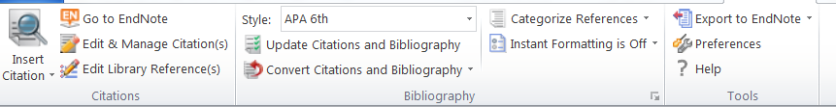
c. To add a list of references.
d. To edit, use this: Resist the urge!! to remove unwanted references by back spacing them out or high-lighting and deleting. This may alter the formatting of your document and make it unusable.

4. EndNote Online looks slightly different…
but the functionality is the same. If you have both EndNote desktop and EndNote online you can change back and forth between your preferred application by clicking on Tools on the tool bar (see picture bottom of previous page) Cite While You Write Preferencesthen Application tab Choose the version you want to use.
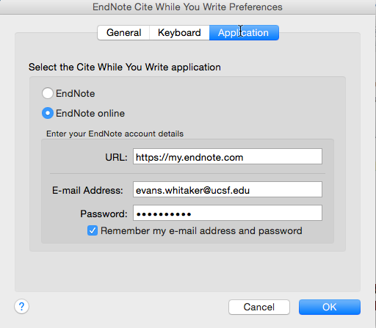
Look at the screen shot to the left for more detail.

EndNote works with Apple Pages word processor: See https://support.apple.com/kb/PH23641?locale=en_US
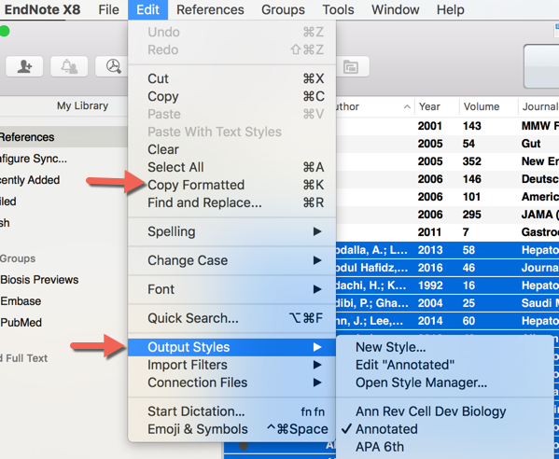
Create a bibliography using EndNote, independent of a paper.

1. In EndNote select the output style you want. From Edit menu, select desired Output Styles (see image to right).
2. Select the items you want to include in your bibliography.
3. From Edit menu select Copy Formatted (see image to right).
4. Paste into a Word document.

NOTES:

