How to use this Handout
I realize as I talk with people trying to use this handout that I did not include a summary of the steps needed to install, configure, and use Zotero (hereinafter Z). Hopefully this page will help.
Outline of steps. More details and screen shots are included further on in the handout.
- Register for an account at Zotero.org. Write down your username and password. You do not need to use your UCSF email.
- Acknowledge an email from Z.
- Login to your online account.
- Close Word if it is open (you will need Word or Open Office/Libre Office to use Z, it does not work with Pages or GoogleDocs. It will work with most LaTeX based writing software. Explore https://ucsf.onthehub.com/WebStore/Welcome.aspx to get academic discounts on software (including Microsoft). Can use special export style to add references to Wikipedia.
- Back at Zotero.org, click on the big Zotero icon in the upper left of the page. Click the big, red Download and then install Zotero 5.0 as you normally would install any software.
- Set Z preferences. This is covered pretty thoroughly on page 3.
- Test your installation
  - Go to CDC.gov in your browser and find the Z icon (see page 2)
  - Open Word and find the Z tool bar. It looks different in different versions of Word. (see page 6)
    - In Word Mac 2007 find Z in “scroll” icon
    - In Word Mac 2011it is a tiny toolbar that appears in far upper left of the screen. You can drag this into a better location.
    - In Word Mac 2016 is appears in the Add-Ins tab
    - In Word for Windows it appears in the Add-Ins tab.
- Use Z to collect information from databases and webpages. You can add PDFs you already have on your computer. Hopefully this is made clear later in this handout.
  - It is easy to add content to Z. In most cases you go to a resource you want to add (like results from a PubMed search or something you find on Google or a website, click the Z icon and either Z will import it or ask what articles you want to import from a list. Z shows a status box in the right lower page to show you it is working. See page 8 for exceptions to the above. Try it…it is pretty intuitive. see exceptions
- Organizing your library: Click the small file folder icon in the far upper left to create a new folder, name it, and then drag articles from My Library to the folder. You can put folders within folders as well.
- Use Z to format a Word document. Page 8 of this handout should take you through those steps.
- One last tip: Remember to right click. Often when you need to do something in Z a right click will show a menu of options that will help you!
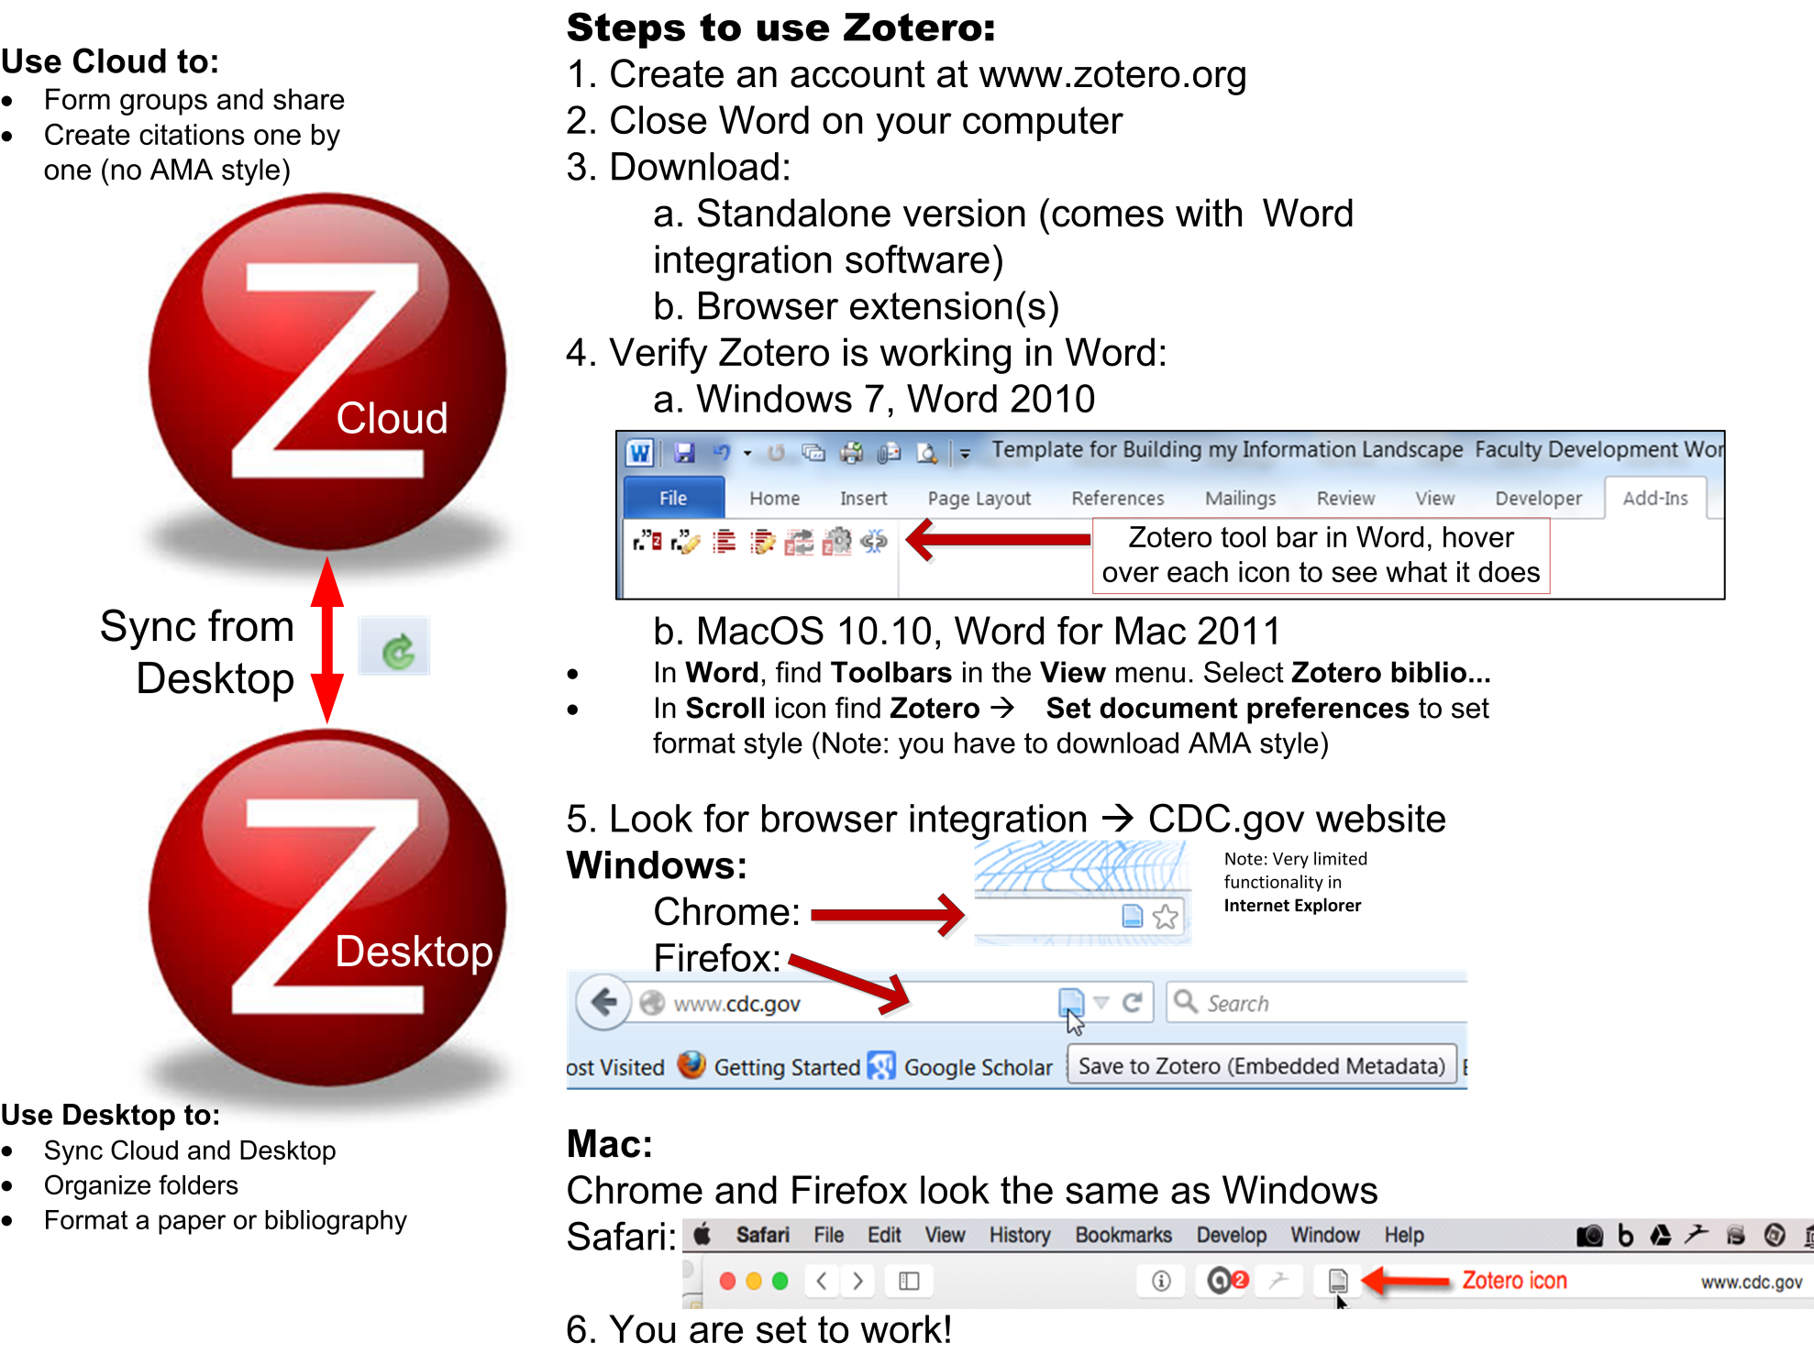

Finer Points about Zotero
Sync between Zotero desktop and Zotero cloud: Find the
located in the upper right of the Zotero desktop interface. Clicking on the curly green arrow will sync the contents of your library between desktop and cloud.
Set preferences: Open Zotero desktop (vs. cloud). From the Zotero menu (Macs) or Tools menu (Windows) find Preferences. Working through the tabs left to right…
1. General tab:
a. Change user interface to Medium or Large. You can change font size as well. Leave the rest unchanged.
b. Choose between Standard and Stacked
2. Sync tab:
a. Enter Zotero web log-in information.
3. Search tab: Click Check for installer. Downloads small file for PDF indexing (link is about half way down the preferences page). Leave the rest unchanged.
4. Export. To set fomat for creating a stand-alone bibliography. If you will be using APA 6th select that, if AMA style do nothing, keep reading.
5. Cite. Notice two tabs: Styles and Word Processors
a. From Word Processors you can see the state of your word processor add-in and reinstall if necessary, also check Use Classic add citation dialog.
b. From Styles you can download additional reference styles here.
6. Advanced. This tab is for primarily for troubleshooting. On first use from the UCSFwpa network you should:
a. Check for Resolvers. Of the 3 found, select the one that say UC San Francisco.
If you use a browser other than Firefox, Chrome or Safari, click/drag the Zotero Bookmarklet to the bookmarks toolbar: https://www.zotero.org/downloadbookmarklet. Click this icon to add material to your Z library. You can also add this from downloads are of the Zotero.org


Once you have searched an article database you should be able to import the material into your Zotero library by looking for the icons at rightmost end of the search box (except for Safari – see previous page). The icons change depending on what type of material Zotero finds on the page, for example: A folder icon means several articles on one page


A website is a page with a blue line at the bottom (see CDC.gov icon on previous page)
A page with lines on it is a journal article
There are book and book chapter icons as well.
To get more storage:

Click on the Zotero home page.

If you do not add too many PDFs to your library, you will not need this extra space. 2GB is $20/year, 6GB is $60, $120 unlimited.

You can use WebDAV for alternate storage in Box and other repositories. See https://www.zotero.org/support/sync for more detailed information.
To get AMA style for Zotero:
Z came out of the social sciences; it is not preloaded with biomedical reference styles.
1. In Zotero desktop find the Tools menu (Windows), Zotero menu (Mac)
2. Open Preferences.
3. In Preferences open the Cite tab, then choose Styles tab (see image below)
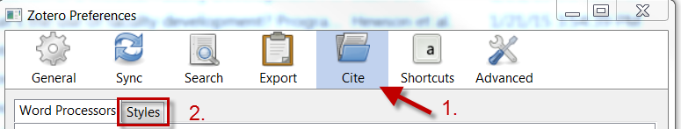
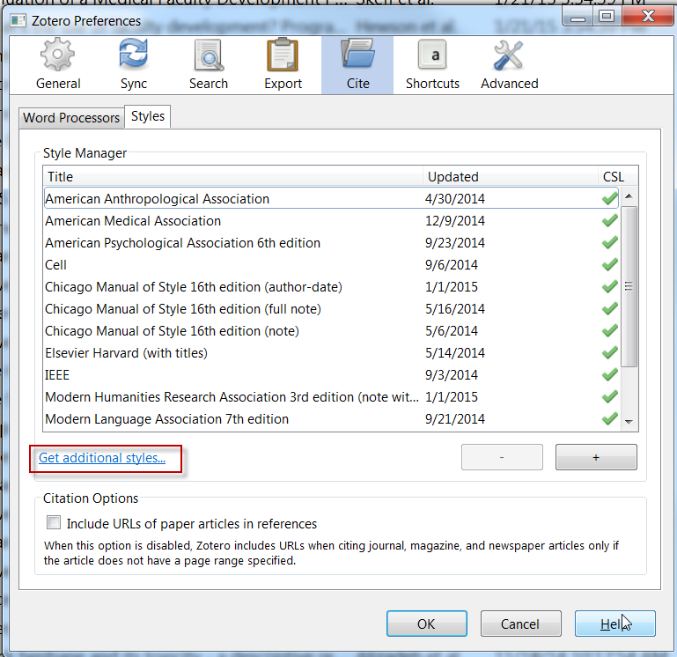
4. Click Get additional styles… (see image bottom of previous page). You will be taken to a website of the Zotero Style Repository (https://www.zotero.org/styles/).
5. Search for and find American Medical Association, click on it, and you will down load a small .csl file. Double click on the downloaded file. You may be prompted to import it into Zotero. Same steps for any other citation types you need.

Use Zotero
To create a bibliography.
Go to Zotero Desktop, find and select the citations you want to include in your bibliography, then right click on those and choose Create Bibliography from Items from the resulting menu. You will be prompted to choose a style and an output and voila!

For the power-user who wants to create a custom style:
Look here: https://www.zotero.org/support/dev/citation_styles
OR to see the editor itself go here: http://editor.citationstyles.org/about/
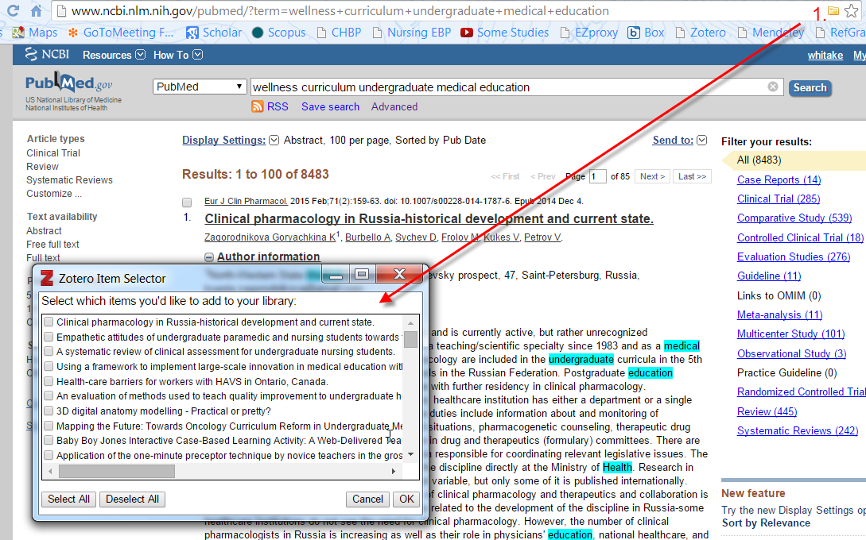
This image shows PubMed import into Zotero. Click the folder icon (1.). Check off the items you want to add to your library
Click OK. You will see a box in right lower screen showing what Z is doing.

What do I do with my PDFs? If you have PDFs that you wish to add to Zotero, just drag the file name (not the PDF itself) to your library. Zotero will import the PDF. Then you right click on the PDF (see image top of next page). Select Retrieve Metadata for PDF to add in the information used for a citation in Word.

In the example from the image the article is identified and renamed based on a GoogleScholar search as “Mini Review of Fructose Metabolism”. Within the folder “Mini Review of Fructose Metabolism” you find a PDF with an unintelligible name. The second image on the next page shows the menu from a right click (or a “two finger” click on a Mac). Choose Rename File from Parent Metadata and Zotero renames the PDF as: Akram and Hamid – 2013 – Mini Review of Fructose Metabolism.pdf

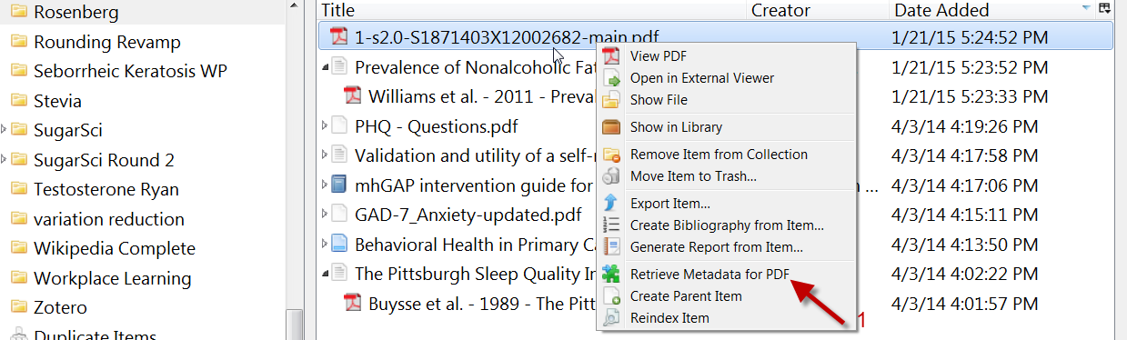

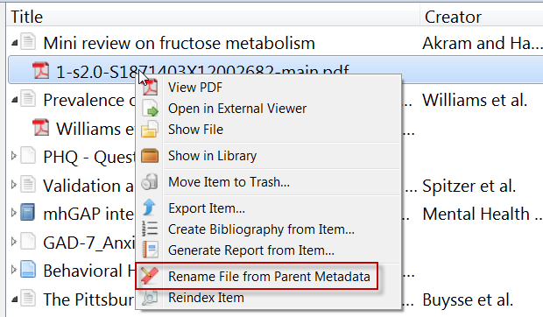

Adding in-text citations and a reference list in Word (also works in OpenOffice or LibreOffice)
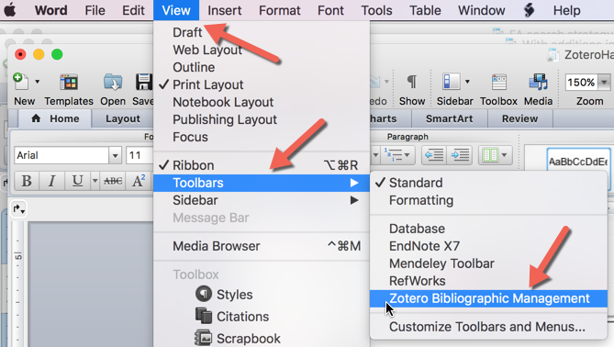
Set up Zotero in Word
This varies a bit by version of Word, and by Mac vs. Windows.
For Word for Mac 2011 you will see a toolbar. If you do not see a toolbar or it disappears, look at screen shot to right. Click on Zotero Bibliographic Management to check or uncheck it. If there is no Zotero Bibliogrpahic Management option, you will need to reinstall the Word add-in for Zotero (You can do this in Zotero preferences under Cite, see page 2). For Word for Mac 2008 you will find Zotero under the scroll icon. Green arrow on figure previous page.
The tool bar or Add-Ins item looks the same everywhere. See image to below. 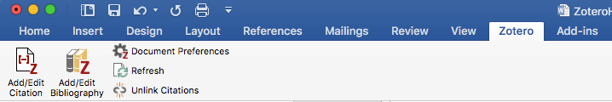
For Word for Mac 2016 you will find a Zotero tab.
For Word on a Windows machine you will find Zotero tab. Appearance and functionality is the same in Windows. If there is no Zotero tab, I suggest you close Word and Zotero. Reopen Zotero. Go to Preferences (in Tools on a Windows machine) and then Cite, Reinstall the Word Add-In. Restart Word and see if the Add-Ins tab now shows itself.

Use of Zotero in Word:
As you are writing your paper in Word and get to a point where you wish to insert a reference, leave you cursor where you want to add, click on Insert Citation on the Zotero toolbar or Add-in. A miniature version of Zotero opens. You find the article you want to cite and click OK and it will add the in-text citation. If you want to cite more than one article in a single location see screen shot below. You can Insert Bibliography at any point in time and it will update as you edit.
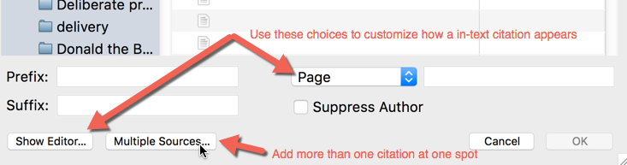

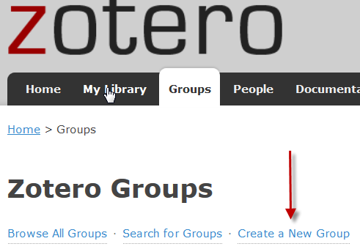
Create groups (for sharing)
Creating groups and group libraries in Zotero. If you are collaborating on a project this is a very useful feature.
There are several steps. Screen shots are from a Windows machine so it will look a bit different on a Mac.

1. From Zotero on the web. One of you will Create a New Group and invite the others. Steps 2-6 only apply to the group creater.
2. Name the group, and set private membership. (This is up to you, of course). Then Create Group
3. On the next page, make sure Private is still set, then set all 3 preferences to Any Group Member. Click Save Settings.
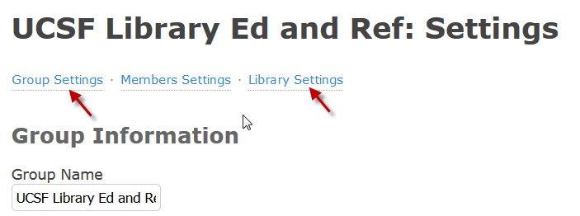
4. Move to near the top of the page and click Member Settings. Click Send More Invitations and add the email addresses of group members. Use the email each member specified when they created a Zotero account. Each invited member will receive an email they should acknowledge to join the group.
a
5. You have already set Library Settings and you can add more information under Group Settings if you wish.
6. Now comes the somewhere between non-intuitive and magical part of adding content to your group library …From the desktop (not web) version of Zotero, the person creating the group drags the desired articles or folders of articles into your shiny new group library. Find Group Libraries near the bottom right hand column of the desktop installation of Zotero. Once you have synced with the web Zotero, your other group members should be able to find your group library in in the Group Libraries in Zotero on their computers. Each member should be able to add notes, highlight, annotate PDFs, add new articles, write comments, etc.
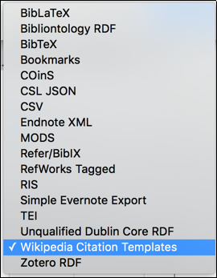
Additional Notes:
- RIS files import easily from one reference manager to another or from a database to Z.
- Z has multiple export styles. See image.
- Z can extract references from Rich Text Format (RTF) files.
- Adding references to Zotero from Embase: Select articles you want to add to Zotero (or add the whole list). Export as RIS file. Import the file into Zotero. See image next page: Green arrows either choose the whole list of results to export (98 in this case), or check off boxes. Blue rectangle exports, default export file type is RIS. In Zotero find Import in the File menu and choose the file you want. Finally, notice the red rectangles. These are all the way you can limit your search results to what you want.

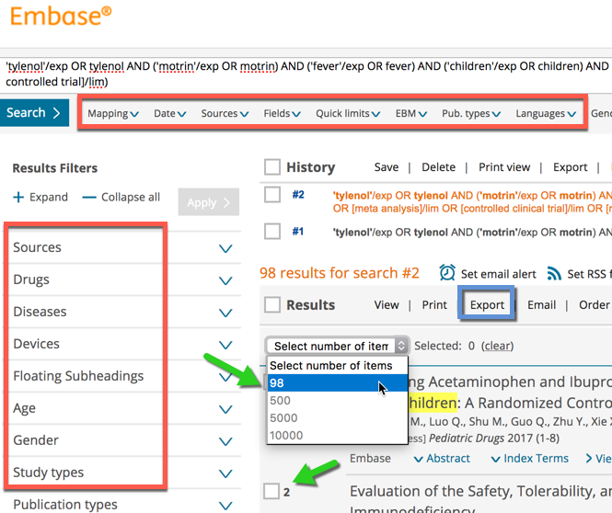

Fine points:
As Z is open source with an active user community which contributes code, there are many plug-ins with which you can add selected capabilities to Z.
Investigate these here: https://www.zotero.org/support/plugins

You can take Zotero onto your mobile device:
Ironically this is where you might spend money. On iPhone or iPad: I liked PaperShip for this: http://www.papershipapp.com/ but it appears that it is no longer supported? You will also notice a link to a desktop version of PaperShip on this webpage. Poorly reviewed, for now I’d suggest that you save your $9.99 and not buy either.
On Android: A work in progress. Zandy was the best but has stopped development. Zotable is new and needs work. There are other options, see here: https://www.zotero.org/support/mobile

Two heads are better than one? You can configure Mendeley to work with Zotero. If you install both, then change settings in Mendeley to sync with Zotero. Potentially this solution would give you the best of both the M and Z worlds. Z is good for adding material, some believe the cite function in M is better. M also has article suggestion features and some metrics to use. My personal experience of this solution was not good. However, that was likely due to very large libraries (~25,000 articles). Slow and problematic performance. At smaller library sizes, I had no problems (1 to 5 K). As of June, 2018 the relationship between M and Z is unclear. See here for more: https://www.zotero.org/support/kb/mendeley_import

