Assignment 7_2021 Due date: Thursday, November 18 10:30 a.m.

- Read the attached article on heterogeneity

  - Comment on why the regression analyses are the same in all four datasets.
  - How would you change the data to create an appropriate linear regression?
  - The data are given in the excel file. Create the appropriate models for the four sets of data. Did you change all datasets?

- Factoid: Crickets make their chirping sounds by rapidly sliding one wing over the other. The faster they move their wings, the higher the chirping sound that is produced. Scientists have noticed that crickets move their wings faster in warm temperatures than in cold temperatures. Therefore, by listening to the pitch of the chirp of crickets, it is possible to tell the temperature of the air. The table below givers the recorded pitch (in vibrations per second) of a cricket chirping recorded at 15 different temperatures.
What if someone asked you what the temperature was, but you couldn't use a thermometer? Could you use the crickets? How would you do this?
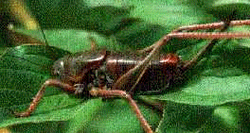

- Using the teens_T1DM.dta data, examine the relationship between the continuous variables. Create a model to predict hba1c by age.

  - How well does this model fit the data? What is the relationship between age and hba1c?
  - Fit the model separately by male/female. What happened to the models?
  - Fit the model separately by mode_delivery. What happened to the models?
  - Using freq_BGM as a continuous variable to predict hba1c, is more frequent measurement of blood glucose predicting higher or lower hba1c?

