Carolyn Rennels
Section leader: Beth Cohen
Opt out of peer review

ASSIGNMENT 1

Question: Is social isolation correlated with advance care planning (ACP) engagement prior to and after an internet-based ACP educational intervention?

The COVID-19 pandemic raised focus on loneliness and isolation (Berg-Weger & Morley, 2020)(Hwang et al., n.d.; Kotwal et al., 2021) as social interactions became challenging and even dangerous. The pandemic, with its risk of disability and death, also highlighted the necessity of advance care planning, or ACP (Moorman et al., 2020)(Abel et al., 2020). Advance care planning is defined as “a process that supports adults at any age or stage of health in understanding and sharing their personal values, life goals, and preferences regarding future medical care”(Sudore et al., 2017). People experiencing social isolation may be less likely to engage in high-quality ACP (Miyashita et al., 2019)(Boerner et al., 2021). The recent landscape of increased isolation as well as increased illness at a population level raises questions about how isolation effects ACP and what clinicians can do to support ACP in socially isolated populations. Using data from the PREPARE intervention, an educational website aiming to increase engagement in ACP (Sudore et al., 2018), we examine 1) baseline rates of ACP planning in a population reporting different levels of social isolation and 2) rates of ACP planning pre-and post-intervention correlated with social connectedness as compared to a control group. These results may inform future ACP interventions targeting relatively isolated populations – important in COVID and beyond.

ASSIGNMENT 2
The study design is previously described in the literature.(Sudore et al., 2016)(Sudore et al., 2018) In brief, this is a single-blind, parallel-group, comparative efficacy randomized clinical trial whose study participants are “English-speaking and Spanish-speaking adults from an urban public hospital who are ≥55 years old, have ≥2 chronic medical conditions and have seen a primary care physician ≥2 times in the last year. Participants are randomized to the PREPARE intervention (review PREPARE and an easy-to-read advance directive) or the control arm (only the easy-to-read advance directive).”

Participants self-reported measures of interest using validated surveys. Survey data was collected between February 1, 2014 and November 30, 2017; these self-reported outcomes were collected for most variables at baseline, 1 week, 3 months, 6 months, and 12 months.(Sudore et al., 2018). Participants did not know whether they were in the active or control group, and research staff were also blinded to outcome assessments as described in the literature.

An alternative study design could include a qualitative component about patient experiences with the PREPARE intervention; however, for feasibility and because the study has concluded, we did not pursue this route.

The target population is a diverse group of older adults who would benefit from comprehensive advance care planning. The accessible population is previously described in the literature and as above. The goal of sampling was to obtain a representative and diverse sample of English-speaking and Spanish-speaking older adults. Recruitment was performed in 4 separate primary care clinics within the San Francisco Health Network (SFHN) in San Francisco, California. Inclusion and exclusion criteria are previously described and intended to capture a diverse population in which the intervention was feasible and ethical; exclusion criteria included poor literacy in either English or Spanish, poor vision, lack of a phone, or prolonged time out of the country, as well as moderate-to-severe cognitive impairment. Primary care clinicians approved their patients’ participation in the study after which point participants were randomized after being sent a recruitment letter. The initial survey was performed in-person, and subsequent follow-up interviews were conducted either by phone or in-person.

The total survivor retention rate (17 decedents not included) was 85.9%; the control group retention rate was 88,7% while the intervention group retention rate was 82.8%. (Sudore et al., 2018)

Limitations to sampling technique include the fact that participants were part of one healthcare system in one city; however, this is a diverse population. Participants were also excluded if they did not have access to a phone, which limits generalizability to a less-connected population. We cannot establish generalizability to non-English and Spanish speaking populations. The intervention required engagement with phone reminders and phone and in-person interviews, which may not be feasible on a wider scale given staff and time limitations.

Assignment 3
The predictor variable is ACP planning both at baseline and at the end of the intervention. The outcome variable is social connectedness as evaluated by the MOS social support scale administered only at baseline(Gjesfjeld et al., n.d.). (Moser et al., 2012)(Monica & California 90401-3208, n.d.)The outcome variable is engagement with Advanced Care Planning at baseline and at 12 months as evidenced by ACP documentation in the medical record; definition as described in the literature is “ the easy-to-read advance directive or other valid advance directives or living wills, a durable power of attorney for healthcare document (DPOAHC), a physicians orders for life sustaining treatment (POLST) form, or other documentation of patients wishes for medical care (ie, documentation of oral directives by a physician, or code status, such as ‘full code’ or ‘do not resuscitate’ or ‘do not intubate’ orders or notes by a physician). “ (Sudore et al., 2016) Random errors were reduced with a large sample size and a diverse population. Systematic errors were reduced by using consistent and validated instruments to collect data.

Research Question: Are rates of ACP planning documented in the medical record associated with social connectedness in a population of older adults with serious illness, and are rates of ACP documentation after an advance care planning program correlated with level of social connectedness?
Null hypothesis: Self-reported level of social connectedness is not associated with baseline rates of advanced care planning as documented in the medical record. ACP engagement after a web-based intervention is similarly not correlated to social connectedness.
Alternative Hypothesis: Self-reported social isolation is associated with rates of advanced care planning as documented in the medical record at the end of an intervention to increase ACP.
Example results: “Of 1797 eligible patients, 986 (54.9%) enrolled, 480 were randomized to PREPARE and 505 to the AD-only group. Level of social isolation was significantly associated with lower baseline ACP documentation. New overall documentation of ACP at 15 months was higher in the PREPARE arm versus the AD-only arm among people who self-reported high social isolation.”(Sudore et al., 2018)
Example conclusion: “In a diverse cohort of English-speaking and Spanish-speaking older adults… those with lower social connectedness reported lower baseline levels of ACP documentation. Interactive online PREPARE program significantly increased documentation of ACP regardless of self-reported social connectedness levels”. These results are important because socially isolated adults may be less likely to engage in ACP documentation and this study offers a potential intervention to increase ACP documentation in a vulnerable group”
I would treat the MOS-SS scale as a continuous variable with reported outcome = the mean total social support, which is how this variable is handled most frequently in the literature(Monica & California 90401-3208, n.d.)(Moser et al., 2012)(Krause & Markides, 1990) and how it was treated in published papers from this RCT. Then I would perform 1) regression analysis at time point 0, predictor variable = ACP documentation vs no ACP documentation (dichotomous) and outcome variable = social connectedness (continuous based on MOS-SS) and 2) regression analysis at time point 15 months with same predictor variables. This is a simplification given we did not cover calculations for regression models. The question is going to be a test of the interaction between PREPARE group assignments and SI scores on ACP completion.
In this case we would use a t test, calculator below:
Alpha (two tailed) = .05
B = .2
S = 1 (standard deviation unknown)
N1 = 424
N0 = 562
Based on results of paper with sample size = 986 and 43% completion of ACP at the end
Study has 80% power to detect an effect size of .180 SD

Assignment 4
The study design is as described above; participants did not know whether they were in the active or control group, and research staff were blinded to outcome assessments. Demographic variables are as included in the table below. The MOS-SS survey was administered at baseline to both intervention and control groups; as seen below, there were no significant differences in mean total social support between groups.(Sudore et al., 2018).

Participants did not know whether they were in the active or control group, and research staff were also blinded to outcome assessments as described in the literature.

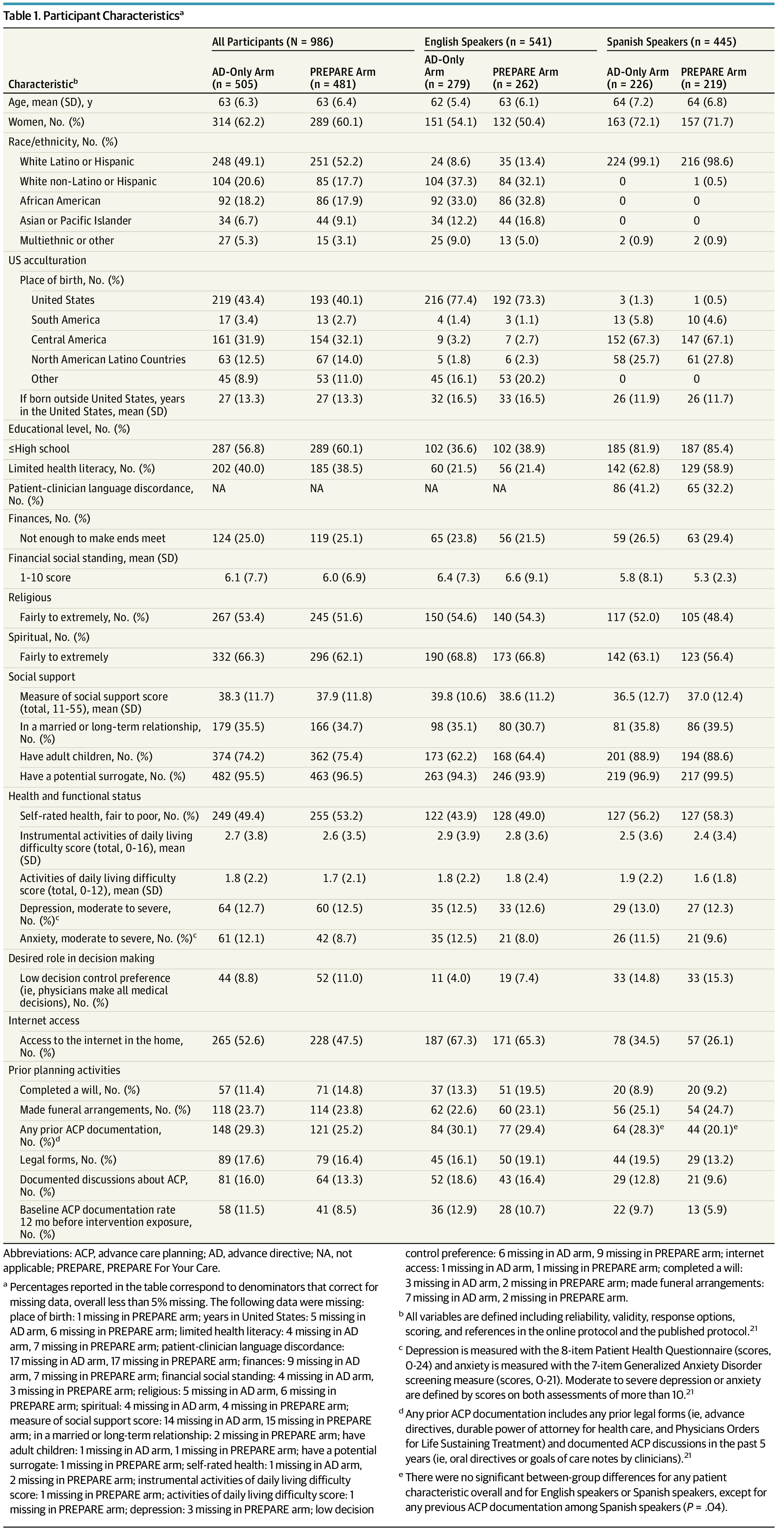

The MOS-SS scale is the focus of this research question; the scale attempts to quantify social support in various domains: emotional/informational support, tangible support, affectionate support, and positive social interaction. The study used the modified 11-item Medical Outcomes Study Social Support Survey (MOS-SSS) to address social support. Versions of his survey have been validated in Spanish and in English.(Costa Requena et al., 2007)(Moser et al., 2012), and so I expect a normal distribution. Advantages of this survey include that it covers a broad range of questions for a somewhat amorphous idea (social support) and it has been validated in different populations and different languages. Disadvantages include that while language for the most part is understandable, some questions may be difficult to understand eg “Someone to help you if you were confined to bed.” If participants do not fully understand this language, there may be inaccurate or biased data.
Ethics:
Consent was obtained from participants. Overall this is a low risk intervention.
Appendix
RAND social support(Monica & California 90401-3208, n.d.)

Modified survey (Moser et al., 2012)
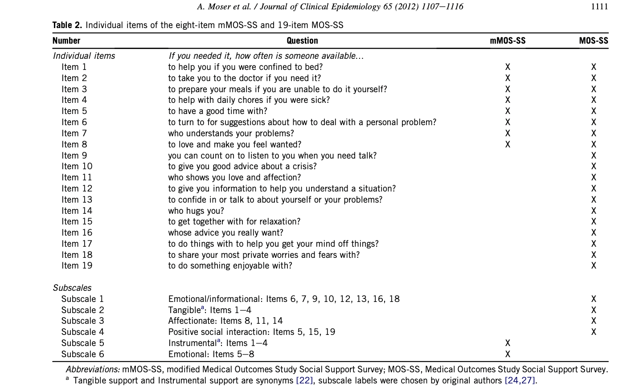

References
Abel, J., Kellehear, A., Millington Sanders, C., Taubert, M., & Kingston, H. (2020). Advance care planning re-imagined: A needed shift for COVID times and beyond. Palliative Care and Social Practice, 14, 2632352420934491. https://doi.org/10.1177/2632352420934491
Berg-Weger, M., & Morley, J. E. (2020). Loneliness and Social Isolation in Older Adults during the COVID-19 Pandemic: Implications for Gerontological Social Work. The Journal of Nutrition, Health & Aging, 24(5), 456–458. https://doi.org/10.1007/s12603-020-1366-8
Boerner, K., Moorman, S. M., Carr, D., & Ornstein, K. A. (2021). Insufficient Advance Care Planning? Correlates of Planning Without Personal Conversations. The Journals of Gerontology: Series B, 76(1), 104–108. https://doi.org/10.1093/geronb/gbaa076
Costa Requena, G., Salamero, M., & Gil, F. (2007). [Validity of the questionnaire MOS-SSS of social support in neoplastic patients]. Medicina Clinica, 128(18), 687–691. https://doi.org/10.1157/13102357
Gjesfjeld, C. D., Greeno, C. G., & Kim, K. H. (n.d.). A Confirmatory Factor Analysis of an Abbreviated Social Support Instrument: The MOS-SSS.
Hwang, T.-J., Rabheru, K., Peisah, C., Reichman, W., & Ikeda, M. (n.d.). Loneliness and social isolation during the COVID-19 pandemic. International Psychogeriatrics, 1–4. https://doi.org/10.1017/S1041610220000988
Kotwal, A. A., Holt-Lunstad, J., Newmark, R. L., Cenzer, I., Smith, A. K., Covinsky, K. E., Escueta, D. P., Lee, J. M., & Perissinotto, C. M. (2021). Social Isolation and Loneliness Among San Francisco Bay Area Older Adults During the COVID-19 Shelter-in-Place Orders. Journal of the American Geriatrics Society, 69(1), 20–29. https://doi.org/10.1111/jgs.16865
Krause, N., & Markides, K. (1990). Measuring social support among older adults. International Journal of Aging & Human Development, 30(1), 37–53. https://doi.org/10.2190/CY26-XCKW-WY1V-VGK3
Miyashita, J., Yamamoto, Y., Shimizu, S., Aoki, T., Azuma, T., Takada, T., Hayashi, M., Kimachi, M., Ikenoue, T., Fukuma, S., & Fukuhara, S. (2019). Association between social networks and discussions regarding advance care planning among Japanese older adults. PloS One. https://doi.org/10.1371/journal.pone.0213894
Monica, 1776 Main Street Santa, & California 90401-3208. (n.d.). Social Support Survey Instrument Scoring Instructions. Retrieved August 18, 2021, from https://www.rand.org/health-care/surveys_tools/mos/social-support/scoring.html
Moorman, S., Boerner, K., & Carr, D. (2020). Rethinking the Role of Advance Care Planning in the Context of Infectious Disease. Journal of Aging & Social Policy, 1–7. https://doi.org/10.1080/08959420.2020.1824540
Moser, A., Stuck, A. E., Silliman, R. A., Ganz, P. A., & Clough-Gorr, K. M. (2012). The eight-item modified Medical Outcomes Study Social Support Survey: Psychometric evaluation showed excellent performance. Journal of Clinical Epidemiology, 65(10), 1107–1116. https://doi.org/10.1016/j.jclinepi.2012.04.007
Sudore, R. L., Barnes, D. E., Le, G. M., Ramos, R., Osua, S. J., Richardson, S. A., Boscardin, J., & Schillinger, D. (2016). Improving advance care planning for English-speaking and Spanish-speaking older adults: Study protocol for the PREPARE randomised controlled trial. BMJ Open, 6(7), e011705. https://doi.org/10.1136/bmjopen-2016-011705
Sudore, R. L., Lum, H. D., You, J. J., Hanson, L. C., Meier, D. E., Pantilat, S. Z., Matlock, D. D., Rietjens, J. A. C., Korfage, I. J., Ritchie, C. S., Kutner, J. S., Teno, J. M., Thomas, J., McMahan, R. D., & Heyland, D. K. (2017). Defining Advance Care Planning for Adults: A Consensus Definition From a Multidisciplinary Delphi Panel. Journal of Pain and Symptom Management, 53(5), 821-832.e1. https://doi.org/10.1016/j.jpainsymman.2016.12.331
Sudore, R. L., Schillinger, D., Katen, M. T., Shi, Y., Boscardin, W. J., Osua, S., & Barnes, D. E. (2018). Engaging Diverse English- and Spanish-Speaking Older Adults in Advance Care Planning: The PREPARE Randomized Clinical Trial. JAMA Internal Medicine, 178(12), 1616. https://doi.org/10.1001/jamainternmed.2018.4657

