Mark Jeng
Section Leader: Meghana Gadgil
Participate in Protocol Critique? No

Validation of pre-screening tools G-8 and VES-13 in younger patients undergoing pre-cellular therapy evaluation

Investigators: Mark Jeng, MD-PhD, Rebecca Olin, MD

ABSTRACT
The Comprehensive Geriatrics assessment (CGA) is increasingly being used to assess vulnerability and frailty in patients undergoing cellular therapies such as hematopoietic cell transplant (HCT). While it is recommended that all cancer patients >70 years old undergo this screening, there is increasing evidence that younger patients may benefit as well. CGA screening is a time-intensive process, and the shorter pre-screening tools used to identify which patients may benefit from a CGA have yet to be validated in younger patients. Here, we propose the application of pre-screening tools—the G-8 survey and the Vulnerable Elder Survey (VES-13)—in adults (40+) being considered for cellular therapy. Sufficient sensitivity of the pre-screening tools would support their use in a broader number of cancer patients undergoing treatment evaluation.

RESEARCH QUESTION
Do pre-screening tools (G-8, VES-13) predict abnormal CGA scores in adults aged 40-59 undergoing pre-cellular therapy evaluation?

SPECIFIC AIMS
- Assess the sensitivity, specificity, and ROC AUC of both pre-screening tools (G-8 and VES-13) in detecting an abnormal CGA score
- Assess the feasibility of administering the pre-screening tools and CGA completely remotely via online survey and video chat.

SIGNIFICANCE
While cellular therapies such as hematopoietic cell transplant (HCT) and CAR-T cells treatments are becoming increasingly utilized as potential curative treatment for many hematologic malignancies, they also associated with significant toxicities and morbidities¹. To better inform providers and patients about the individualized risks and benefits of this treatment, various tools are increasingly being utilized to select patients who may have improved disease outcomes and decreased treatment-related complications after cellular therapy treatment. The Comprehensive Geriatrics assessment (CGA) remains one of the best studied and widely adopted tools in this evaluation process, incorporating multiple health domains including physical function, mental health, cognition, nutrition, polypharmacy, comorbidities, and social support². The age-inclusion criteria for studies using CGA varies widely, with some research including patients as young as 50 years old. Interestingly, specific prognostic components of the CGA such as cognitive impairment are often found at similar rates in the “younger” <60 year-old cohort vs >60 year-old cohort³. Additionally, multivariate analyses comparing younger and older cohorts demonstrate that above a certain cut-off, age does not serve as a significant independent predictor of post-HCT outcomes^{4,5}; altogether supporting the use of CGA in more potential HCT candidates, regardless of age. However, CGA screening is a time-intensive process⁶, and the shorter pre-screening tools^{7–9} often utilized to identify which patients may benefit from a CGA have yet to be validated in a younger demographic. Here, we propose the application of pre-screening tools—the Vulnerable Elder Survey (VES-13) and G-8 survey—in adults (40+) being considered for cellular therapy. We will evaluate the ability of these pre-screening tools to identify patients yielding an abnormal score on the CGA. An adequate sensitivity of these tools would support their wide-adopted use as a rapid and feasible first step within the pre-cellular therapy evaluation process for younger patients, which will in-turn broaden the utilization and efficiency of pre-screening/screening tools within the transplant evaluation process for a greater number of patients.

METHODS
Overview
In this study, we plan to utilize a cross-sectional design to evaluate the utility of VES-13 and G-8 questionnaires as adequate pre-screening tools in detecting abnormal CGA scores in patients undergoing pre-cellular therapy evaluation. All patients meeting the inclusion criteria will undergo remote screening (digital survey, video visit) to collect all VES-13/G-8/CGA information. The sensitivity, specificity, and ROC values of both VES-13 and G-8 in detecting an abnormal CGA within this younger population (40-59 years old) will be compared to older patients (60+ years old). To increase feasibility and decrease overall cost, we will consider only performing the evaluation on younger population (40-59 years old) and compare results to previously published test characteristics in older patients undergoing pre-cellular therapy evaluation⁸. The time-frame (including recruitment and administration of the assessments) will occur over 1-year.

Subjects and Variables
- The target population of this study includes patients aged 40+ undergoing evaluation for cellular therapy, including allogeneic HCT, autologous HCT, and CAR-T cell therapy.
- The accessible population includes this same population of patients, recruited from the BMT and CAR-T clinic from October 2021 to October 2022.

Inclusion Criteria
- Age ≥ 40 years old
- Undergoing allogeneic stem cell transplantation evaluation at UCSF
- Able to give written informed consent and willingness to comply with the requirements of the protocol
- Ability to access and utilize digital evaluation tools, including internet and video calls

A cut-off age of 40 years or greater was selected given the increased prevalence of pre-fraility/fraility markers, as well as a stronger association between fraility and mortality, after this age threshold^{10,11}. Subjects will be identified for potential enrollment primarily by physicians and bone marrow transplant coordinators. The recruitment of patients will be conducted consecutively within the aforementioned timeframe, and patients will be considered enrolled once the informed consent has been signed. Factors that will impact the generalizability of this study include the single-institution recruitment of patients, and the pre-requisite of technology tools to participate within the study.

Measurements
Predictor Variables: G-8 and VES-13
To help identify which patients may benefit from receiving the full time-intensive CGA, a number of pre-screening tools have been tested and validated. For oncology patients, recent systematic reviews have consistently shown that the G-8 and the Vulnerable Elder Survey (VES-13) have the most evidence to support their clinical use, both of which can be administered in under 5 minutes^{9,12}.
The G8 screening tool [Protocol Appendix 1] was specifically developed for use in older persons with cancer, and includes items on age, self-rated health, nutrition, mobility, and medication use, and is scored from 0 (worst) to 17 (best), with 14 or less being a cutoff for an abnormal score¹³. The G8 screening tool score was constructed from individual items from the GA and from clinical data. While the G-8 has a higher sensitivity for identifying an abnormal CGA score (largely between 80-90%), it has mostly been validated as a provider-administered tool^{9,12}.
In comparison, the Vulnerable Elder survey (VES-13) [Protocol Appendix 2] is a 13-item survey including age, self-rated health, and functional status. It is scored from 0 to 10 (with 10 being the worst), and a cutoff of 3 or higher is considered abnormal; each additional point on the VES-13 is associated with an incrementally higher risk of functional decline and mortality in community dwelling elders¹⁴. While the VES-13 has a higher specificity (between 70-100%) and is a completely patient-reported tool, its lower sensitivity (between 20-72%) limits its use as a sole pre-screening tool^{9,12}.
Both VES-13 and G-8 information will be obtained through a combination of self-reported surveys (administered through UCSF Red-cap), EMR data, and a separate video visit with a trained provider. Given the higher sensitivity observed with the G-8 tool, we will prioritize the study design and sample size calculations around this pre-screening tool. Of note, the combination of these tools together has not been shown to significantly increase the overall diagnostic properties¹⁵. While there are recent attempts to adapt the CGA into languages such as Spanish, more validation studies are required before these tools can be widely adopted for non-English speakers¹⁶.

Outcome variable: CGA
The Comprehensive Geriatric Assessment (CGA) is a widely adopted tool that identifies areas of frailty and vulnerability in patients—both within the general population as well as a broad range of chronic diseases—by assessing multiple health domains including physical function, mental health, cognition, nutrition, polypharmacy, comorbidities, and social support [Protocol Appendix 3A,B]. In the field of oncology, the CGA has been used to estimate treatment outcomes, guide both patient and provider decision making, and used to follow changes in performance status throughout the treatment course¹⁷. As such, beginning in 2005 the CGA has been recommended for screening in all cancer patients >70 years old by the International Society of Geriatric Oncology².
The primary outcome for this study is an abnormal CGA, based on having 2 or more abnormal domains. Each domain was assessed using validated tools¹⁸. Where possible, we used tools that were either specific for the HCT population or had been used in an HCT population previously. For some CGA domains that had not been assessed in HCT, we chose tools that might reasonably be sensitive and specific measures for deficits, with the understanding that the pre-HCT population may be a very highly select group of fitter patients. For the physical performance and cognition domains, we selected/modified tools that could be easily administered through a survey format or a video call. The CGA will be broken up into two sections: a subject-administered component [Protocol Appendix 3A] and a provider-administered component [Protocol Appendix 3B]. For the subject-administered portion, it will be similarly constructed as a Red-cap survey and administered within the same link bundle as the VES-13 and G8 pre-screening surveys. For the provider-administered component, each patient will make a 20-minute video appointment with a previously trained research staff (either research coordinator, nurse practitioner, MD, or MD student). This appointment will focus on the physical performance and cognition assessment components of the CGA, and include 5 additional minutes for questions and trouble-shooting.

Measurement errors and potential bias/confounders
To limit the intra- and inter-observer variability of the provider assessment, we will plan to standardize the way the questions and assessments are made, as well as a training course for the providers. Providers administering the video assessment will be blinded to the results of the survey to minimize observer bias. Scoring of the patient-reported surveys will be done automatically based on pre-specified metrics, and scoring of the provider-administered component will be done by an independent rater watching the recording. To minimize the possibility of health changes occurring between the self-reported and video assessment, both parts will be completed within a one-week time frame for each patient. Finally, to help facilitate understanding and utilization of the tools, each survey link will also include an explanation of how to complete the survey, commonly asked questions about the survey questions, and a research coordinator phone number that can be called during business hours if additional questions arise. In order to limit the number of patients that may be excluded from this study (given the dependence on technology to participate), we will attempt to set aside a separate room in clinic that has computer/video access (as well as monetary fund to help with transportation) for patients needing assistance.

STATISTICAL ISSUES
Hypothesis
We predict that the G-8 pre-screening tool will achieve an adequate sensitivity (>80%) in detecting an abnormal CGA score in patients 40+ undergoing pre-cellular therapy evaluation.
Analysis plan
To report associations between baseline patient characteristics and abnormal CGA score, we used Chi-square/Fisher’s tests for categorical variables and the t-test for continuous variables. To determine the association between pre-screening tools VES-13 and G8 and an abnormal CGA score, we calculated the sensitivity and specificity for a VES-13 score of 3 or greater and for a G-8 score of 14 or less for an abnormal CGA score. We constructed a receiver operating characteristics (ROC) curve and calculated the area under the curve (AUC) to determine the discriminatory ability of the VES-13 score and the G8 score to predict an abnormal CGA.

Sample size calculation
A prior systemic review evaluating the use of G8 in oncology patients demonstrated a sensitivity ranging between 80-90% within a majority of studies¹². Using 0.8 as the expected proportion of patients with an abnormal CGA score with a positive G8 score (and thus 0.2 as the expected proportion of patients with an abnormal CGA score and a negative G8 score—the false negative proportion), we plan to recruit at least 109 patients with an abnormal CGA score to provide a two-sided 95% confidence interval (CI) of sensitivity estimates with a width equal to 0.15 or closer. Assuming that 30% of our sampled patient population is expected to have an abnormal CGA score and 10% drop out rate, we will plan to recruit 404 patients in total.

ETHICAL CONSIDERATIONS
Overall, this study has very little potential harm to the participants given the nature of the intervention (an online survey and video chat appointment). One potential harm is the participation in the physical evaluation by the provider, which includes a “Timed Up & Go” portion where the patient will be asked to stand up from a seated position, walk across the room and back. To mitigate the harm for patients with a particularly high fall risk, we will consider requiring supervision (either a home caregiver or in-person clinic supervision). Potential ethical concerns for this study include the inclusion criteria, which requires access and capacity to use technology. This inclusion criteria may create a selection bias for patients with a higher socio-economic status, less cognitive impairment, and more home support. To address this, we will consider providing patients the option to come to clinic for computer/video access (as well as money to help with transportation) for patients needing assistance. Other ethical concerns include the availability of the assessment only in English. While there are recent studies beginning to evaluate the use of these tools in other languages such as Spanish, at this time there is insufficient validation of these tools in non-English languages in order for them to be adopted for this study¹⁶. All methods for data collection will be approved by the UCSF IRB prior to initiation of database building.

References
1. Ringdén, O. et al. Outcome of Allogeneic Hematopoietic Stem Cell Transplantation in Patients Age >69 Years with Acute Myelogenous Leukemia: On Behalf of the Acute Leukemia Working Party of the European Society for Blood and Marrow Transplantation. Biol. Blood Marrow Transplant. 25, 1975–1983 (2019).
2. Extermann, M. et al. Use of comprehensive geriatric assessment in older cancer patients: Crit. Rev. Oncol. Hematol. 55, 241–252 (2005).
3. Olin, R. L. et al. Geriatric assessment in older alloHCT recipients: association of functional and cognitive impairment with outcomes. Blood Adv. 4, 2810–2820 (2020).
4. Lim, Z., Brand, R. & Martino, R. Allogeneic Hematopoietic Stem-Cell Transplantation for Patients 50 Years or Older With Myelodysplastic Syndromes or Secondary Acute Myeloid Leukemia. J. Clin. Oncol. 7.
5. McClune, B. L. et al. Effect of Age on Outcome of Reduced-Intensity Hematopoietic Cell Transplantation for Older Patients With Acute Myeloid Leukemia in First Complete Remission or With Myelodysplastic Syndrome. J. Clin. Oncol. 28, 1878–1887 (2010).
6. Hurria, A. et al. Developing a cancer-specific geriatric assessment: A feasibility study. Cancer 104, 1998–2005 (2005).
7. Hamaker, M. E. et al. Frailty screening methods for predicting outcome of a comprehensive geriatric assessment in elderly patients with cancer: a systematic review. Lancet Oncol. 13, e437–e444 (2012).
8. Holmes, H. M. et al. Optimal screening for geriatric assessment in older allogeneic hematopoietic cell transplantation candidates. J. Geriatr. Oncol. 5, 422–430 (2014).
9. van Walree, I. C. et al. A systematic review on the association of the G8 with geriatric assessment, prognosis and course of treatment in older patients with cancer. J. Geriatr. Oncol. 10, 847–858 (2019).
10. Gordon, S. J., Baker, N., Kidd, M., Maeder, A. & Grimmer, K. A. Pre-frailty factors in community-dwelling 40–75 year olds: opportunities for successful ageing. BMC Geriatr. 20, 96 (2020).
11. Oude Voshaar, R. C. et al. Course of frailty stratified by physical and mental multimorbidity patterns: a 5-year follow-up of 92,640 participants of the LifeLines cohort study. BMC Med. 19, 29 (2021).
12. Garcia, M. V., Agar, M. R., Soo, W.-K., To, T. & Phillips, J. L. Screening Tools for Identifying Older Adults With Cancer Who May Benefit From a Geriatric Assessment: A Systematic Review. JAMA Oncol. 7, 616 (2021).
13. Bellera, C. A. et al. Screening older cancer patients: first evaluation of the G-8 geriatric screening tool. Ann. Oncol. 23, 2166–2172 (2012).
14. Min, L. C., Elliott, M. N., Wenger, N. S. & Saliba, D. Higher Vulnerable Elders Survey Scores Predict Death and Functional Decline in Vulnerable Older People: VES-13 SCORES PREDICT DEATH AND FUNCTIONAL DECLINE. J. Am. Geriatr. Soc. 54, 507–511 (2006).
15. Pottel, L. et al. Serial comprehensive geriatric assessment in elderly head and neck cancer patients undergoing curative radiotherapy identifies evolution of multidimensional health problems and is indicative of quality of life: Geriatric assessment in elderly head and neck cancer. Eur. J. Cancer Care (Engl.) 23, 401–412 (2014).
16. Pérez-de-Acha-Chávez, A. et al. Feasibility and reliability of a self-administered geriatric assessment tool for Spanish-speaking Mexican older adults with cancer. J. Geriatr. Oncol. S187940682100134X (2021) doi:10.1016/j.jgo.2021.05.013.
17. Wildiers, H. et al. International Society of Geriatric Oncology Consensus on Geriatric Assessment in Older Patients With Cancer. J. Clin. Oncol. 32, 2595–2603 (2014).
18. Rodin, M. B. & Mohile, S. G. A Practical Approach to Geriatric Assessment in Oncology. J. Clin. Oncol. 25, 1936–1944 (2007).

Protocol Appendix 1
G-8 Pre-screening tool (provider-administered)
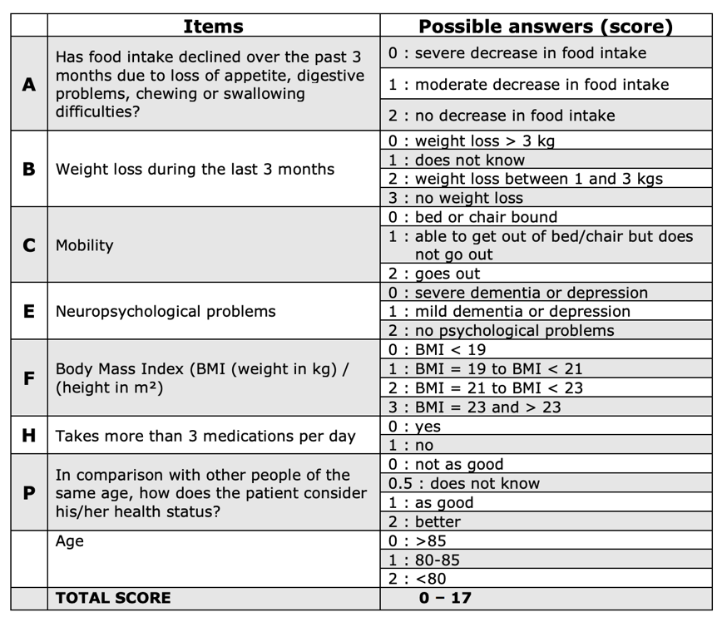

Protocol Appendix 2
VES-13 Pre-screening tool (patient-reported)

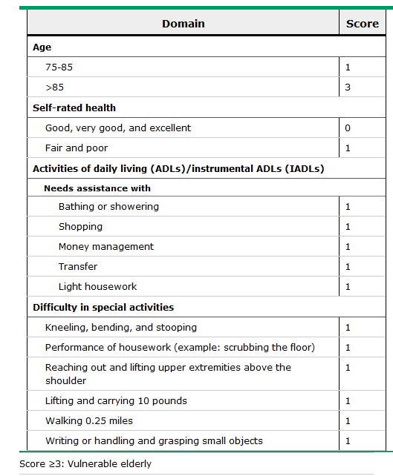
Protocol Appendix 3A

Geriatric Assessment Subject Questionnaire (A-H)
A. Background Information
1. What is the highest grade you finished in school?
 | 1-8 grades |  | Junior college degree
 | 9-11 grades |  | College degree (B.A./B.S.)
 | High school graduate |  | Some post-college work
 | Some college |  | Advanced degree
2. What is your marital status?
 | Single, never married |  | Divorced
 | Married |  | Widowed
 | Separated
3. With whom do you live? (Mark all that apply.)
 | Wife/husband/partner |  | Live alone
 | Children |  | Others
 | Parents/parent(s)-in-law
4. What is your current employment status?
 | Currently working full-time |  | Unemployed
 | Currently working part-time |  | Retired
 | Homemaker |  | Student
 | Disabled |  | Other
5. What was your employment status at the time of diagnosis of cancer?
 | Currently working full-time |  | Unemployed
 | Currently working part-time |  | Retired
 | Homemaker |  | Student
 | Disabled |  | Other

B. Daily Activities
1. Can you use the telephone…
without help, including looking up and dialing;
with some help (can answer phone or dial operator in an emergency, but need a special phone or help in getting the phone number or dialing); or
are you completely unable to use the telephone?
2. Can you get to places out of walking distance…
without help (drive your own car, or travel alone on buses and taxis);
with some help (need someone to help you or go with you when traveling); or
are you unable to travel unless emergency arrangements are made for a specialized vehicle like an ambulance?
3. Can you go shopping for groceries or clothes (assuming you have transportation)…
without help (taking care of all shopping needs yourself)
with some help (need someone to go with you on all shopping trips); or
are you completely unable to do any shopping?
4. Can you prepare your own meals…
without help (plan and cook full meals yourself);
with some help (can prepare some things but unable to cook full meals yourself); or
are you completely unable to prepare any meals?
5. Can you do your housework…
without help (can clean floors, etc.);
with some help (can do light housework but need help with heavy work); or
are you completely unable to do any housework?
6. Can you take your own medicines…
without help (in the right doses at the right time);
with some help (able to take medicine if someone prepares it for you and/or reminds you to take it); or
are you completely unable to take your medicines?
7. Can you handle your own money…
without help (write checks, pay bills, etc.);
with some help (manage day-to-day buying but need help with managing your checkbook and paying your bills); or
are you completely unable to handle money?

C. Physical Activities
Activities |  | Limited a lot | Limited a little | Not limited at all
a. | Vigorous activities, such as: running, lifting heavy objects, participating in strenuous activities
b. | Moderate activities, such as: moving a table, pushing a vacuum cleaner, bowling, or playing golf
c. | Lifting or carrying groceries
d. | Climbing several flights of stairs
e. | Climbing one flight of stairs
f. | Bending, kneeling, or stooping
g. | Walking more than a mile
h. | Walking several blocks
i. | Walking one block
j. | Bathing or dressing yourself
The following items are activities you might do during a typical day. Does your health limit you in these activities?

D. Current Health Rating

INSTRUCTIONS: Which one of the following statements best describes you at this time?
Normal, no complaints, no symptoms of disease
Able to carry on normal activity, minor symptoms of disease
Normal activity with effort, some symptoms of disease
Care for self, unable to carry on normal activity or do active work
Require occasional assistance but able to care for most of personal needs
Require considerable assistance for personal care
Disabled, require special care and assistance
Severely disabled, require continuous nursing care

E. Falls
How many times have you fallen in the last 6 months?

F. Your Health
1. Do you have any of the following illnesses at the present time? If so, how much does it interfere with your activities?

Illness |  | No | Yes |  | Not  at All | Somewhat | A Great Deal
a. | Other cancer
b. | Arthritis, rheumatism, or other connective tissue disorders
c. | Glaucoma
d. | Emphysema or chronic bronchitis
e. | High blood pressure
f. | Heart disease
g. | Circulation trouble in arms or legs
h. | Diabetes
i. | Stomach or intestinal disorders
j. | Osteoporosis
k. | Chronic kidney or liver disease
l. | Stroke
m. | Depression

2. How is your eyesight (with glasses or contacts)?
 | Excellent |  | Good |  | Fair |  | Poor |  | Totally blind
If fair, poor, or totally blind, how much does this interfere with your activities?
 | Not at all |  | Somewhat |  | A great deal

3. How is your hearing (with a hearing aid, if needed)?
 | Excellent |  | Good |  | Fair |  | Poor |  | Totally deaf
If fair, poor, or totally deaf, how much does this interfere with your activities?
 | Not at all |  | Somewhat |  | A great deal
4. Do you have any other physical problems or illnesses (other than those listed in questions 1-3) at the present time that seriously affect your health?
No
Yes, specify:
If Yes, how much does this interfere with your activities?
 | Not at all |  | Somewhat |  | A great deal

5. Please list all prescribed medications or over-the-counter herbs or vitamins that you are currently taking.

G. Your Mood
INSTRUCTIONS: These questions are designed to help your doctor know how you feel. Read each item and mark the box that indicates the reply which comes closest to how you have been feeling in the past month.
During the past month, how much of the time…

 |  | None of the Time | A Little of the Time | Some of the Time | A Good Bit of the Time | Most of the Time | All of the Time
1. | have you been a very nervous person?
2. | have you felt calm and peaceful?
3. | have you felt downhearted and blue?
4. | have you been a happy person?
5. | have you felt so down in the dumps that nothing could cheer you up?

H. Social Support
INSTRUCTIONS: People sometimes look to others for companionship, assistance or other types of support. How often is each of the following kinds of support available to you now if you need it?

 |  | None of the Time | A Little of the Time | Some of the Time | Most of the Time | All of the Time
1. | Someone to help if you were confined to bed.
2. | Someone you can count on to listen to you when you need to talk.
3. | Someone to give you good advice about a crisis.
4. | Someone to take you to the doctor if you needed it.
5. | Someone to give you information to help you understand a situation.
6. | Someone to prepare your meals if you were unable to do it.
7. | Someone whose advice you really want.
8. | Someone to help you with daily chores if you were sick.
9. | Someone to share your most private worries and fears with.
10. | Someone to turn to for suggestions about how to deal with a personal problem.
11. | Someone to confide in or talk to about yourself or your problem.
12. | Someone who understands your problems.

Protocol Appendix 3B

Geriatric Assessment Provider Questionnaire (A-D)
A. Functional Status
1. Please rate your assessment of subject’s Karnofsky Performance Status as of date this form completed. (Scale is listed below.)
Karnofsky Performance Status

% | CRITERIA
100 | Able to carry on normal activity and able to work. No special care is needed.
90 | Able to carry on normal activity; minor signs or symptoms of disease.
80 | Normal activity with effort; some signs or symptoms or disease.
70 | Cares for self. Unable to carry on normal activity or to do active work.
60 | Requires occasional assistance, but is able to care for most of his/her needs.
50 | Requires considerable assistance and frequent medical care.
40 | Disabled; requires special care and assistance.
30 | Severely disabled, hospitalization is indicated although death not imminent.
20 | Very sick, hospitalization necessary; active supportive treatment necessary.
10 | Moribund; fatal processes progressing rapidly.
0 | Dead

B. Nutrition (From subject’s chart or subject’s self-report)
What is the subject’s height?
What is the subject’s current weight?
What was the subject’s weight approximately 6 months ago?

C. Timed Up and Go
INSTRUCTIONS: The Timed Up and Go measures, in seconds, the time it takes for an individual to stand up from a standard chair (approximate seat height of 46 cm or 1.5 feet), walk a distance of 3 meters (approximately 10 feet), turn, walk back to the chair, and sit down again. The subject wears his/her regular footwear and uses their customary walking aid (none, cane, walker, etc.) No physical assistance is given. The subject starts with his back against the chair, his arm resting on the chair’s arm, and his walking aid in his hand. He is instructed that on the word “go”, he is to get up and walk at a comfortable and safe pace to a line on the floor 3 meters (approximately 10 feet) away, turn, return to the chair, and sit down again. The subject walks through the test once before being timed in order to become familiar with the test. Either a wrist watch with a second hand or a stop-watch can be used to time the performance.
Time to perform Timed Up and Go (seconds)

D. Cognition: *** requires real-time scoring ***
SCORING INSTRUCTIONS:
Questions 1, 2, 3: 0 points if response is correct, 1 point if response is incorrect.
Questions 4, 5, 6: one point for each error. For questions 4 and 5 the maximum score is 2; for question 6 the maximum score is 5.

Blessed Orientation-Memory-Concentration (BOMC) Test
Question |  | Subject’s Response | Max. Errors | Score | Weight | Final Score
1. | What year is it now? (without looking at a calendar) | _______ | 1 |  0=correct   1=incorrect | x 4
2. | What month is it now?  (without looking at a calendar) | _______ | 1 |  0=correct   1=incorrect | x 3
Memory Phrase:
Repeat this phrase after me: “John Brown, 42 Market Street, Chicago”

3. | About what time is it? (within 1 hour – without looking at a watch) | ____:____ | 1 |  0=correct   1=incorrect | x 3
4. | Count backwards 20 to 1. | one point for each error | 2 | _______ | x 2
5. | Say the months in reverse order. | one point for each error | 2 | _______ | x 2
6. | Repeat the Memory Phrase. | one point for each error | 5 | _______ | x 2
 |  |  |  | Total Score:

If a subject has a BOMC score ≥ 11, suggesting gross cognitive impairment, NOTIFY THE P.I. so that further evaluation and/or intervention can be performed as deemed medically appropriate.

