Megan Humphrey, MD
Beth Cohen, MD

Participate in Protocol Critique?
No

A Comparison of Entrustable Professional Activities to Traditional Milestone Evaluations
Megan Humphrey, MD, Jeff Kohlwes, MD, MPH
University of California, San Francisco

Abstract:

Written evaluations are a backbone of residency feedback and a tool used to determine a resident’s competency and assist a programs ability to determine if a residency can be considered for promotion. At University of California, San Francisco (UCSF), the Internal Medicine Residency wards rotations at different sites have implemented two different evaluation tools: traditional milestone evaluation and entrustable professional activities (EPA) evaluation. Since the employment of EPA at UCSF, no comparison has been made to determine if these two tools are comparable in their ability to provide feedback. This study plans to compare the two evaluation tools to deem if EPA evaluations and milestone evaluations will have statistical insignificant differences in average evaluation scores.

Research question:

Are average EPA and milestone scores equivalent among IM residents on inpatient ward rotations?

Significance/Introduction:

The purpose of medical residency is to take recently honed, medical learners and in a few short years turn them into proficient, skillful physicians. The expectation and responsibility fall to the training program to ensure expected competencies are met.^{1,4} Traditionally, these assessments came in the form of evaluations from supervisors via concrete objective review, which are then used to determine a trainee’s promotion.¹ However, despite intended goals to ensure comparable environments and exposures, it’s fair to say that no two-residency experience is identical. It calls into question, are traditional evaluations effective in conveying the nuances of a trainee’s experience?

To account for these distinctions, the implementation of entrustable professional activities (EPAs) has resulted in a practical approach to assessing competency in real-world settings.^{1,6,7} EPAs refer to clinical activities that a physician can be expected to encounter day to day.^{3,6} Using EPAs as a marker of competency, a holistic review can be made to infer a resident’s ability to conduct a task independently.^{3,5,6}

In 2017*, UCSF Internal Medicine Wards converted from milestone-based evaluations to EPAs at two of their three sites. Since then, no comparison has been made to assess if the two evaluation systems result in average scores.

Methods:

The ideal study population to evaluate the comparability of EPAs would be internal medicine residents across the nation at all ACGME certified intuitions. Our study chose to use data from the University of California at San Francisco (UCSF) internal medicine residents enrolled from years 2017* to 2019*. This would all include 180 residents; *** categorical, *** primary care, and *** preliminary neurology, interns and residents, rotating at the three systems care hospitals, including tertiary care center, public county, and Veterans Affairs, during this time period. No exclusions were made for residents who did not matriculate, deferred promotion, or had extended leave of absences, as only active enrollment at time of supervisory assessment, not date submitted, is required for inclusion.

Data will be collected, via retrospective data review, from submitted evaluations EPAs and traditional milestone evaluations via Medhub from this time period. All data will be redacted for confidentiality at the primary level before any
We aim to compare average scores generated in either EPA or traditional milestone assessments, to determine if the evaluations are equivalent tools. We will do so by collecting entrustment scores included with each evaluation from the VA and public county site and a generated averaged milestone score from the tertiary care center, categorized by each year of residency. This means for each of the years captured in our study, we will have three cohorts, PGY1, PGY2, PGY3, respectively, used for comparison.

In additional, we will look at the trends of scores between residency years, word count in subjective portion of evaluation, percent completion (ie of evaluations assigned to supervisor, how many are submitted), and time to completion.
We do not anticipate missing data points, as evaluations cannot be submitted until fully completed. We will try to minimize random errors by using verified data collection software and manually reviewing the data for discrepancies.

A total of 2160 wards rotations evaluations will be used for the study. (Estimated to be near 1500 for this write up. In actuality, we will have a predetermined number. based on 4-6 wards rotation PGY1, and an average of 3 wards rotations PGY2 and PGY3. Therefore 180 residents with average of 12 wards rotations each evaluation collected for 3 years, results in about 2160, assuming all evaluations are submitted). Two-thirds of which will be EPA evaluations completed at the VA and SFGH sites, 1425. The subsequent third at UCW, 735 in total.

Once averages (means) are generated for each of the evaluation types, subcategorized into residency years, we will calculate standard deviation (SD) from the mean. From this SD, we will be able to determine the minimum detectable effect size. Based on an estimated SD of 1 an effective size of 0.127 points difference and 0.064 difference in scores if the SD is 0.5, was calculated, with alpha preset at 0.05 and 80% power. We feel this is an acceptable amount of chance and risk of inaccuracy. To improve our accuracy, we will proceed with a two-tailed t-test.
For some of our other study goals (ie. percent completion of evaluations), we will be using a chi-squared test to see if there is a statistically significant difference in completion rates between sites. Based on prior research, there appears to be a completion rate of about 66% for faculty evaluations.² However, based on ACGME regulations there is an expected completion of 70% and programs will be flagged for not meeting this threshold.

Since our study is being completed at three difference sites, including a tertiary care center, public county, and Veterans Affairs hospital, we anticipate there being inherent differences in results. Each of these sites has differing hiring processes, expected faculty duties, clinical hours – specifically teaching ward service, and patient populations, which we anticipate will have effect of some of the measures in our study. While we cannot adjust for these differences, we plan to also like to look at characteristics of supervisors responsible for completing surveys. We will attempt to gather information relating to average age of faculty and average designated clinical teaching time. We will also look at any external incentives for evaluation completion.

*** Please see attached example evaluations for review ***

References:

- About the residency performance and competency evaluation process. ACP. (n.d.). https://www.acponline.org/about-acp/about-internal-medicine/career-paths/residency-career-counseling/preparing-for-internal-medicine-board-certification/the-board-certification-process/about-the-residency-performance-and-competency-evaluation-process.

- Blankush, Joseph M et al. “What are the associations between the quantity of faculty evaluations and residents' perception of quality feedback?.” Annals of medicine and surgery (2012) vol. 16 40-43. 6 Mar. 2017, doi:10.1016/j.amsu.2017.03.001
- Cate O. T. (2018). A primer on entrustable professional activities. Korean journal of medical education, 30(1), 1–10. https://doi.org/10.3946/kjme.2018.76

- Cooney, T G. “Evaluation of residents: challenges and opportunities.” Journal of general internal medicine vol. 16,7 (2001): 498-9. doi:10.1046/j.1525-1497.2001.016007498.x

- Karen E. Hauer, Jeffrey Kohlwes, Patricia Cornett, Harry Hollander, Olle ten Cate, Sumant R. Ranji, Krishan Soni, William Iobst, Patricia O'Sullivan; Identifying Entrustable Professional Activities in Internal Medicine Training. J Grad Med Educ 1 March 2013; 5 (1): 54–59. doi: https://doi.org/10.4300/JGME-D-12-00060.1

- Sklar, David P. MD Competencies, Milestones, and Entrustable Professional Activities, Academic Medicine: April 2015 - Volume 90 - Issue 4 - p 395-397 doi: 10.1097/ACM.0000000000000659

- Ten Cate, Olle. “Nuts and bolts of entrustable professional activities.” Journal of graduate medical education vol. 5,1 (2013): 157-8. doi:10.4300/JGME-D-12-00380.1

Example Milestone Evaluation: UCW
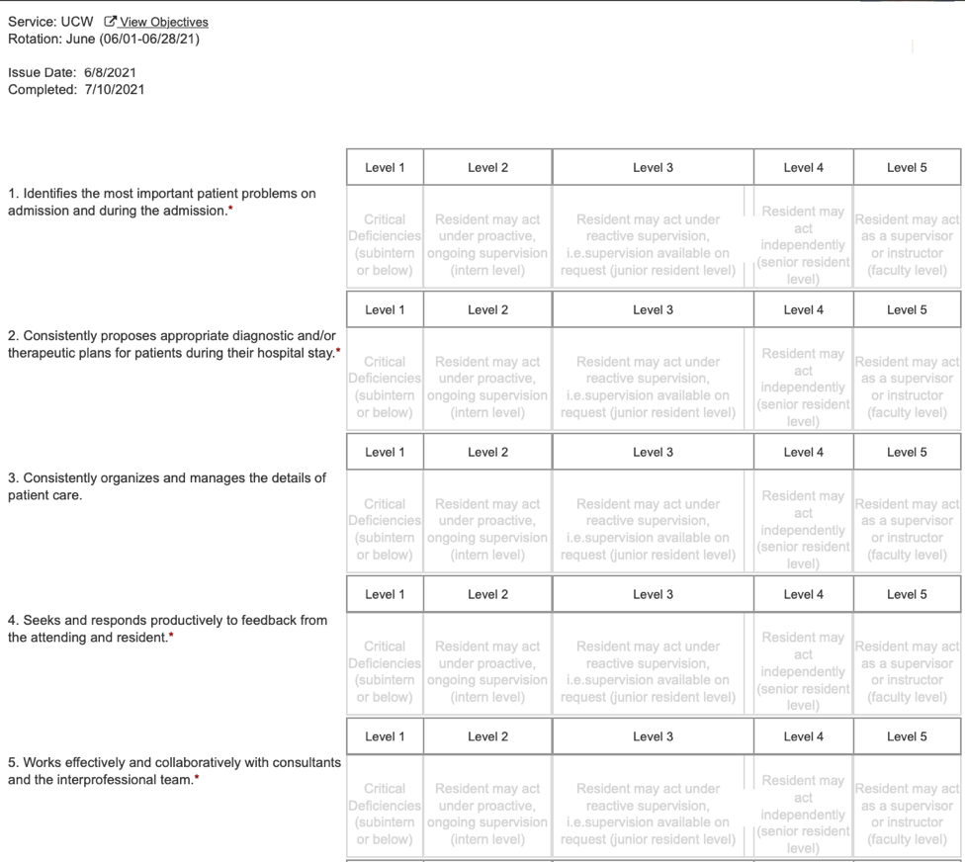
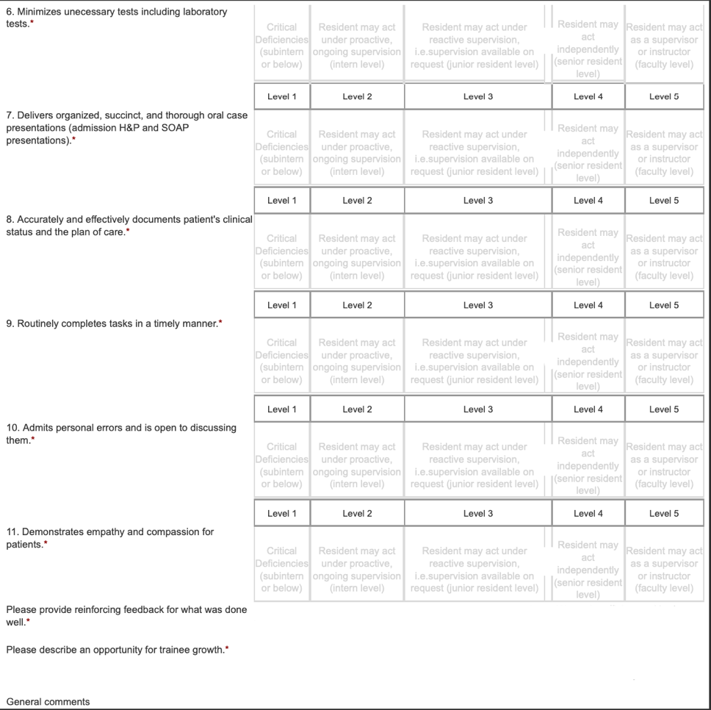

Example EPA Evaluation: VAW
