Alexander Beagle
Section leader: Meghana Gadgil
Decline to receive formal feedback

Fluid resuscitation and associations with clinical outcomes in patients with heart failure and sepsis

Background and Research Question
Sepsis is a common cause of hospitalization, and despite recent advances in goal-directed approaches to care, approximately 15% of all patients with sepsis ultimately die while hospitalized.^{1–3} The Surviving Sepsis guidelines suggest that septic patients should be administered intravenous fluids as part of initial resuscitative management, but despite being a cornerstone of the approach to sepsis, fluid resuscitation is an area lacking in scientific evidence to guide practice.⁴ Patients from a general sepsis population who critically ill appear to benefit from additional fluid, but this trend reverse at approximately 5L received in the first day (approximately 70 cc/kg assuming a 70kg patient).⁵ Whether patients with conditions affecting fluid regulation such as heart failure derive similar benefits from additional fluids remains unclear.

Previous studies have demonstrated that patients with heart failure are at higher risk of mortality and requirement of mechanical ventilation when septic.^{6,7} Given dysregulation of fluid balance in patients with heart failure resulting fluid overload, there is the concern that these patients will experience higher rates of mortality and mechanical ventilation as a direct result of administering fluids. While adherence to the 30 cc/kg fluid bolus in the Surviving Sepsis guidelines appears to be low in patients without heart failure (around two-thirds by one estimate,⁸ patients with heart failure typically receive even less fluid.^{8,9}
Few studies are available that examine the relationships between early resuscitative fluid administration and clinical outcomes in patients with heart failure. Three retrospective cohort studies showed that hypoxemic respiratory failure (usually defined as requirement of mechanical ventilation) is no more likely when receiving at least a 30 cc/kg bolus as part of early fluid resuscitation in patients with heart failure.^{8,10,11} As one example, among 208 heart failure patients, those who received more than 30 mL/kg of fluid were not intubated more frequently than those who received less than 30 mL/kg.¹² However, the group receiving less fluid in this study had significantly worse renal function at baseline, and the group receiving more fluid had more patients who indicated their goals of care did not include intubation, both of which may contribute to equalized intubation rates.

Interestingly, literature on the association between mortality and receiving a fluid bolus consistent with the Surviving Sepsis guidelines in heart failure patients suggests a benefit from more liberal fluid management strategies. A retrospective study of 211 patients found that septic patients with a preceding diagnosis of heart failure who received a 30 mL/kg fluid bolus in the first three hours of hospitalization had lower rates of in-hospital mortality than those who did not.¹³ However, total fluid volumes received are not described in this study, making it difficult to assess whether this mortality benefit is due more to administration of fluid within three hours of presentation or the total volume received. A similar result was found in a recent study of 312 patients with heart failure who either did or did not receive at least 30 cc/kg of fluid in the first 6 hours.⁸ While this study did show that patients with lower mortality received more fluid in the first 6 hours (3.2 vs 1.1L), the group who met the >30 cc/kg criteria had higher rates of tachycardia and hypotension, which likely influenced clinical decision-making. Additionally, this study did not use the most recent Sepsis-III definitions of sepsis. No clinical trials have been performed on this topic.
While the current literature suggests a mortality benefit without increased risk of respiratory failure from more liberal fluid administration strategies, it remains unclear what fluid administration strategy is best for patients with compensated heart failure and sepsis. This has also not been studied in populations defined by the most recent Sepsis-3 guidelines.¹⁴ This study aims to assess whether adult patients with compensated heart failure and sepsis according to Sepsis-3 criteria¹⁴ have higher rates of in-hospital mortality when administered larger initial resuscitative fluid volumes up to 70 cc/kg. Results from this study could inform future randomized controlled trials of septic patients with heart failure aimed at developing refined fluid resuscitation targets in this population.

Research Question: Do adult patients with compensated heart failure and sepsis have lower rates of in-hospital mortality when administered larger initial resuscitative fluid volumes up to 70 cc/kg?

Study Design
To address this question, we have developed a retrospective cohort study of patients with sepsis at the University of California, San Francisco (UCSF) Helen Diller Medical Center at Parnassus Heights. This center is a large academic hospital in an urban setting with approximately 30,000 emergency department (ED) encounters annually using an Epic-based (Epic 2017, Epic Systems Corporation, Verona, Wisconsin) electronic health record (EHR) implemented on June 1st, 2012. De-identified study data were obtained from a relational database storing clinical and administrative data since that date. This study was approved by the UCSF Committee on Human Research.

Study population
Our target population for this study is adult patients admitted to UCSF with sepsis, as defined by Sepsis-3 criteria,¹⁴ who are not clinically volume overloaded at presentation. Our accessible population includes all adult patients (age 18 years and older) who presented to the UCSF ED between June 2012 and December 2018 with a suspected systemic infection, defined as blood cultures ordered and parenteral antibiotics administered in the first 24 hours. From this, we will sample by including patients who met validated Sepsis-3 EHR criteria, which requires both a change in the Sequential Organ Failure Assessment (SOFA) score of at least two points within 48 hours of ED presentation^{14,15} and either four continuous days of antibiotics or a validated sepsis billing code at discharge.¹⁶ Patients who died or were discharged to hospice before accruing four days of antibiotics will be included. A diagnosis of heart failure will be identified using ICD-10 codes. Exclusion criteria: receiving more than 70 cc/kg of fluid in the first six hours, volume overload on presentation (defined as receiving intravenous diuretics within the first 6 hours of hospitalization), and renal failure chronically requiring dialysis prior to admission.

Measures
Data on demographic characteristics, clinical assessments, comorbidities, triage vital signs, laboratory testing, fluid volume received in the first 6 hours, and clinical outcomes will be extracted from the EHR database. These data will include time-linked components required to compute SOFA scores at the time of meeting Sepsis-3 criteria,^{15,17} as well as the van Walraven modified Elixhauser Comorbidity Index.¹⁸
Fluids received in the first 6 hours from ER presentation will be expressed as a continuous variable and converted to weight-adjusted terms by dividing the volume received (mL) by the first available patient weight (kg) recorded during the hospitalization. Data cleaning will be performed to remove suspected erroneous values, such negative fluid volume. Fluids will be included whether ordered as bolus or continuous (volume will be determined as rate x length of time administered during the first six hours), and will include both crystalloid and colloid solutions. The primary outcome for this study is in-hospital mortality (dichotomous), the secondary outcome is whether mechanical ventilation was required in the first 48 hours (dichotomous).

Statistics
The association between fluid volume and mortality (and mechanical ventilation) will be tested by logistic regression. We will use multivariable logistic regression to control for the influence of potential confounders. The predictor, fluid volume, will be expressed in terms of an additional 10 cc/kg. Possible results: In this study, we found that receiving an additional 10 cc/kg of fluid in the first six hours was associated with reduced odds of in-hospital mortality (P<0.05) and was not associated with requiring mechanical ventilation (P=0.43). We found that patients with heart failure tend to have a lower rate of mortality for each additional 10 cc/kg of fluid administered, after adjustment for potential confounders, and no association between fluid volume administered and the odds of requiring mechanical ventilation.

Sample Size and Power
The research question is: is an additional 10 cc/kg of fluid administered in the first six hours (up to 70 cc/kg) associated with decreased odds of mortality in adult patients with compensated heart failure and sepsis? The null hypothesis is that fluid volume is not associated with mortality. Possible alternative hypotheses are that CHF patients are more or less likely to die when receiving larger volumes of fluid. This will be tested by logistic regression. Alpha will be set at 0.05 according to the usual convention, using two tails given mortality could either be higher or lower with more fluid in heart failure, and beta will be set at 0.20 to achieve 80% power to detect the effect size described below. The effect is estimated from a study of associations between fluid resuscitation volume and mortality in patients without respect to heart failure status, in which an additional 20 cc/kg of fluid (roughly one SD) was associated with a lower probability of death (15 to 10%), corresponding to an odds ratio (OR) of roughly 0.71 for an additional 20 cc/kg of fluids.⁵ Detecting this effect in a univariate logistic regression would require a sample size of 402 subjects. We plan to use multivariable logistic regression to adjust for the effects of potential confounders, such as markers of baseline illness severity. Given a marker of illness severity would be expected to be highly associated with the predictor in our model (fluid volume administered), we will assume a strong correlation of 0.8. This yields a variance inflation factor of 5 and a required sample size of 2005 to detect this effect.

Enhancing Causal Inference
There are several variables that could confound a relationship between volume of fluid resuscitation and mortality or mechanical ventilation in patients with heart failure. Considering potential demographic factors, ones that would be reasonably expected to correlate with fluid receipt and mortality are age and limited English proficiency. We doubt that gender, race, or ethnicity are significantly correlated with fluid volumes administered and therefore not likely to be confounders, though we plan to test for associations in model development. Another category is clinical data, of which potential confounders include illness severity (SOFA score at time of meeting sepsis criteria) and burden of comorbidities at baseline (Elixhauser Comorbidity Index), and vital signs not incorporated in SOFA score (presence of abnormal temperature, tachycardia, tachypnea). To limit systematic bias due to presence of a condition on admission that significantly affects medical decision-making around fluid resuscitation, we plan to exclude patients who are in decompensated heart failure on presentation (received IV diuresis in the first six hours from triage), and patients with renal failure on chronic dialysis.

One possible method to account for these potential confounders is stratification. For example, the association between fluid volume and mortality could be tested separately among patients whose sepsis is mild, moderate, or severe by SOFA score at time of presentation, which would be beneficial in that it is easily understood, clinically relevant, and simply communicated. For example, the association between fluids administered and mortality may be fully confounded by illness severity on presentation. In this case, additional fluid would not be associated with mortality in groups of patients clustered by illness severity, such as mild, moderate, or severe, and that would be easily communicated.

An alternative is adjustment in multiple regression. The benefit of this approach is that it estimates the odds of mortality per additional volume of fluid resuscitation accounting for the partial explanatory effects of multiple confounders simultaneously, thus producing an estimate of effect that more effectively captures the individual contribution of fluid volume on mortality. Ultimately, this is what the study question is trying to capture. We plan to use this approach, though will consider presenting information in stratified format if there is a clinically significant case of confounding for a small number of variables such as the one described above that would be meaningful to communicate individually.

Questionnaires
This study will be conducted entirely with retrospective de-identified medical record data and thus will not use a questionnaire that is completed by study subjects. However, it does use composite scores that have been validated and are questionnaire-like. For example, SOFA scores were validated in a population of nearly 1,500 patients admitted to ICUs in Europe and developed to predict ICU mortality among patients with sepsis. The domains assessed include laboratory data, requirement of interventions associated with more severe illness like mechanical ventilation or vasopressors, and mental status, though they can be alternatively organized into organ systems such that the score describes summative organ dysfunction. The SOFA score is provided in the appendix.

References
1. Rhee C, Dantes R, Epstein L, et al. Incidence and trends of sepsis in US hospitals using clinical vs claims data, 2009-2014. JAMA - J Am Med Assoc. 2017;318(13):1241-1249.
2. Kaukonen K-M, Bailey M, Suzuki S, Pilcher D, Bellomo R. Mortality Related to Severe Sepsis and Septic Shock Among Critically Ill Patients in Australia and New Zealand, 2000-2012. JAMA. 2014;311(13):1308.
3. Liu V, Escobar GJ, Greene JD, et al. Hospital deaths in patients with sepsis from 2 independent cohorts. JAMA. 2014;312(1):90-92.
4. Rhodes A, Evans LE, Alhazzani W, et al. Surviving Sepsis Campaign: International Guidelines for Management of Sepsis and Septic Shock: 2016. Vol 45.; 2017.
5. Marik PE, Zwirble WTL, Bittner EA, Sahatjian J, Hansell D. Fluid administration in severe sepsis and septic shock , patterns and outcomes : an analysis of a large national database. Intensive Care Med. 2017;43(5):625-632.
6. Abou Dagher G, Hajjar K, Khoury C, et al. Outcomes of patients with systolic heart failure presenting with sepsis to the emergency department of a tertiary hospital: A retrospective chart review study from Lebanon. BMJ Open. 2018;8(7):1-8.
7. Alon D, Stein GY, Korenfeld R, Fuchs S. Predictors and Outcomes of Infection-Related Hospital Admissions of Heart Failure Patients. PLoS One. 2013;8(8):8-11.
8. Acharya R, Patel A, Schultz E, et al. Fluid resuscitation and outcomes in heart failure patients with severe sepsis or septic shock: A retrospective case-control study. PLoS One. 2021;16(8):e0256368.
9. Kuttab HI, Lykins JD, Hughes MD, et al. Evaluation and Predictors of Fluid Resuscitation in Patients With Severe Sepsis and Septic Shock. Crit Care Med. 2019;47(11):1582-1590.
10. Khan RA, Khan NA, Bauer SR, et al. Association Between Volume of Fluid Resuscitation and Intubation in High-Risk Patients With Sepsis, Heart Failure, End-Stage Renal Disease, and Cirrhosis. Chest. 2020;157(2):286-292.
11. Jagan N, Morrow LE, Walters RW, et al. Sepsis, the Administration of IV Fluids, and Respiratory Failure. Chest. 2021;159(4):1437-1444.
12. Khan RA, Khan NA, Bauer SR, et al. Association Between Volume of Fluid Resuscitation and Intubation in High-Risk Patients With Sepsis, Heart Failure, End-Stage Renal Disease, and Cirrhosis. Chest. 2020;157(2):286-292.
13. Taenzer AH, Patel SJ, Allen TL, et al. Improvement in Mortality With Early Fluid Bolus in Sepsis Patients With a History of Congestive Heart Failure. Mayo Clin Proc Innov Qual Outcomes. 2020;4(5):537-541.
14. Singer M, Deutschman CS, Seymour CW, et al. The Third International Consensus Definitions for Sepsis and Septic Shock (Sepsis-3). JAMA. 2016;315(8):801.
15. Vincent J-L, Moreno R, Takala J, et al. The SOFA (Sepsis-related Organ Failure Assessment) score to describe organ dysfunction/failure. Intensive Care Med. 1996;22(7):707-710.
16. Rhee C, Dantes R, Epstein L, et al. Incidence and Trends of Sepsis in US Hospitals Using Clinical vs Claims Data, 2009-2014. JAMA. 2017;318(13):1241.
17. Seymour CW, Liu VX, Iwashyna TJ, et al. Assessment of Clinical Criteria for Sepsis. JAMA. 2016;315(8):762.
18. van Walraven C, Austin PC, Jennings A, Quan H, Forster AJ. A Modification of the Elixhauser Comorbidity Measures Into a Point System for Hospital Death Using Administrative Data. Med Care. 2009;47(6):626-633.
19. Brookhart MA, Schneeweiss S, Rothman KJ, Glynn RJ, Avorn J, Stürmer T. Variable selection for propensity score models. Am J Epidemiol. 2006;163(12):1149-1156.

Appendix - Sequential Organ Failure Assessment Score
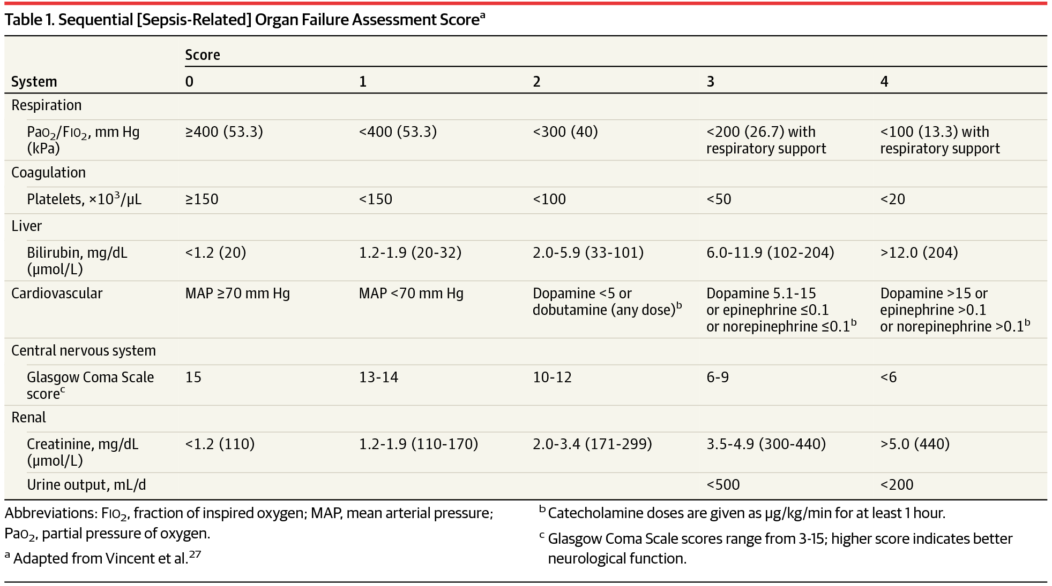
The SOFA score is the sum of the component scores.

