How to Register and Login to CITI

- Google “CITI training” as shown below and click on the first entry CITI – Collaborative Institutional Training Initiative.

- You will see the below screen. Click on register to create a new account or login if you already have an account.



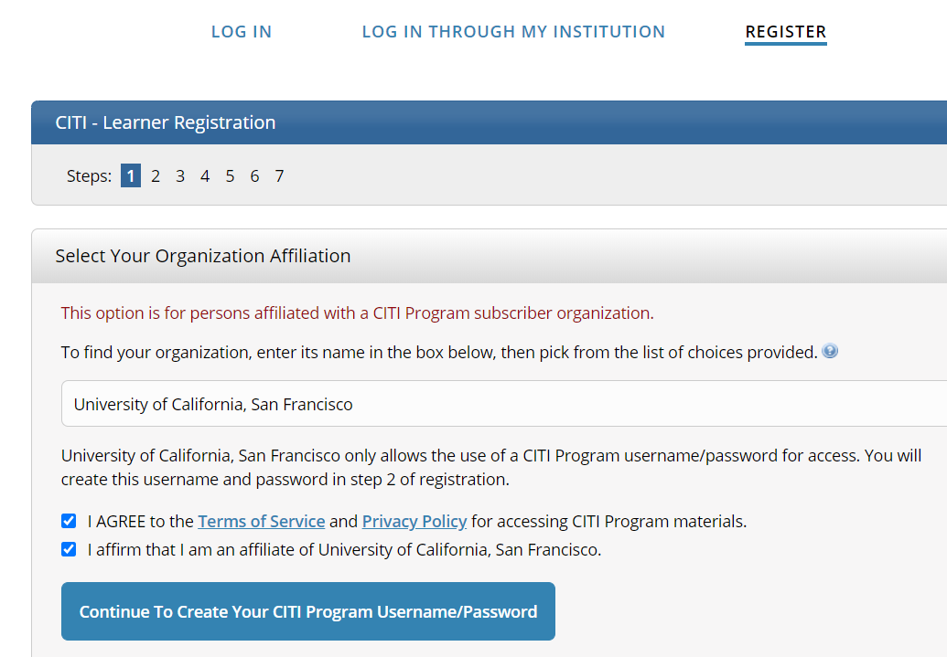
- Step 1: Type in University of California and select San Francisco. Do not just type in UCSF as there may be other non-relevant affilations. Affiliation menu will disappear once you make a selection. Check “I AGREE” and “I affirm.” Click “Continue to Create Your CITI Program Username/Password”.

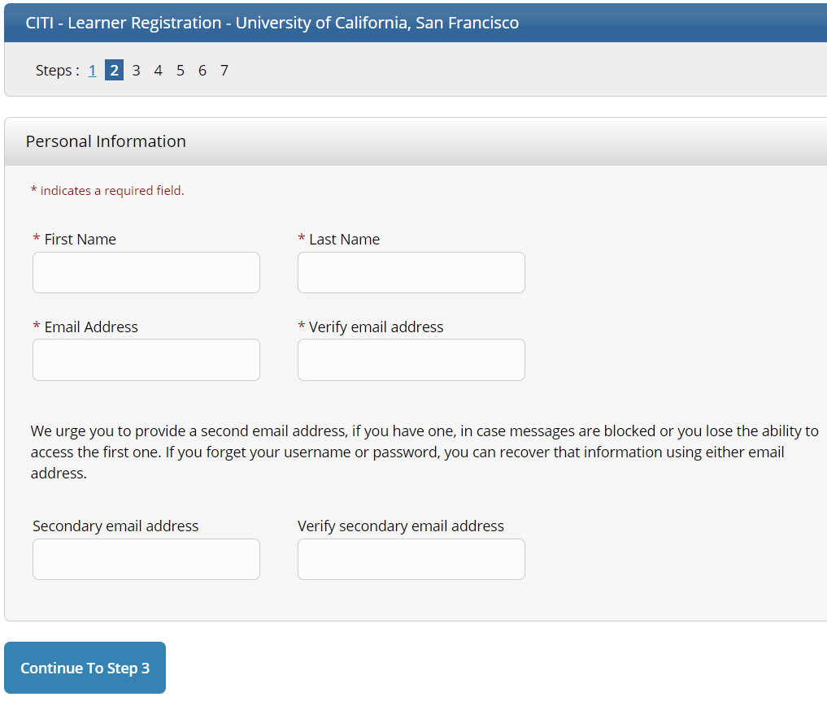
- Step 2: Complete your name, email, and click “Continue to Step 3”.

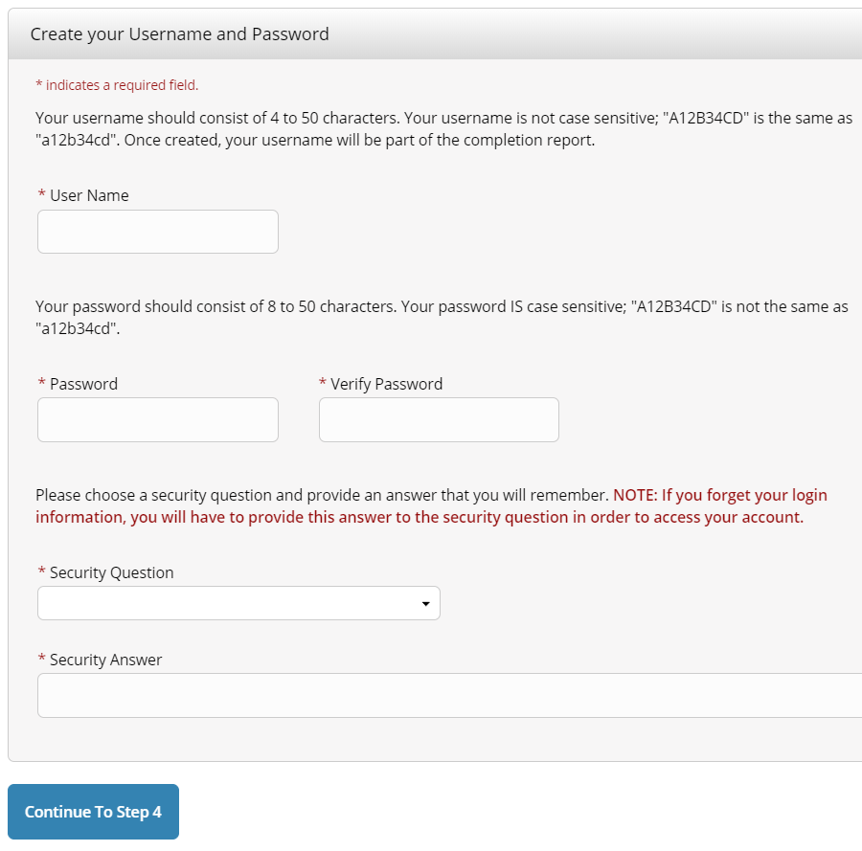
- Step 3: Select a username and password (remember/save this information for future access). Click “Continue to Step 4”.

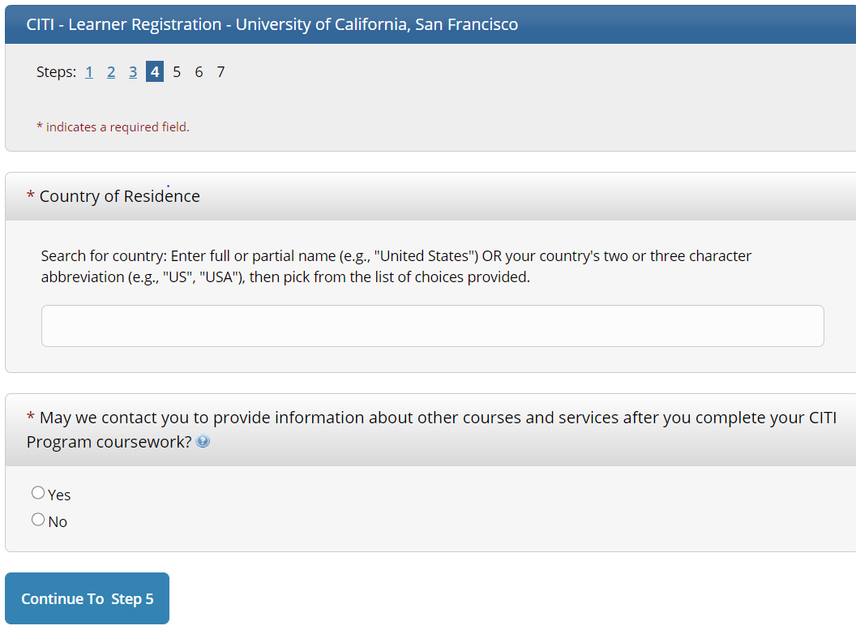
- Step 4: Complete the demographic information listed. Click “Continue to Step 5”.

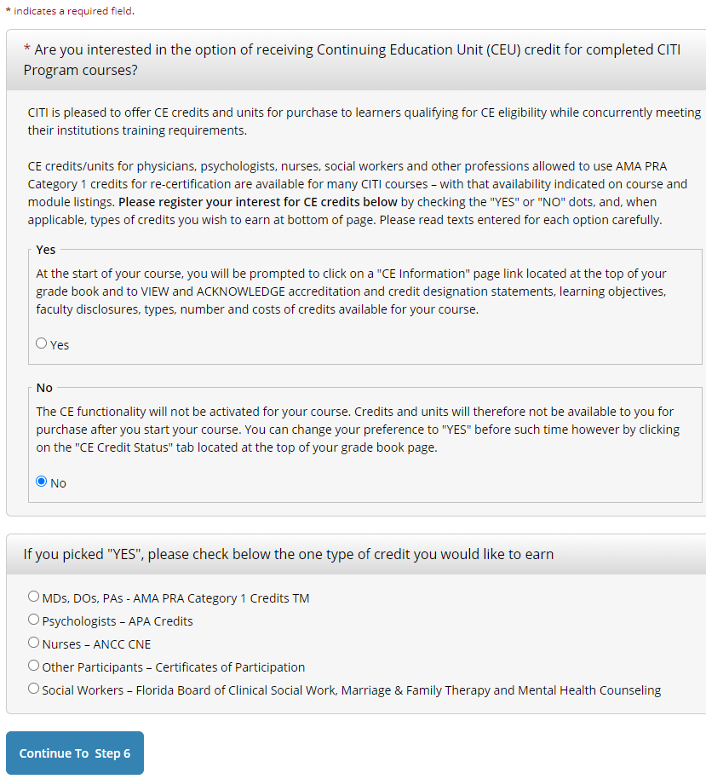
- Step 5: Click “No” for CE, otherwise you will have to pay. Click to “Continue to Step 6”.

- Step 6: Complete additional demographic information. After, click “Continue to Step 7”.
- Step 7: Select “Human Subjects Protection Training.” Leave the other questions blank and choose “not at this time” for question 6. Click on “Complete Registration” and on the next screen you will choose “Finalize Registration.”
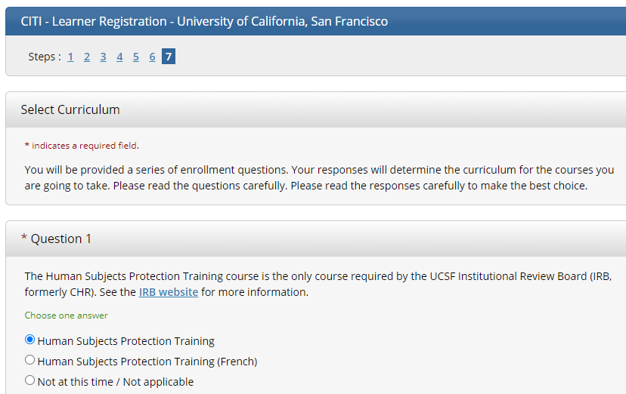

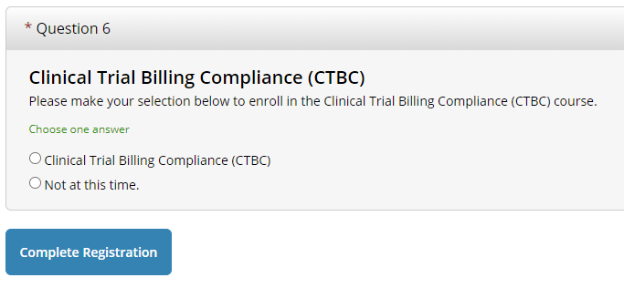

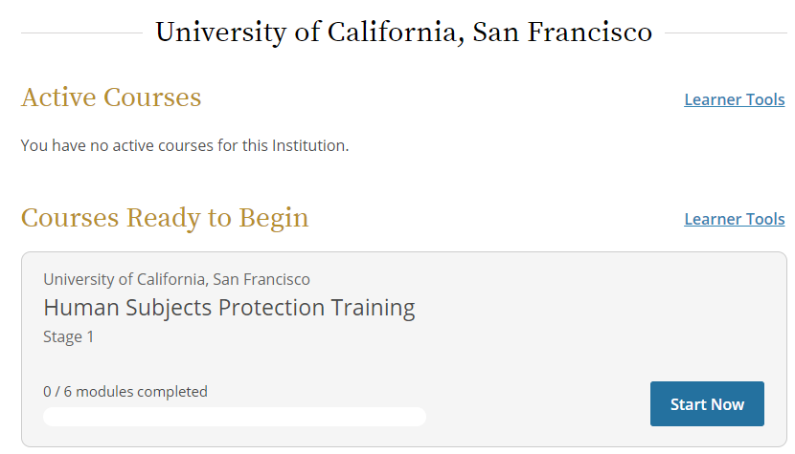
- Once you are registered, click View Courses and click “Start Now” on the Human Subjects Protection Training.

YOU ARE NOW REGISTERED AND CAN FINISH THE FOLLOWING LATER
- You need to complete 6 modules. There are four required modules and two elective modules. You can choose any two elective modules, but we suggest selecting two relevant modules. You need an average of 80% across all quizzes to meet the CITI requirement.

- After you have completed the modules, View courses, click on the “View print share record” and copy the link to email to your faculty mentor.

