UCSF CITI training modules

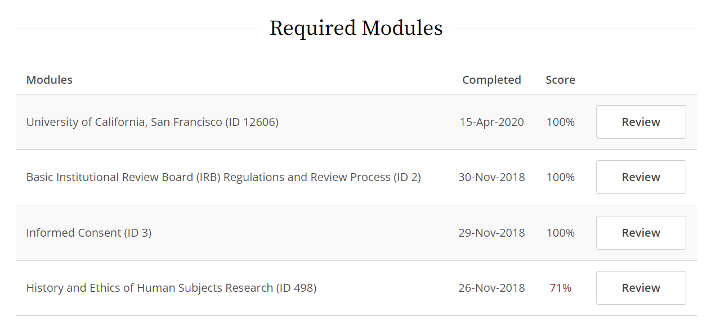
Note: SB stands for Social and Behavioral; FDA is the Food and Drug Administration
Choose optional modules that pertain to your project
