Quality Improvement
Project Charter

Topic:

Problem Statement

- What product, process or service is involved?

- Explain the problem:

- What are the expectations (target/goal) for this product, process or service?

Final Problem Statement:

SMART Goal
Specific:
Measurable:
Attainable:
Relevant:
Timely:
Final SMART Goal:

Team Members
Sponsor(s):
Champion(s):
Project Lead(s):
Team Members:
Improvement Advisor:
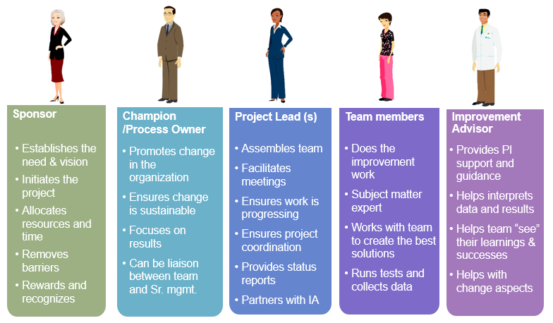
Family of Measures:
Outcome Measures (List the measure you ultimately want to affect):

Process Measures (List the measures that will tell you if the parts or steps in the system are performing as planned to affect the outcome measure.):

Balance Measures (List the measures you will track to determine whether you are introducing problems in other parts of the system.):

Stakeholder Analysis Table
Stakeholder | Voice | Key Issues | Critical Stakeholder Requirements
Person or Group of Interest | What does the stakeholder need or want from us? | Identify the issues that prevent satisfaction | Summarize key issues and translate them into specific/measurable requirements

Root Cause Analysis: Process Map or Fishbone Diagram
Pick Chart
Benefit/Payoff | High | Implement (Just Do It) | Collaborate
Benefit/Payoff | Low | Possible | Kibosh
 |  | Low | High
 |  | Effort

PDSA Testing Action Plan

Summary of Planned Tests of Change
Description of planned tests of change (TOCs) | Person/Accountable Role  (i.e., who will be accountable for completing this test, including data & feedback collection) | Where will Test be conducted  (e.g., specific unit, ICU, OR, ED, area of the Clinic, etc.)? | How frequently will Test be conducted (e.g., by shift, hourly, daily, weekly, etc.)? | For how long overall will Test be conducted  (e.g., one day, one week, one month, etc.
Test #1

Test #2:

Test #3:

Test #4:

Test #5:

Plan
List the tasks needed to set up this test of change | Person Responsible | When to be done | Where to be done

Communication Plan
List the tasks needed to communicate this test of change | Person Responsible | When to be done | Where to be done

Potential Barriers | Mitigation

Data Analysis Plan

Measure | How will it be collected? | Who will collect it? | When/how often will it be collected? | How will it be analyzed? What graph/outcome produced? | Who will analyze it? | When/how often will it be analyzed?

Project Timeline
Month | Team Member | Activity

Sustainability Plan
- What actions should happen, by whom and for how long?

- What needs to be measured and who will measure it?

- How will change be communicated?

- What training is necessary?

 | Item | Action | Responsible Person | Frequency | Issue/Comments
Bundle of Actions | Action 1:
Bundle of Actions | Action 2:
Bundle of Actions | Action 3:
Data Analysis | Gather Data:
Data Analysis | Analyze Data:
Data Analysis | Report Results:
Communication | Project Team:
Communication | FM Leaders:
Communication | Leadership:
Communication | Others:
Training | Project Meeting:
Training | FM Huddles:
Training | Other:

