Step-by-Step Commands using the example I showed in class
RCT Dataset
- Population: NF1 patients with plexiform neurofibromas (peripheral nerve tumors) that can cause pain and disfigurement
- Stratified by Disease Grade (mild-1, intermediate-2, severe-3)
- Randomized to Treatment (Placebo-0 vs. Drug-1)
- Outcome: QOL Score in 3 areas (physical, emotional, cognitive)
Task: Create a bar graph that displays mean physical scores with 95% CI by Grade & Treatment
Step 1: Preparing Data
use "/Users/tiff/Box Documents/TICR/Biostat 212-TA/Mini Lecture/NF1 QOL Dataset Demo.dta"
Take a look at the data using the list command
list
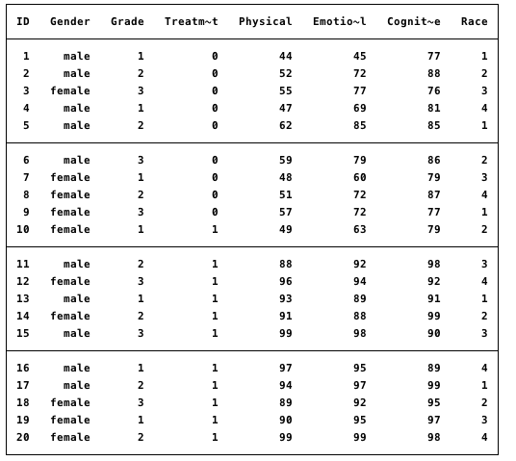
My raw dataset includes individual patient information.
But I want to analyze mean Physical scores by patient groups (ie. by treatment and disease grade)
I can do this by collapsing data across observations using the collapse command
Lets first look at average scores across categories by treatment group:
collapse Physical Emotional Cognitive, by(Treatment)
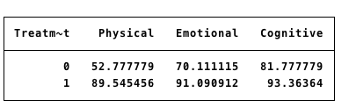
You can see that average scores were lower in all categories for patients who received placebo vs. drug.
To add error bars, I need to calculate the CI for the mean using these equations:
CI for mean = (mean + (1.96 x SE)) to (mean – (1.96 x SE))
SE for mean = SD / sqrt(n)
I can ask STATA to calculate the mean, standard deviation (SD) and number of observations (n) pertaining to my y-variable of interest “Physical” and save them as new variables which I will call “meanphysical,” “sdphysical,” and “n”
General commands:
(mean) meanyvar=yvar
(sd) sdyvar=yvar
(count) n=yvar
collapse (mean) meanphysical= Physical (sd) sdphysical=Physical (count) n=Physical, by(Treatment Grade)

Next, I calculate the upper and lower bounds of my CI and save these values as new variables “hiphysical” and “lowphysical”
generate hiphysical = meanphysical + 1.96*(sdphysical / sqrt(n))
generate lowphysical = meanphysical - 1.96*(sdphysical / sqrt(n))

Step 2: Create Graphs Using Collapsed Data

We can now make a bar graph using the graph bar command. Not bad, but this will not support error bars.

graph bar (mean) yvar, over(xvar1) over(xvar2) asyvars

graph bar meanphysical, over(Treatment) over(Grade) asyvars

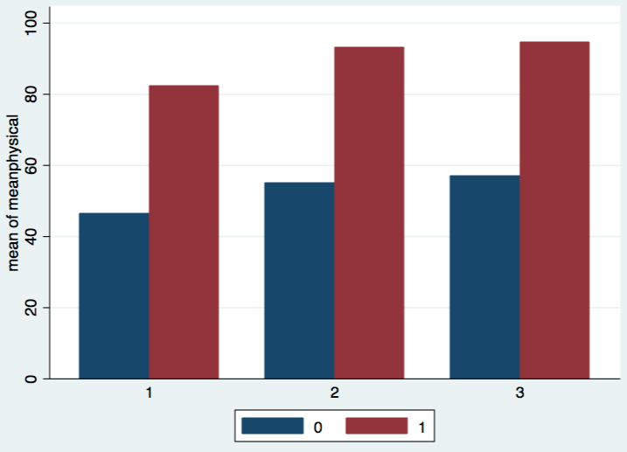

The twoway bar command makes lovely error bars, but it splits the figure into three different bar graphs, which is not ideal.

twoway (graphtype yvar xvar1) (rcap hiyvar lowyvar xvar1), by(xvar2)

graph twoway (bar meanphysical Treatment) (rcap hiphysical lowphysical Treatment), by(Grade)

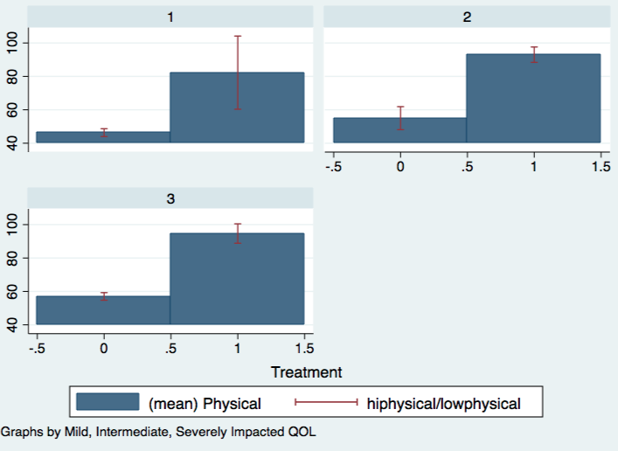

We can finesse the twoway bar command to make a graph that resembles the graph bar command and then combine that with error bars.

To do this, we combine the two x-variables (Grade and Treatment) into one new variable, “GradeTreatment.”

generate GradeTreatment = Treatment if Grade == 1
replace GradeTreatment = Treatment+3 if Grade == 2
replace GradeTreatment = Treatment+6 if Grade == 3

Note that “GradeTreatment” has a gap between 3 and 6. You want a separation between the bars on the x-axis. Since we have 2 bars (placebo/drug) per Grade, we create the gaps at 3 and 6. If you have 3 bars per Grade (placebo/drug1/drug2), you would create gaps at 4 and 8.
We Sort (by ascending order) and Separate into thirds by Grade

sort GradeTreatment
list GradeTreatment Grade Treatment, sepby(Grade)

Now we employ the twoway bar command using this new combination variable

twoway (graphytype meanyvar xvar1xvar2)
twoway (bar meanphysical GradeTreatment)

Now overlay the error bars using rcap graph

twoway (graphytype meanyvar xvar1xvar2) (rcap hiyvar lowyvar xvarxvar2)
twoway (bar meanphysical GradeTreatment) (rcap hiphysical lowphysical GradeTreatment)

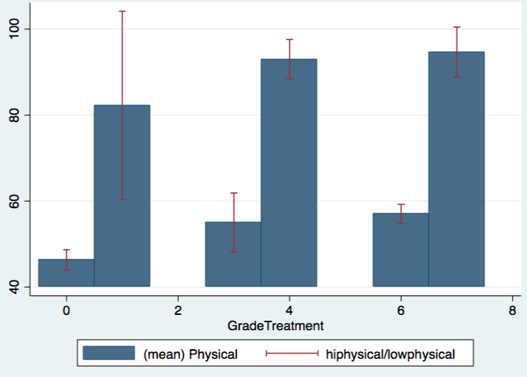

Not bad, but we want placebo and drug to be different colors. If you try to change the color of one bar now, they all turn the same color. This is because you just combined the x-variables. Lets fix this and add a corresponding legend.

twoway (bar meanphysical GradeTreatment if Treatment==0) ///
(bar meanphysical GradeTreatment if Treatment==1) ///
(rcap hiphysical lowphysical GradeTreatment), ///
legend(row(1) order(1 "Placebo" 2 "Drug") ) ///
xlabel( 0.5 "Severe" 3.5 "Intermediate" 6.5 "Mild", noticks) ///
xtitle("Disease Severity Grade") ytitle("Physical QOL Score") ///

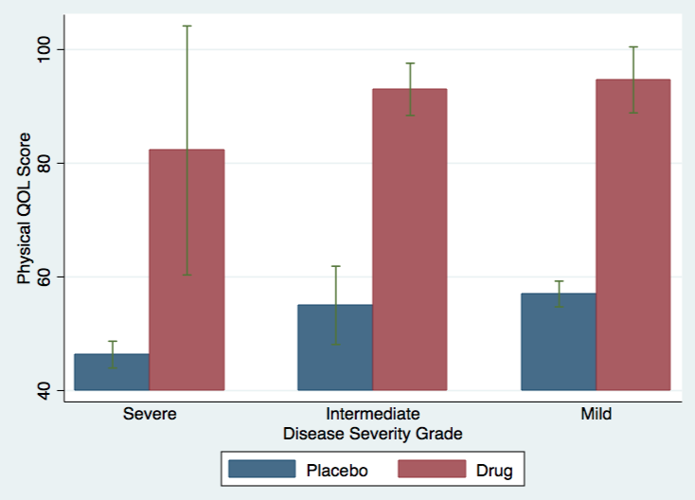

I created the a one-row legend using row(1) and listed placebo first and then drug, hence “order(1 xvar 2 xvar).
The numbers I used for xlabel dictate how far apart the labels are on the graph.

References:
- http://www.ats.ucla.edu/stat/stata/faq/barcap.htm (step-by-step, excellent resource in general for STATA queries)
- http://blogs.worldbank.org/impactevaluations/tools-trade-graphing-impacts-standard-error-bars (uses Excel to manipulate data first)

