Health Technology Assessment Unit University of Calgary
Who we are: A team of health services researchers passionate about bridging the gap between science and policy.
Our Vision: To be a leader in supporting evidence-informed health policy with innovative and relevant research.
What we offer:
- Evidence synthesis
- Systematic reviews
- Economic evaluations
- Health Technology Assessments
- Health technology reassessment

CURRENT PROJECTS
- Health technology assessments in partnership with the Alberta Health Technologies Decision Process
- Systematic review of drug reimbursement decision making processes and cost containment tools across OECD nations
- A model for health technology reassessment in Alberta
- Cost-effectiveness of cardiac rehabilitation

Our Mission:
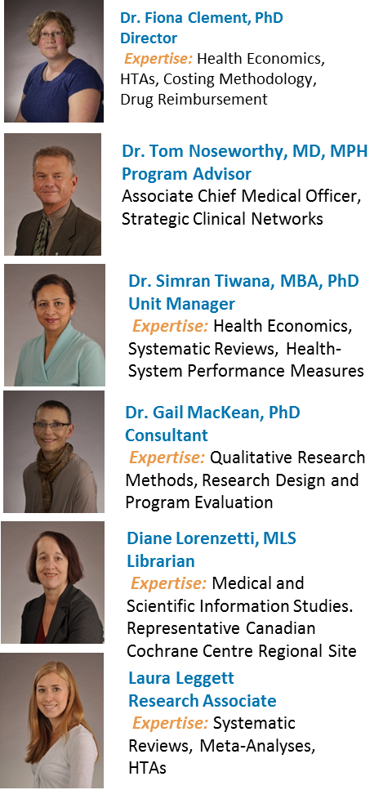

Contact Information:
Dr. Fiona Clement, Director
fclement@ucalgary.ca
Phone: 403-210-9373

Contact Us:
Dr. Fiona Clement, Director
fclement@ucalgary.ca

Contact Us
Dr. Fiona Clement
Director, HTA Unit
fclement@ucalgary.ca

Our OuO

Our Team
Our Team
- To complete health technology assessments to support evidence-informed health policy in Alberta
- To use innovative research to integrate evidence into policy
- To promote the flow of research to policy
- To create a receptive audience for evidence-informed health policy
Our Values:
- Research should work for the common good
- Evidence-informed policy is the way to go!
- Never stop learning

