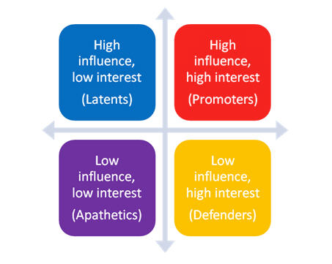
Hepatitis C screening: identifying the optimal target population
Issue overview: The Alberta Health Technologies Decision Process has initiated an evidence review to establish the optimal screening strategy for Hepatitis C in Alberta. In parallel, new anti-viral drugs for the treatment of Hepatitis C are being considered by the national recommendation-making body, the Common Drug Review (CDR), for public reimbursement. The Health Technology Assessment Unit at the University of Calgary has been asked to develop robust, evidence-based, policy options for both screening and treatment.
Promoters:
- Ministry of Health (government of Alberta): The Ministry of Health will be both the implementer and payer of the screening programme and drugs. The government will be required to defend any decision it makes. Thus the government is highly interested in the outcome and process of this work to ensure that the final outcome is most optimal solution and defendable to the public.
- Drug makers (Gilead): A screening programme will directly affect the number of patients identified for treatment which will impact the drug sales. “Big Pharma” is highly influential and very interested in this work.
- Laboratory services: The laboratory services will have to cope with the additional blood tests resulting from a screening programme. They are concerned about workload and given they are globally funded, cost absorption.
- Hepatology services: Hepatology currently sees 600 patients a year in Alberta. Depending on the screening programme recommended, the demand could increase to above 20,000 patients in Alberta; a completely unrealistic increase in service requirements. Hepatology is influential and has very high interest.
- Canadian gastroenterologists association: The professional organization of gastroenterologists, which includes hepatology, will be very interested as they are lobbying for increased screening and treatment of HCV.
Latents:
- Targeted groups – birth cohort, general population: the general population has high influence over the government but will be generally uninterested in the work.
- Other professional organizations – Alberta medical association: The professional association of doctors are highly influential with the Ministry of Health but generally uninterested. They have other causes that are much more important to them.
- Media: Generally, I think the media will be uninterested.
Apathetics:
- Other levels of government: the other ministries and the municipal governments generally will not be interested and will not be influential in health.
Defenders:
- Targeted groups – drug using population, prisoners, refugees, immigrants from high prevalence countries: This groups are at high risk of transmission and have a high burden of HCV. However, they are generally not able to be influential as they are disadvantaged.
- Hepatitis patients:
- Clinics for vulnerable populations:
- Public Health Agency of Canada: The agency is not influential as it is a recommendation making body that is at arms length of the federal government. It is generally not highly regarded by the Chief medical officers of the provinces and it is largely ignored. However, they will be very interested in the decision in Alberta.

