Start of ICS in ED

HW 6
1. Thinking about the protocol you are developing, identify the process and outcome indicators associated with the intervention/program and briefly describe an approach to measuring each.
Outcomes indicators for training intervention:
-Provider attitudes and knowledge of ICS prescribing and ICS patient education on-line survey, focus groups
-How many ICS were prescribed in ED and how many prescriptions were filledhospital data most likely available through billing system
-Patient knowledge of ICS usage after being prescribed an ICS in the EDonline survey, focus groups
Process indicators for training intervention and environmental restructuring intervention:
-how many trainings were heldprogram log
-how many people attendedprogram log
-how many times did community advisory board meetprogram log
-are ICS inhalers available in ED discussion with Operations Manager (?) of ED
-did program work with hospital medication formulary to select appropriate ICS medicationsdiscussion with site coordinator of study
2. Define one or more “intermediate” outcome measures [reflecting changes in environment, organizational culture, systems of care, patient or public behavior, and/or clinician behaviors] that can inform you about the mechanism by which your intervention achieves its downstream effect on health and inform you about the acceptability of your intervention.
An intermediate outcome measure would be ICS prescriptions written in the ED and how many of said prescriptions were filled. An increase in prescription rates would indicate that this intervention is acceptable to the providers. While prescribing and filling a medication prescription does not necessary indicate use, it is somewhat correlated. Taking ICS is associated with decreased asthma morbidity and mortality, the downstream effect on health we are hoping to achieve.
3. Identify a mixed methods study design and briefly describe the quantitative and qualitative data you will collect for program/intervention evaluation.
The quantitative data I would collect would be ICS prescription rates in the ED before and after the training intervention. The qualitative data I would collect would be focus group responses of providers concerning training effectiveness and attitudes about ICS prescription in ED, and patient focus groups concerning attitudes of receiving ICS prescriptions and education in ED.

- Use the COM-B model to identify what needs to change in order for ONE of your selected target behaviors to occur. Note that TDF domains corresponding to each COM-B category are in parentheses, and that some of you may have already done this or aspects of this in Week 4.
Want to look at process and feasibility of intervention as well as effectiveness of outcome

COM-B Components | What needs to happen for the target behavior to occur? | Is there a need for change?
Physical capability  (Physical skills) | Write ICS order | No
Psychological capability  (Knowledge; Cognitive and interpersonal skills; Memory, attention and decision processes; Behavioral regulation) | Identifying eligible pts  Know what is the appropriate ICS dose for asthma category  Remember to write prescription  Teaching pt  Pt picking up med  Pt using med | yes
Physical opportunity  (Environmental context and resources) | Have ICS prescriptions available in ED | no
Social opportunity  (Social influences) | Do other providers write ICS prescriptions in ED? | Yes
Reflective motivation  (Professional/social role and identity; Beliefs about capabilities; Optimism; Beliefs about consequences; Intentions; Goals) | ICS work to control asthma and reduce future visits  ED providers have time and resources to write ICS prescriptions | Yes
Automatic motivation  (Reinforcement; Emotion) | Fear of extra work disrupting patient flow | Yes
Behavioral diagnosis of the relevant COM-B components: | List the COM-B categories you want to target with your intervention  I would like to target psychological capability, social opportunity and reflective motivation

- Use the APEASE criteria to identify appropriate intervention functions based on the behavioral diagnosis (See Table 2.3 in Michie et al Chapter 2)

Candidate intervention functions | Is the intervention function needed based on the behavioral diagnosis?
Education | Yes
Persuasion | No
Incentivisation | Yes
Coercion | No
Training | Yes
Restriction | No
Environmental restructuring | Yes
Modelling | No
Enablement | No
Selected intervention functions: | List the selected functions your intervention(s) will serve. Select based on APEASE criteria (affordability, practicability, effectiveness/cost-effectiveness, acceptability, side-effects/safety, equity).  Starting ICS in ED is affordable, it is practical in the less acute part of the ED, it is cost-effective, I think it will be acceptable, it is safe, and it increases health access so it is equitable.

3. For one of the intervention functions you selected, select a specific behavior change technique you will employ in your intervention strategy and specify how it will be delivered. See Table 3.3 in Chapter 3 of Behavioral Change Wheel (Michie et al) for list of most frequently used behavior change techniques for each intervention function.
a. BCW Intervention Function: Education
b. Behavior Change Technique: Psychological capability
c. Mode of delivery (i.e., intervention details): education intervention to review ICS dosing for different asthma categories. Will take place as lecture during grand rounds, and later there will be a link in EMR with summary of recommendations for easy prescribing
Needed behaviors:
Identifying eligible pts
Know what is the appropriate ICS dose for asthma category
Remember to write prescription
Teaching pt
Pt picking up med
Pt using med
- Identify an individual (e.g., patient or provider) or group (e.g., community group or organization) that contributes to or is involved in the principal behavior you are attempting to change. Specify the desired behavior change (who needs to change what, when, where and how)?
Emergency Medicine providers. The behavior I am looking to change is prescribing ICS in the ED to asthmatic patients.
- Using any of the individual explanatory theories in “Theory at a Glance”, develop an explanatory model for the target behavior (above) that you will be attempting to influence with your intervention. This can be an extension/based on previously published literature or your best guess of expected findings. Figures are always very useful... keep it simple. You can also use the logic model of the problem concept as presented in Bartholemew and Mullen (Five roles for using theory and evidence in the design and testing of behavior change interventions). Be sure to include components beyond the individual, such as suggested by the socio-ecological model.
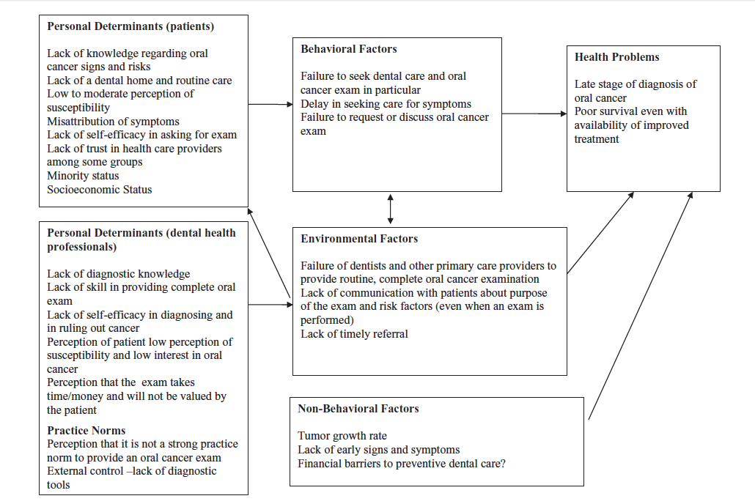
Mortality and morbidity from asthma
Lost work and school days
Increased system costs
Failure to ask for ICS in ED or at PCP
Delay in starting controller meds
Patients:
Lack of knowledge regarding ICS
Mixed beliefs about efficacy about ICS
Concerns about long term ICS
Moderate perception of susceptibility
Lack of trust in healthcare providers
SES
Lack of self-efficacy in seeing PCP to get ICS

Failure to start ICS in ED
Lack of referral
Lack of communication to patients why ICS important
ED doctors:
Long-term asthma management not seen as ED problem
Lack of knowledge
Practice norms that discourage long-term disease management
Not valued by patient

Asthma severity
Finical barriers to ICS
Air environment

- Create your own version of Table 1 from Michie et al (Making psychological theory useful for implementing evidence based practice: a consensus approach) that reflects some of the different theoretical domains and interview questions, tailored to the behavior you want to change. Be sure to select several domains likely to be of interest based on the literature or your experience/best guess.
Knowledge: training ED providers about ICS perceptions
Professional identity: focus on changing ED provider perception that they can help manage chronic health problems
Social influences: have tool so physicians can compare prescription rates to other providers in ED

1.Based on Shortell’s article “An empirical assessment of high-performing medical groups: results from a national study", describe the organization/system in which your intervention will take place using the specific predictor measures within Environment, Resource acquisition, Resource deployment and Quality-centered care (Table 1).
Environment: community hospital Oakland, lower levels of physical resources, good relationship with ED staff, human capital high
Resource acquisition: low to medium
Resource deployment: medium
Quality-centered care: unsure, suspect medium to high level

2. Discuss which of these factors might serve as barriers to successful implementation of your intervention, and how you will try to design an intervention to overcome these barriers.
The lower level of resource acquisition may serve as a barrier to successful implementation of this intervention. To overcome this barrier, I will submit a grant to help obtain funding to get project off the ground (ie pay for training, poster endorsements). Once operational, this project should be self-sustaining.

1. Define the community/communities for your project and explain why each is a stakeholder for your study.
Communities involved in this project are ED physicians, primary care physicians and asthma patients. This study involves trying to change the behavior of both ED physicians and asthma patients, thus both are stakeholders in this project. Primary care physicians are the primary mangers of asthma patients.
2. Describe your plan for approaching potential community partners to ask for their involvement.
I would like to discuss this project with the patient advisory council for Highland General Hospital (HGH). There are pre-existing avenues within HGH to get in contact with the patient advisory council. Additionally I would like to reach out to PCP and ED physician at both establishments.
3. Identify which stages of your project you'll incorporate community input, and describe what types of input you'll solicit.
I would like community input at the planning stage of intervention and after the pilot stage has been completed to get feedback. I would like open-ended feedback through small focus groups.
4. Name three ways you plan to share your results, beyond writing an academic article or presenting at an academic conference.
I would like to write up a summary article for the public HGH website, make a presentation to the patient advisory board at the end of the study to go over results, and consider doing an asthma controller medication in-service for emergency department staff.

What evidence are you proposing to translate into practice?
I am proposing to translate the practice of having Emergency Department (ED) providers refer to primary care and initiate inhaled corticosteroid (ICS) therapy for asthma patients being seen in the ED for asthma exacerbation.
A. Justify that this evidence is “ready for translation.”
There are existing guidelines advocating for ED providers to prescribe ICS to asthma patients(1).
B. Identify a single, key behavior change target for your translational activity.
The behavior is prescribing ICS and PCP referral in the ED. The target population is ED physicians. To achieve this behavior change I would like to add prompt in the EMR to ask to initiate ICS and have form to refer to PCP whenever a reason for visit listed entered is asthma or when a provider orders albuterol nebulizer in the ED. I would also need to additional ED provider education.
2. Conduct a “gap analysis” of your target behavior. Look to diverse sources for “best guess” estimates if specific measures are not available.
A. What is the quality (performance) gap?
Less than 20-25% of US pediatric ED physicians prescribe controller medications to patients with persistent asthma(2, 3).
B. What is the outcome gap?
Morbidity and loss of productivity due to asthma including ED visits, hospitalizations, missed work and school, and self-rated health.
3. Is there evidence that changing performance will improve health (clinical outcomes)?
ICS have been shown to improve health of persistent asthmatics (4).

1. Self TH, Twilla JD, Rogers ML, Rumbak MJ. Inhaled corticosteroids should be initiated before discharge from the emergency department in patients with persistent asthma. The Journal of asthma : official journal of the Association for the Care of Asthma. 2009;46(10):974-9.
2. Andrews AL, Teufel RJ, 2nd, Basco WT, Jr. Initiating inhaled steroid treatment for children with asthma in the emergency room: current reported prescribing rates and frequently cited barriers. Pediatric emergency care. 2013;29(9):957-62.
3. Scarfone RJ, Zorc JJ, Angsuco CJ. Emergency physicians' prescribing of asthma controller medications. Pediatrics. 2006;117(3):821-7.
4. Andrews AL, Simpson AN, Basco WT, Jr., Teufel RJ, 2nd. Asthma medication ratio predicts emergency department visits and hospitalizations in children with asthma. Medicare & medicaid research review. 2013;3(4).

http://www.guideline.gov/content.aspx?id=38255

