epi222 hw7:

Part 1:
- Choose a paper describing the development or validation of a measure of relevance in health disparities research (please give the full citation and/or upload the paper if that's possible).
Stephen J. Mooney, Michael D. M. Bader, Gina S. Lovasi, Kathryn M. Neckerman, Julien O. Teitler, and Andrew G. Rundle. Validity of an Ecometric Neighborhood Physical Disorder Measure Constructed by Virtual Street Audit. American Journal of Epidemiology. DOI: 10.1093/aje/kwu180
- What was the definition of the construct?
The authors attempted to measure a construct referred to as neighborhood 'physical disorder,' but with mixed results. Much of the aggregate data suffers from 'same-source' bias (correlation between the errors of self-reported individuals health/behaviors and the self-reported levels of community health). This study attempted to validate a neighborhood audit process for measuring 'physical disorder' virtually using Google Maps.
Questions on the tool included, "Is there garbage, litter, or broken glass in the street or on the sidewalks?" and "Do any buildings have windows with bars?"
- How did the authors provide evidence on the validity of the measure?
The authors validated this tool by assessing the correlations between the average interpolated disorder (visually assessed via the Google maps) for all predicted surface points in each US Census tract and the actual Census characteristics they expected to be associated with disorder (they compared the modeled vs. actual)
Could you think of additional approaches to validating the measure?
I would include validators from the cities in the model, because this seems like a process in which familiarity could play a role.
- How did the authors provide evidence on the reliability of the measure?
The authors reported Cohen's Kappa and Cronbach's Alpha statistics (using a Bayesian Information Criterion comparison). The reliability of the Google Map audit was evaluated using Kriged interpolations, correlation/regression scatter plots.
Could you think of additional approaches to evaluating the reliability of the measure?
For the questions, I maybe would have incorporated the use of PCA or have experts review and weigh-in on the questions (economic/built environment experts)

- Describe the implications of a lack of measurement validity or reliability for future research applications.
Physical disorder is a fascinating construct, and assessing entire neighborhoods could be helpful in identifying regions at risk and the allocation of resources. But it seems like the auditing process would need to be done by someone familiar with the neighborhoods/regions/cultural factors in each of the neighborhoods for this method to be valid.

Part 2:
- Find a paper describing a health disparity (please give the full citation or upload the paper)
Kucirka et al. Association of Race and Age With Survival Among Patients Undergoing Dialysis. JAMA. 2011;306(6):620-626
- Summarize the construct and measurement of the dimension of disparity (e.g., race, SES) and the outcome measured (e.g., self-rated health).
Dimension of disparity: age and race.
Outcome measured: Death in black vs white patients who receive dialysis.
- What is the evidence for the validity and reliability of the measures?
The authors do not explicitly state the reliability or validity for measuring race and age, but these data were gathered from the CMS Medical Evidence Form. The renal data were extracted from the United States Renal Data System, and mortality information was collected from the Social Security Master Death File.

- What is the reference category used for the disparity measure?
The reference category for the unadjusted relative risks was white patients.

Why does this reference category make sense (or not) for this research question?
This reference category seems to fit the specific research questions, and it refers to the way risk is stratified for ESRD (which is only by black/non-black).

- How is the disparity quantified?
In adjusted hazard ratios and Fine and Gray competing risk models
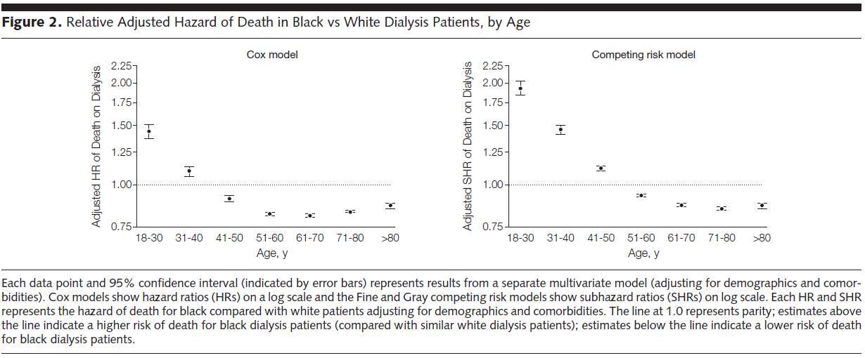

Is this an absolute or relative measure or are both provided?

Both are provided in the table:
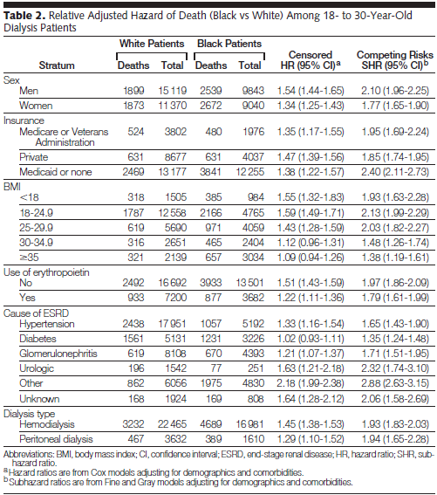

Describe which type of measure you would prefer for this research area, or, if both, why.
I understand the utility in ratio measurements, but the raw numbers help provide perspective. For an individual experiencing ESRD and death, these events are happening regardless of how many other people are sharing or at risk for encountering the same circumstance. On the other hand, human life is partially a gamble on experiencing disease or early death, so the number of people encountering premature death and disease should be balanced against everyone who was capable of sharing a similar fate. Both measurements are important.
Part 3:
- Read someone else's response to part 1 above (identifying a construct) and comment, specifically noting whether you can see any additional implications of measurement quality for future research or whether you agree with those noted by your classmate.

Molly Altman
EPI 222 – Week 7
2/15/16
Part 1:
1.Choose a paper describing the development or validation of a measure of relevance in health disparities research (please give the full citation and/or upload the paper if that's possible).

Heaman MI, Sword WA, Akhtar-Danesh N, et al. Quality of prenatal care questionnaire: instrument development and testing. BMC Pregnancy Childbirth. 2014;14:188.

2.What was the definition of the construct?

Quality is defined as a judgment or evaluation of several dimensions specific to the service being delivered, whereas satisfaction is an affective or emotional response to a specific consumer experience

3.How did the authors provide evidence on the validity of the measure? Could you think of additional approaches to validating the measure?

This paper described the development and testing of a psychometric instrument measuring perceived quality of prenatal care. Construct validity and reliability testing was performed following development, comparing to perceived satisfaction. As this is the only instrument thus far measuring quality of prenatal care, comparison to patient satisfaction is likely one of the few ways to measure this construct.

4.How did the authors provide evidence on the reliability of the measure? Could you think of additional approaches to evaluating the reliability of the measure?

Reliability testing was performed overall and within content subgroups. It may be helpful to do more specific reliability testing within racial/ethnic subgroups or other sociodemographic groups in order to assure appropriateness for health disparities work.

5.Describe the implications of a lack of measurement validity or reliability for future research applications.

Until this article, there was no instrument to measure perceived quality of care during pregnancy/birth period. The lack of such an instrument significantly limited the ability to assess the impact of patient perception of quality and respect/disrespect during care, a potentially significant factor in poor outcomes and health disparities.

