*A) MULTIPLICATIVE INTERACTION BETWEEN A AND M*
program define myprog1
drop _all

set obs 1000
*GENERATING A, Y AND RANDOM ERROR U*
gen a=uniform()>0.5
gen m=uniform()>0.2
gen u=rnormal(0,5)

*SPECIFYING DISTRIBUTION OF Y CONDITIONAL ON A, M, U*
gen y= 3*a + 2*m + 2*(a*m) + u

*PATE – IGNORING INTERACTION*
regress y a m
end

*SIMULATION - 1000 reps*
simulate _b _se, reps(1000): myprog1
hist _b_a

list _b_a _se_a in 1/10

Histogram of PATE of A on Y controlling for M:

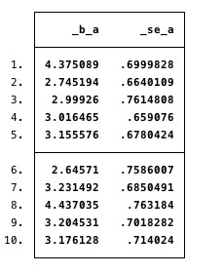

Histogram of interaction parameter under alternative hypothesis

*B) MULTIPLICATIVE INTERACTION - STRATIFIED BY M*
program define myprog2
drop _all
set obs 1000
gen id= _n

gen a=uniform()>0.5
gen m=uniform()>0.2
gen u=rnormal(0,5)
gen y= 3*a + 2*m + 2*(a*m) + u
regress y a if m==1
end

simulate _b _se, reps(1000): myprog2
hist _b_a
list _b_a _se_a in 1/10

Histogram of effect of A within strata M=1

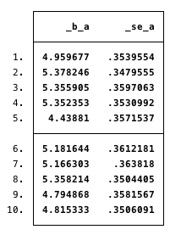

** M==0 **
program define myprog3
drop _all
set obs 1000
gen id= _n

gen a=uniform()>0.5
gen m=uniform()>0.2
gen u=rnormal(0,5)
gen y= 3*a + 2*m + 2*(a*m) + u
regress y a if m==0
end

simulate _b _se, reps(1000): myprog3
hist _b_a
list _b_a _se_a in 1/10

Histogram of effect of A within strata M=0

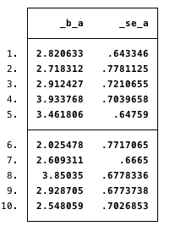

Under the NULL (no interaction between A and M)

program define myprog4
drop _all
set obs 1000

gen a=uniform()>0.5
gen m=uniform()>0.2
gen u=rnormal(0,5)
gen y= 3*a + 2*m + u
regress y a m
end

simulate _b _se, reps(1000): myprog4
hist _b_1.a#1.m
list _b_1.a#1.m_se_1.a#1.m in 1/10

Histogram of interaction parameter under the null

