If you have trouble reading in the breast cancer data into Modeler and it looks like the following:

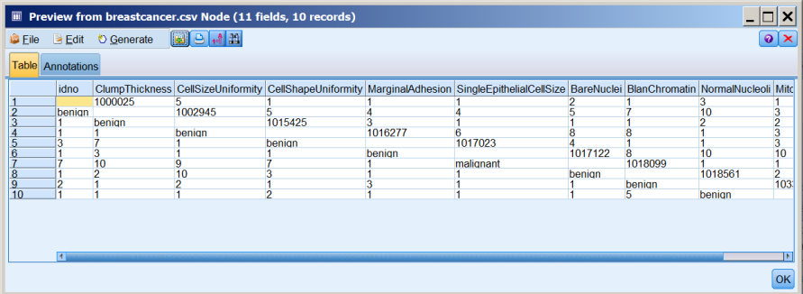

Try checking the box “Allow multiple blank delimiters” (see below) and that may solve the problem:

