Please identify a quantitative research article evaluating mediation in your field and provide the citation.

“The impact of human development on individual health: a causal mediation analysis examining pathways through education and body mass index” by A.Wang and O.A.Arah

What is the primary discipline of the authors?

The authors are both professors at UCLA in the department of epidemiology and Health Policy research.

Draw a DAG representing the implicit or explicit causal model explored in this paper (you do not need to post your DAG, but we will try to discuss in class).

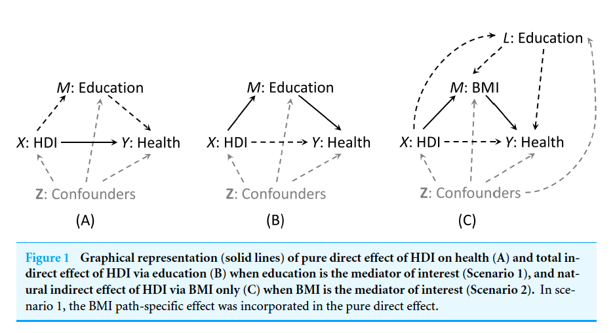

What is the exposure of interest?

Human development Index (HDI), at the country level.

What is the outcome of interest?

Health, summarized by a factor extracted from the answers to 16 questions in 8 health domains. The factor is at the country level while questions were at the individual level.

What is the hypothesized mediator of interest and how is it measured?

Two mediators were considered – Education and BMI. Individual education was measured by the years of schooling and averaged at the country level. Individual BMI was calculated and averaged at the country level.

Describe the modeling approach and briefly report the estimated total, direct, and indirect effects (if these are reported).

The authors simply used regression to calculate the estimated total, direct and indirect effects (subdivided per gender):

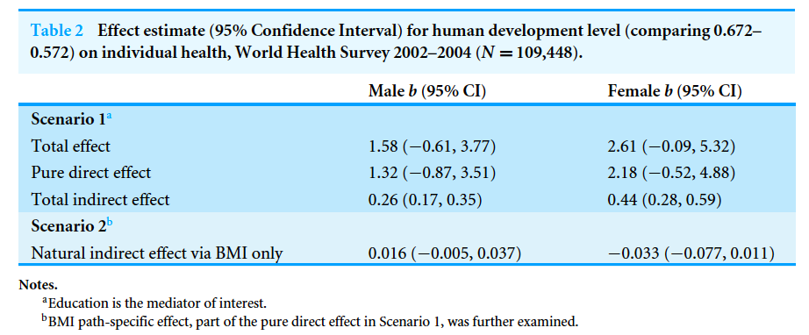

If the direct effect is reported, would you describe this as a natural direct effect, a controlled direct effect, or something else?

I think the authors reported the controlled direct effect.

Do you think there is potential measurement error in the mediator and how would that affect the results?

The exposure, HDI is determined at the country level and, although probably over-simplifying the construct it is trying to measure leaves little room to measurement error. The mediator on the other hand is obtained by self-reported years of education and measurement error could be substantial. If that is the case, the indirect effect via the mediator might be underestimated a little be.

Do you think there are unmeasured confounders of the mediator-outcome association and how would that affect the results of the mediation analysis?

Certainly but even more concerning, the authors considered, in their analysis of mediation via BMI, education as a confounder of the mediator-outcome relationship, while also being a potential mediator of the exposure-outcome relation. That DAG prevents the estimation of the direct effect with simple regression and requires more advanced estimation methods such as marginal structural equations by the use of probability weights.

