(I am considering whether I need to do a mediation analysis of cross-sectional data I have on informal cash payments in Hungarian maternity care. My mediation analysis involves a binary exposure, outcome, and mediator. So, I made up a continuous exposure and outcome for this exercise).

Background: Our prior work confirmed other (limited) survey data that 60% of all Hungarian maternity care users will pay an informal cash payment to their obstetrician. Informal cash payments are widespread in post-communist health care, occur outside official channels, and potentially distort care. During prenatal care in Hungary if a woman desires to know the obstetrician who will be at her birth, she will form a tacit contract with a prenatal obstetrician who agrees to attend the birth. In return, the woman will pay a “tip” for this “extra service.”

Previously, we demonstrated that this “tip”, contrary to an expression of gratitude, functions instead as a fee-for-service. In many other specialities fee-for-service models have been shown to incentivize extra care from prescriptions to procedures. In our population of women who selected a “chosen” prenatal obstetrician when compared to women who did not choose a prenatal doctor, we noted a higher caesarean section prevalence (45% vs 33 %) , inductions of labor 32% vs. 19%), episiotomy (75% vs. 62%) and epidural (15% vs. 5%). Furthermore, we found that the probability of paying informally was mostly predicted by the obstetrician’s attendance at birth. Thus, obstetricians who attend births in order to get paid informally may experience pressure to shorten the duration of pregnancy by scheduling caesareans. Shorter duration of pregnancy could lead to lower newborn birth weight, an outcome typically associated with lower income women (higher income women tend to tip their obstetricians)

Exposure: Average monthly income during pregnancy

Outcome: Birth weight

Mediator: Chosen doctor present at delivery

Potential effects:
Income: 300 Euros/month (std 100)
Birth weight: 3000g (std 500g)
Effect if doctor present at delivery: -300g/100 Euros (this happens 80% of the time)
Effect if doctor not present: -50g/100 Euros

Stata code:
set seed 5734
set obs 1000

**expsoure variable
gen income=rnormal(300, 100)

**outcome variable
gen birthwt = rnormal(3000, 500)

*mediating variable
gen drpresent = runiformint(0,1)
replace drpresent = 0 in 201/1000
replace birthwt=rnormal(2700,100) if drpresent==1
replace birthwt=rnormal(2950,100) if drpresent==0

*regress with random sample 100
sample 100, count
regress birthwt income drpresent

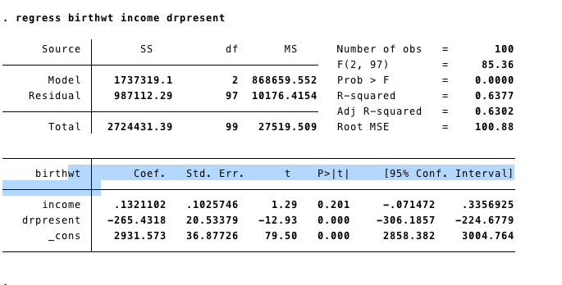

In a random sample of 100, having the doctor present did decrease the birth weight by 265g on average, which was statistically significant (95%CI -306 to -224).

bootstrap, reps(1000) size(100): regress birthwt income drpresent
(running regress on estimation sample)

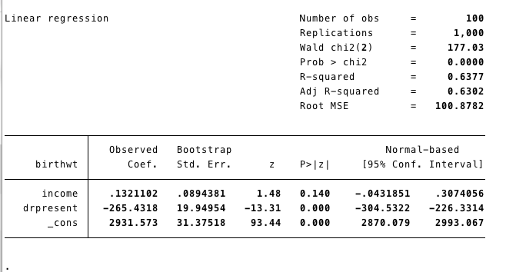

In a bootstrapped sample after 1000 runs, having the doctor present did decrease the birth weight by 265g on average (same as the random sample), but the confidence interval was slightly more narrow (95%CI -304 to -226).

replace birthwt=rnormal(2950,100)
(100 real changes made)
bootstrap, reps(1000) size(100): regress birthwt income drpresent
(running regress on estimation sample)
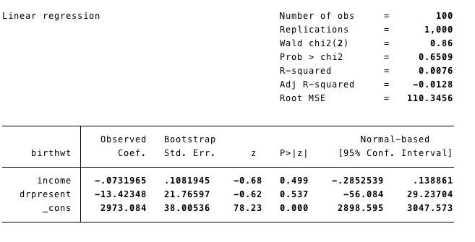

After setting the causal effect to the null, all the effect of drpresent became non-significant.

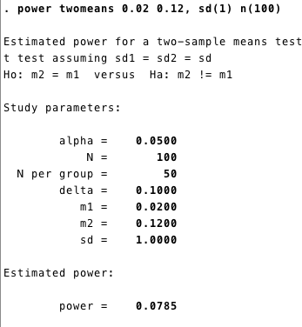

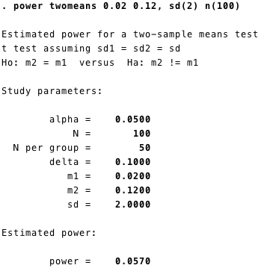

I got an error message for running the last power test.

