Nick Rubashkin
Epi265
Week 8 response
5/23/17

Modify your data generation code from last week to match the following causal DAG:
S1
Y
X

S2
U

Where S1 and S2 are indicators for whether an observation is selected into the analysis (ie, when S1=0 or S2=0, the observations are excluded).

Write out data generating rules to match this causal DAG for at least 2 values S1 (e.g., S1 = 1 for 90% of observations vs S1=1 for 50% of observations) and 2 values for S2. Please be sure that your data generating model entails that U influences X, Y, and S2.

For each, write a simulation model generating data with N=500 individuals following these data generating rules. Report the structural causal model for each variable in the DAG, including the distributions of the error terms. Use the statistical method of your choice to estimate the effect of X on Y in each scenario, assuming that U is unmeasured (ie, your estimate will likely be biased because you cannot account for U).

**EpiHmwk8
clear
set seed 5734
set obs 1000
** x = monthly income in Euros
** y = birth weight in grams
**exposure variable
gen income=rnormal(300, 100)
**unmeasured confounder U
gen U=rnormal(20,2)
**error term
gen error=rnormal()
**selection based on U the unmeasured confounder
replace income=0 if U>22 //137 real changes made
**structural equation
gen birthwt=3000 + 1.5*income + 1.5*U + error
**S1 variable is predicted by x and y
gen S1=3*income + 2*birthwt
**S2 variable is predicted by U
gen S2=2*U

**Generate indicator variable for different prevalences of S1 and S2
gen S1ind1=0
replace S1ind1=1 if S1>7000 //794 real changes made
gen S1ind2=0
replace S1ind2=1 if S1>7500 //634 real changes made
gen S2ind1=0
replace S2ind1=1 if S2>35 //888 real changes made
gen S2ind2=0replace
S2ind2=1 if S2>38 //683 real changes made
*regress based on different prevalances of S1 and S2
Prevalence of S1 | Prevalence of S2 | Coefficient | 95%CI
Not sure—is this the # of real changes over the sample size? (794/1000)? |  | 1.500419 | 1.499359 -- 1.501479
888/1000? |  | 1.500281 | 1.499008 -- 1.501553
 | 888/1000? | 1.500228 | 1.49941 -- 1.501045
 | 683/1000? | 1.500353 | 1.499523 -- 1.501182

bootstrap, reps (1000) size(500): regress birthwt income U if S1ind2==1
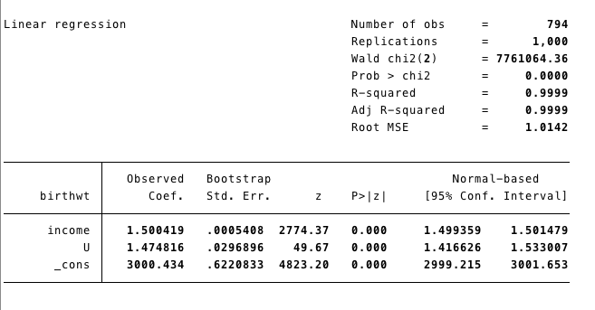

bootstrap, reps (1000) size(500): regress birthwt income U if S2ind1==1
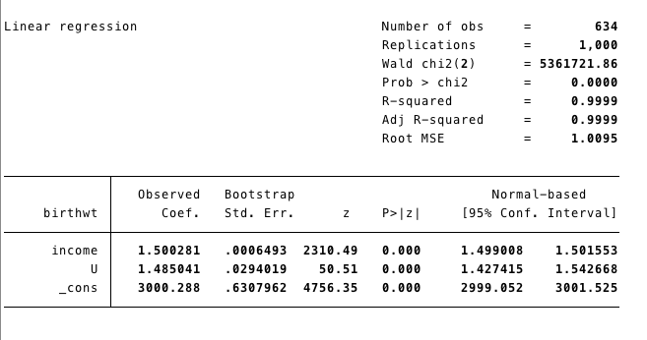

bootstrap, reps (1000) size(500): regress birthwt income U if S2ind2==1
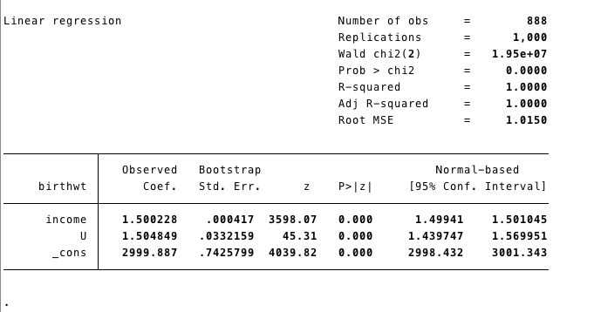

bootstrap, reps (1000) size(500): regress birthwt income U if S2ind2==1
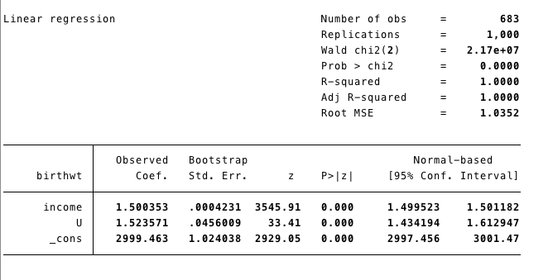
Now assume the null, that X has no effect on Y. Under each of your four scenarios above, what is:
- The average estimate of the effect of X on Y (ie, if you repeat your chosen statistical analysis across repeated iterations, what is the average value of the parameter estimate for the association between X and Y)?

gen birthwt=3000 + 0*income + 1.5*U + error
Prevalence of S1 | Prevalence of S2 | Coefficient | 95%CI
Not sure—is this the # of real changes over the sample size? (794/1000)? |  | .0004187 | -.0006376 -- .001475
888/1000? |  | .0002807 | -.001013 -- .0015743
 | 888/1000? | .0002276 | -.0005671 -- .0010223
 | 683/1000? | .0003526 | -.0005008 -- .0012061

bootstrap, reps (1000) size(500): regress birthwt income U if S1ind1==1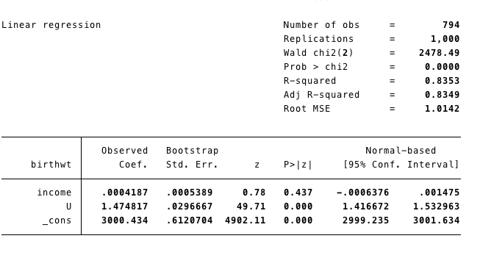

bootstrap, reps (1000) size(500): regress birthwt income U if S1ind2==1
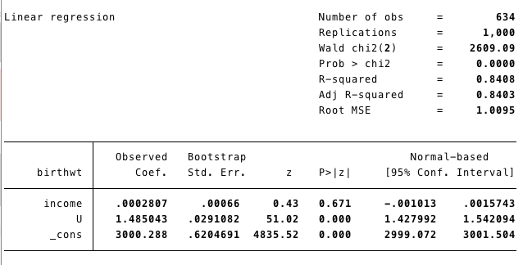
bootstrap, reps (1000) size(500): regress birthwt income U if S2ind1==1
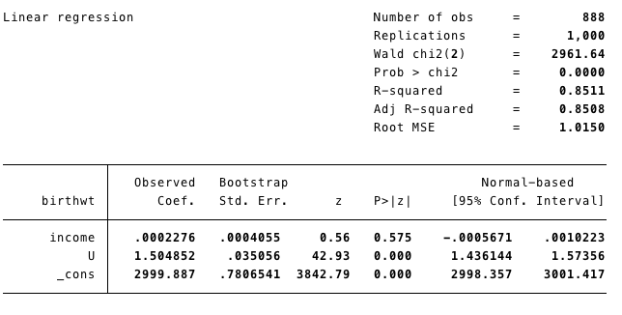

bootstrap, reps (1000) size(500): regress birthwt income U if S2ind2==1
