Biostat 212 Online Office Hours Session Tips and FAQs (v.7/19/2013)
Jen Cocohoba, Pharm.D.

We will provide a weekly online computer lab/office hours session via the web-based meeting software called GoToMeeting. This document provides some tips on logging in and getting the most out of these sessions.

Reminder: Logging in to Biostat 212 online office hours
You have already received a general TICR email on how to log on to GoToMeeting. You can enter via the Biostat 212 syllabus link, or via the email that you received to your Outlook. Or you can log on to the website (http://www.gotomeeting.com). On the GoToMeeting website upper right hand corner click on the “Join a meeting” button and enter the Biostat 212 Office Hours ID. You will find the Office Hours ID in the syllabus for each session. Make sure you accept (“yes” “grant” or “trust”) the download of any required GoToMeeting software. If you log in during a non-office hours time, no one will be available.

Enhancing your Biostat 212 online office hours experience
- Consider turning on your webcam: it can be nice to see others and have others see you.
- Consider testing your audio equipment prior to logging in. Using a USB headset can require a strong internet connection in order for the audio to be clear. If your audio is not working well, consider using your telephone to dial in to the meeting instead. You can find the phone number in the middle of the GoToMeeting panel.
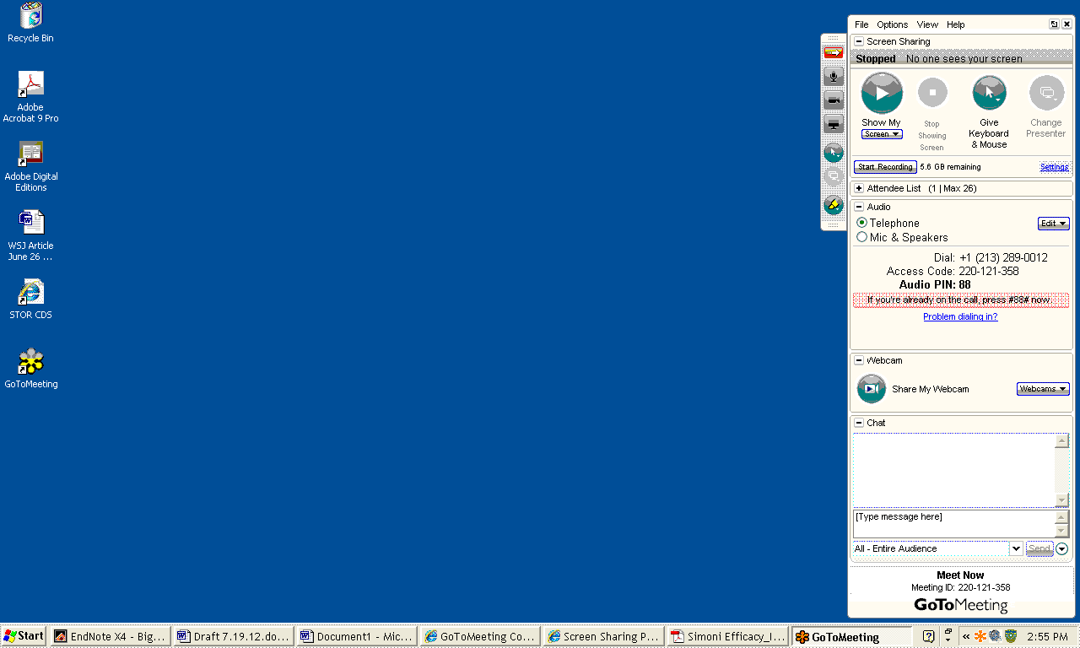
Phone number for dialing in to the meeting

- Ensure your place in the queue: You may virtually come and go from Online Office Hours. However, if multiple people are attending you may have to wait before your question is addressed, similar to the in-person lab sections. To ensure your place in line, please type a short message in the chat box, so that the moderator can keep track of who is next.

When multiple people attend office hours, type a message here so that the moderator knows that you have a question (and knows who to help first)

- Share your computer screen: When you are having trouble with a STATA command, it is very helpful for the TA/moderator to be able to view your computer to “diagnose” the trouble. GoToMeeting has a screen-sharing feature which allows you to do this.

- Step 1 – Jen Cocohoba will “change presenters” so that you have the option to share screen
- Step 2 – Close any windows you don’t want anyone else to see, then click on the green round button that says “Show my screen”
Click here to show your screen (NOTE: everyone attending office hours will be able to see)

- Step 3 – Jen Cocohoba may send you a request to “take control” of your computer screen. This is in case she needs to type in commands into your STATA. Accept the request when it pops up on your screen by clicking “yes”
- Step 4 -- When your consult is complete, click the “change presenter” button to shift presentation mode back to Jen Cocohoba (she may do this)
Click here to change the presenter back to the moderator (Jen may do this for you)

- Listen in on other students’ questions: It can be helpful to listen in (and watch) the questions that other Biostat 212 students pose during office hours --- you may have similar questions or may learn a tip or trick that helps you with your current or future labs!

See you online!

