Dear Epi 204 Students,
Happy holidays! I know that I speak for the course faculty when I thank you for your interest and attention in Epi 204. We would appreciate your suggestions on how to improve the course, so please fill out the course evaluation if you haven’t already.
I posted the final exam key on the CLE. The class did very well on the final exam as shown on the histogram below.
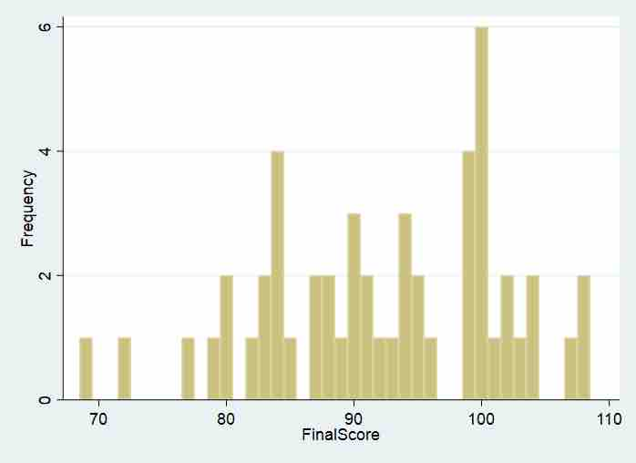
The overall course scores were also excellent. I dropped your lowest homework score and then assigned your course score as the higher of 0.6*HW + 0.4*Final and 0.5*HW + 0.5*Final.
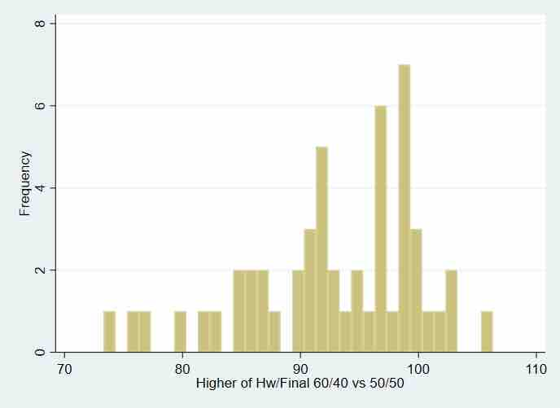
I assigned grades according to 90+ A, 80-<90 B, 70-<80 C.
Best, Michael

