Assignment 5_2018 Due date: Thursday, November 1st 10:30 a.m.

- A study conducted by Muhlhofer, et al at UCSF examined the duration of induced coma and seizure recurrence within the first 48 hours of sedation and final disposition of the patient. Here is information from a poster presentation of the data.
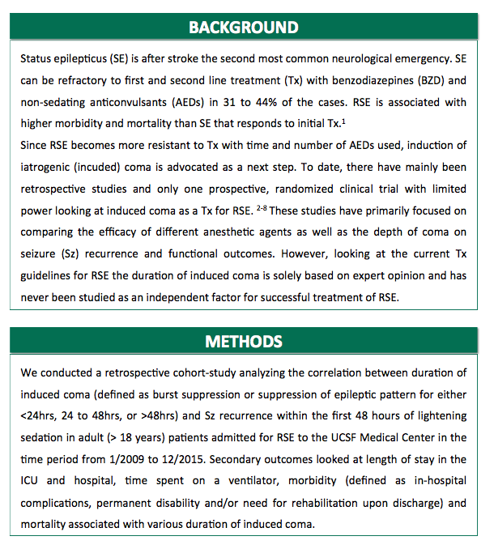
The data are called seizures.dta. A list of variables is given in SeizureVariables.xlsx.
- Test whether there are differences in seizure recurrence by age, weight, total complications, and age of onset. Use both parametric (t-test) and non-parametric (Wilcoxon rank sum) tests. Are there any differences between the groups? Between the tests?
- Calculate the proportion with burst suppression (vEEG_Sz). Calculate the confidence interval. Note that you can do this, and test if there is a difference between groups, with the prtest command. Is there a difference? Write a sentence or two describing the results.
- Create a new variable that is 0 if steady state time is less than 24 hours, 1 if steady state time is 24-48 hours and 2 if steady state time is greater than 48 hours. Note that you can generate a new variable and then replace it with 0, 1, or 2 using the three SS variables. Test whether there is a difference in hospital stay using one-way ANOVA using Scheffe or Bonferroni [oneway HospStay new_variable, scheffe or Bonferroni]. Is there a difference? Which group has the longest stay?
- Repeat question (c) using a non-parametric analysis. Are the results different?

- Read the Gonsal article ‘Significance Testing is Broken” and the JAMA article “Understanding the Role of p-Values”. Are both articles suggesting the same thing? What are two pitfalls of p-values that may have been committed in the seizure study you just analyzed? Be specific and refer to the two articles and the study.

