Ribka Amsalu. Homework 1. Jan 14. 2019
1. Write a paragraph describing the extent to which an socioecological framework incorporating issues related to social determinants has been applied to your area of research. Are there opportunities for improving our understanding of or approach to disparities in your area with a greater emphasis on a socioecological framework? Consider drawing a DAG or a socioecological model (like the one shown in class for obesity) to illustrate your point (you can take a picture to post on the forum).
I am conducting a systematic review and summarizing the evidence to determine whether epidemics and pandemics of infectious disease are associated with adverse pregnancy outcomes. The evidence I have gathered so far from literature search is predominantly on the biological susceptibility of pregnant women to infectious disease due to the physiological changes that occur in pregnancy and adverse pregnancy outcomes. There are few studies that have explored the influence of maternal education (that could potentially influence health care seeking and disease prevention behavior) or gender (the socially defined role of women as caretakers to those who are sick) or the differential risk women have to infectious disease exposure and its consequences.
This is work in progress but here is a socioecological framework that incorporates

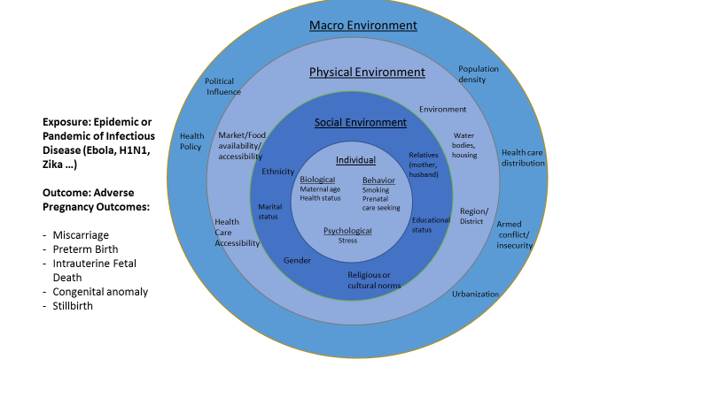
2. In the WHO reading, the authors describe structural stratifiers (e.g. income, education, etc) and intermediary determinants such as material and psychosocial circumstances. Pick 3 of these factors (at least one structural and one intermediary). Explain why you chose the factors (might use Braveman article to provide justification) and describe how each could be an important determinant of a health outcome of your choosing. The association could be reported in published research or it could be your hypothesized relationship. Consider whether how these factors might function over the lifecourse and/or intergenerationally..
Structural: Education & Gender
Education. I selected maternal education, as it is relatively easy to measure (as categorical or continuous variable) and is relevant for the specific exposure and health outcome. Education level could potentially influence behavior that could decrease disease exposure such as hygienic practices and also influence behaviors that are associated with outcome like timely health care seeking and adhering to treatment. Past studies have shown association of parental educational with prenatal outcomes.
Intergenerational: the role of education in intergenerational social mobility and influence of parental education on children has been documented in earlier studies.
Gender: the societal role of women as care-takers places them at increased vulnerability and potential differential exposure to infectious disease.
Intergenerational. Gender norms are formed at early age and are influenced by the cultural norms of a given society that is passed on from generation to generation.
Intermediary
Biological factors: the physiologic change in pregnancy increases susceptibility to infectious diseases. Adverse pregnancy outcomes of stillbirth, preterm birth, miscarriage have been reported in observational studies of Dengue and other infectious diseases.

Shapiro, G. D., Bushnik, T., Sheppard, A. J., Kramer, M. S., Kaufman, J. S., & Yang, S. (2017). Paternal education and adverse birth outcomes in Canada. J Epidemiol Community Health, 71(1), 67-72. doi:10.1136/jech-2015-206894
Nkangu, M. N., Olatunde, O. A., & Yaya, S. (2017). The perspective of gender on the Ebola virus using a risk management and population health framework: a scoping review. Infect Dis Poverty, 6(1), 135. doi:10.1186/s40249-017-0346-7
Sappenfield, E., Jamieson, D. J., & Kourtis, A. P. (2013). Pregnancy and susceptibility to infectious diseases. Infect Dis Obstet Gynecol, 2013, 752852. doi:10.1155/2013/752852
Xiong, Y. Q., Mo, Y., Shi, T. L., Zhu, L., & Chen, Q. (2017). Dengue virus infection during pregnancy increased the risk of adverse fetal outcomes? An updated meta-analysis. J Clin Virol, 94, 42-49. doi:10.1016/j.jcv.2017.07.008

