Epidemiology 222 Health Disparities Assignment 1 -Week 2
Curt Johanson (added course 2/2/2019)
- Write a paragraph describing the extent to which an socioecological framework incorporating issues related to social determinants has been applied to your area of research. Are there opportunities for improving our understanding of or approach to disparities in your area with a greater emphasis on a socioecological framework? Consider drawing a DAG or a socioecological model (like the one shown in class for obesity) to illustrate your point (you can take a picture to post on the forum).

This is a complex socio ecological framework that reflects most but not all of the complex confounding and mediating variables at multiple levels that effect the use of PrEP to reduce HIV infection rates for high risk groups. In this specific case, I am modeling the factors that would be significant for a 19 year old black gay or bisexual male with insurance and access to care issues. This DAG displays the social ecological framework for the 4 domains that are targets for intervention – Individual, community, health care system, and policy level (CDC/WHO etc.) The diagram pretty much speaks for itself. I will upload it in a separate file as well for easier viewing.

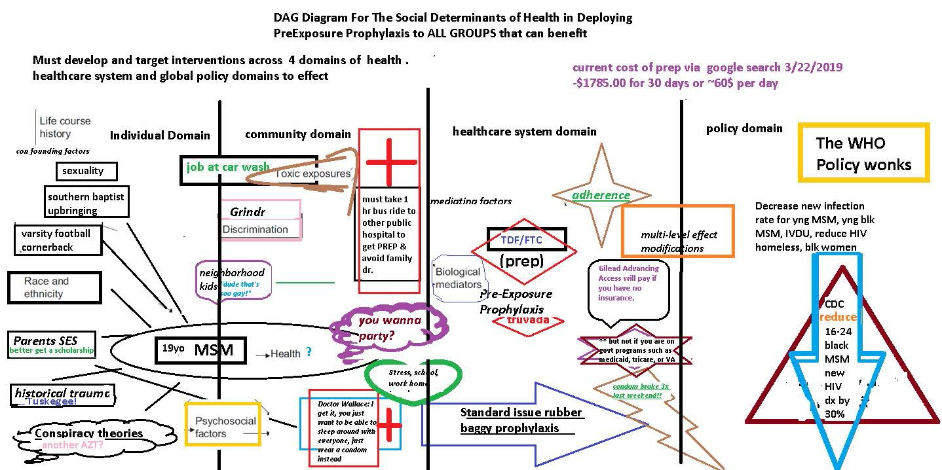

- In the WHO reading, the authors describe structural stratifiers (e.g. income, education, etc) and intermediary determinants such as material and psychosocial circumstances. Pick 3 of these factors (at least one structural and one intermediary). Explain why you chose the factors (might use Braveman article to provide justification) and describe how each could be an important determinant of a health outcome of your choosing. The association could be reported in published research or it could be your hypothesized relationship. Consider whether how these factors might function over the lifecourse and/or intergenerationally..

I will use parental educational level and parental religion as confounding variables as stratifiers. Early Sexual promiscuity <16 years old will be as an intermediary determinant behavior effected by the background characteristics of being raised southern Baptist and having parents from lower educational level. My predicted association is that could significantly enhance someone’s promiscuity in teen years through repression and rebellion acting against religious teachings and not having parents who are as informed and educated. All of these things together could lead to increased chance of HIV diagnosis through avoidant behaviors of not wanting to talk about sexual health issues with family doctors, get tested frequently, etc.

