The Future Of Clinical Trials: How AI & Big Tech Could Make Drug Development

Cheaper, Faster, & More Effective
Testing new drugs is a slow, expensive, and manual process. Artificial intelligence has the potential to disrupt every stage of the clinical trials process — from matching eligible patients to studies to monitoring adherence and data collection.

This year, over 1.7 million people in the United States will be diagnosed with cancer for the first time. At the same time, more than 10,000 clinical trials will look to recruit thousands of new patients for potentially life-saving experimental cancer drugs. And yet, less than 5% of cancer patients end up enrolling in trials.

AI IN HEALTHCARE: THE FUTURE OF THE CLINICAL TRIAL
Join us for a live briefing. We’ll deep dive into the clinical trial process and discuss how AI has the potential to shake up the healthcare industry.

It’s not hard to guess why. For terminal illnesses like cancer, patients may only enroll in a drug trial when existing forms of treatments have already failed. On top of that, not all patients diagnosed with untreatable cancer are eligible to participate — even finding out if they are eligible is a herculean task for many.
For those that are eligible, participating in a trial is cost- and time-intensive, while rudimentary data collection methods compound the problem.
The process is inefficient for other stakeholders too: drug trials average nearly a decade, costing up to billions of dollars. Many trials fail due to enrollment issues.
The $65B clinical trials market needs a makeover.
Artificial intelligence is touted as the magic bullet for everything, and the technology could have huge potential for streamlining the clunky clinical trial process, from IoT for remote monitoring, to machine learning for EHR processing, to AI-based cybersecurity for data protection.
Using CB Insights data and firsthand experience working at a clinical research site, we analyzed the promises and limitations of AI in clinical trials. Below, we map out a patient’s journey through a typical clinical trial process, and explore the potential of AI at each step.
Note: We specifically focus on drug-based trials, although technologies discussed in the final section of the report are applicable to a wider range of clinical studies.

AI IN HEALTHCARE
Healthcare AI startups have raised $3.6B since 2013. Check out companies involved in healthcare AI in the AI in Healthcare collection.

Why faster trials are critical for pharma companies
Bringing a drug to market is a long and arduous process. Although there is no central repository of drug R&D-related expenditures and timelines, studies estimate that the clinical trial process — where new drugs are tested on patients before the FDA approves them — averages 7.5 years, and costs anywhere between $161M — $2B per drug. Clinical trials are conducted in multiple phases, with Phase III trials requiring a larger pool of patients and being significantly more expensive and complex than Phase I trials. Despite the time and capital invested in trials, only 1 in 10 drugs that enter Phase I of a clinical trial will be approved by the FDA.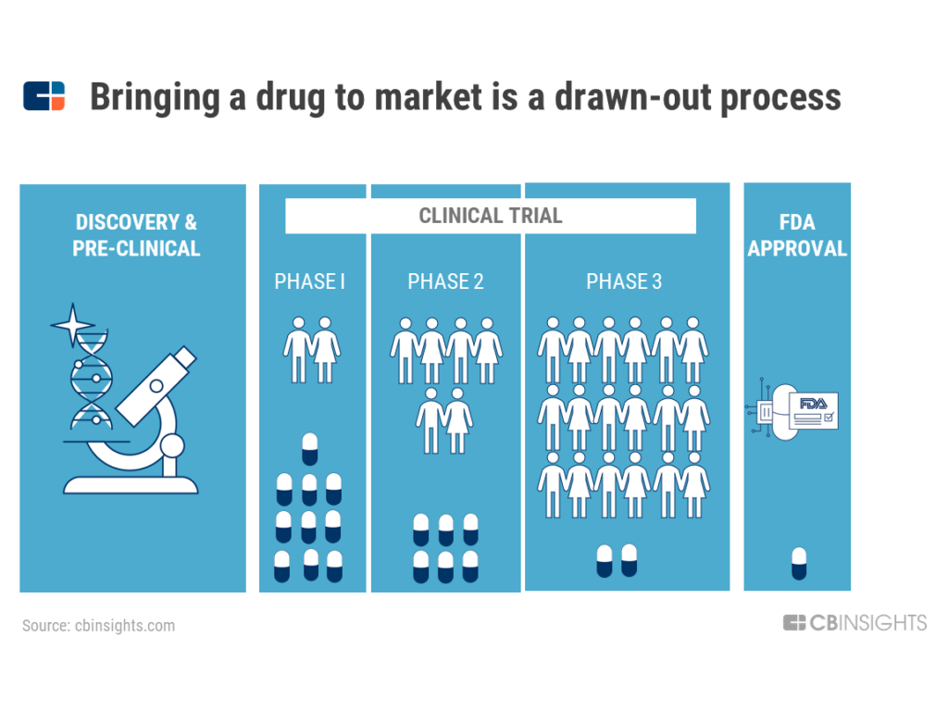
Clinical trials fail for a variety of reasons, including failure to recruit enough participants, mid-trail patient drop out, unintended & severe side effects, and poor data collection methods.
Naturally, trials that fail at a later stage prove more costly for both the company conducting the trial and the patients. Switzerland-based Novartis, for instance, attributed a 15% drop in its Q1’17 net income to a failed Phase III drug intended to treat heart failure. In the US, two months after pharmaceutical company Tenax Therapeutics’ main drug failed in a Phase III trial, the CEO resigned, and the company was reportedly considering a merger or sale.
The cost of failure is more pronounced for smaller bio-pharma and drug manufacturing startups entering the space. The risk of failure is absolute, especially when there is only one promising drug in the pipeline.
The high costs associated with drug R&D ultimately affect healthcare prices for doctors and consumers. R&D costs — not just of successful drugs, but also ones that failed during the research process — is an oft-cited reason for exorbitant drug prices.

The current state of clinical trials
The human cost of failed or inefficient trials is with the patient.
In the infographic below, we map out what a patient’s journey typically looks like today, after all forms of available treatments have failed to work.

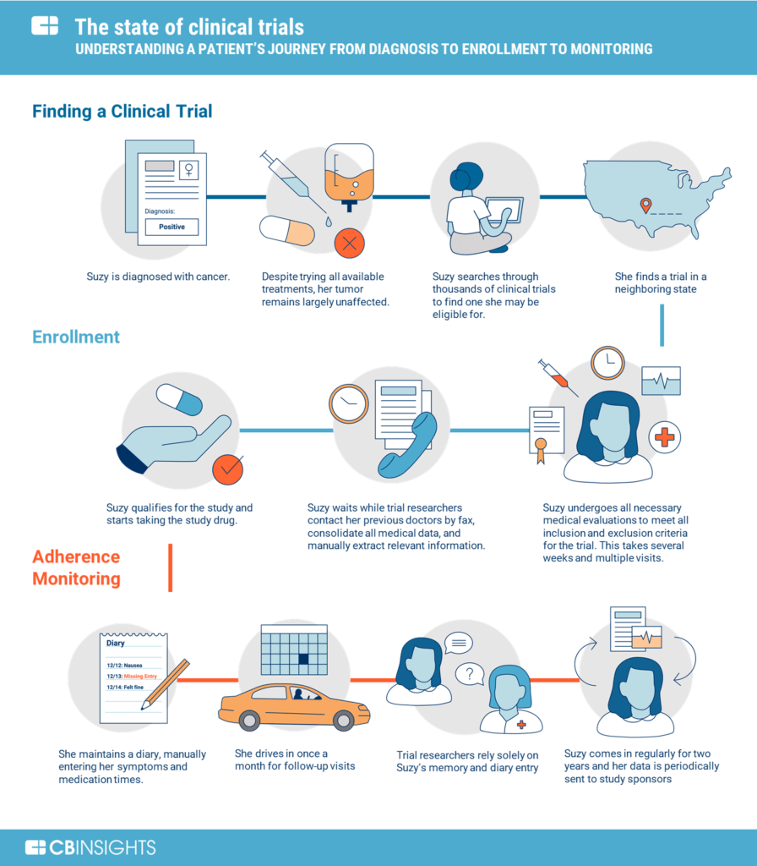
For most patients, finding a clinical trial is a trying process, with enrollment and participation bringing in new challenges. Many clinical studies still use rudimentary and outdated methods for data collection and verification: sending patient medical records via fax, manually counting leftover pills in bottles, and relying on patients’ diary entries to determine medication adherence. This process begs for disruption.

How AI could change every stage of clinical trials
Artificial intelligence technology has the potential to change every stage of the clinical trials process, from finding a trial to enrollment to medication adherence.

FINDING A CLINICAL TRIAL
Matching the right trial with the right patient is a time-consuming and challenging process for both the clinical study team and the patient.
“In fact, only 3 percent of cancer patients today are enrolled in clinical trials.” — WhiteHouse.gov, May 2018
Roughly 80% of clinical trials fail to meet enrollment timelines, and approximately one-third of Phase III clinical study terminations are due to enrollment difficulties, according to a Cognizant report on recruitment forecasts.
For context, there are over 18,000 clinical studies in the US that are currently recruiting patients, including around 1,000 studies for breast cancer alone.
Patients may occasionally get trial recommendations from their doctors, if a physician is aware of an ongoing trial. Otherwise, the onus of scouring through ClinicalTrials.Gov — a comprehensive federal database of past and ongoing clinical trials — falls on the patient.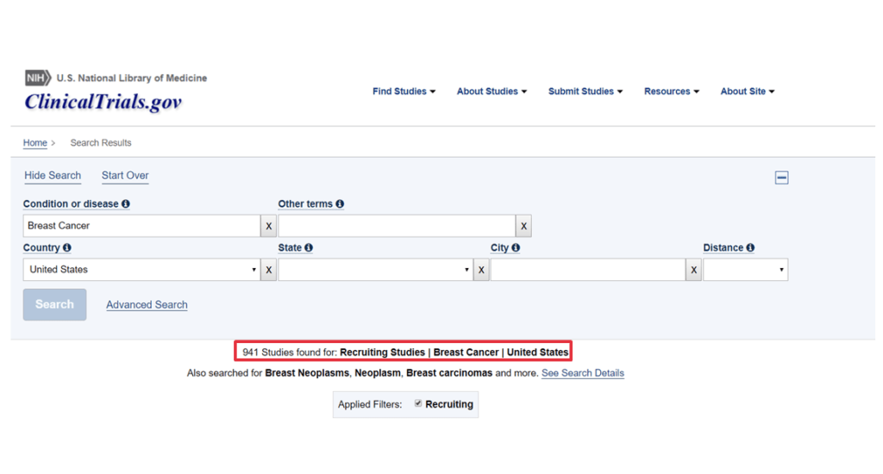
An ideal AI solution would be artificial intelligence software that extracts relevant information from a patient’s medical records, compares it with ongoing trials, and suggests matching studies.
In fact, extracting information from medical records — including EHRs and lab images — is one of the most sought-after applications of artificial intelligence in healthcare.
However, the technology will have to grapple with challenges like unstructured healthcare data and disparate data sources that don’t communicate with each other.

The EHR interoperability challenge
Despite the federal government spending more than $28B to digitize electronic health records (EHRs) in the last decade, there is no centralized repository or standard format for patient medical data. In fact, it’s hard for patients to access their own records from all the health institutions they’ve visited.
HIPAA, a law that protects patients’ medical data and privacy, does allow sharing of patient data with personally identifiable information like name and SSN numbers retracted, usually after a patient has signed a general consent form. This makes it possible for AI startups to analyze this medical dataset and suggest eligible patients within minutes, a process that would otherwise take months.
But the issue of interoperability — that is, the ability to share health information easily across institutions and software systems — still persists.
Different hospitals and providers treating the same patient may not use the same EHR software to enter data. In clinical trials, researchers still fax requests for specific patient records to different hospitals, who then fax or email the information, often as images (including images of handwritten notes or PDF files).
This poses a challenge for AI technology. As one study by researchers from MIT, Harvard, Johns Hopkins, and NYU highlights:
“Standard natural language processing tasks such as sentiment analysis and word sense disambiguation are difficult in clinical notes, which are misspelled, acronym-laden, and copy-paste heavy.”
Health AI company Flatiron Health explains this further in a patent filing: “Structured data can also become unstructured due to transmission methods. For example, a spreadsheet that is faxed or turned into a read-only document (such as PDF) loses much of its structure.”
This dated, manual system makes it difficult for clinical trial researchers to collect accurate data needed to determine a patient’s eligibility.
Last year, California-based startup Mendel.ai tried to solve the challenge of piecing together a patient’s medical history by allowing cancer patients to submit their medical records to its platform. Alternatively, patients could give Mendel permission to collect all medical records from doctors on their behalf.
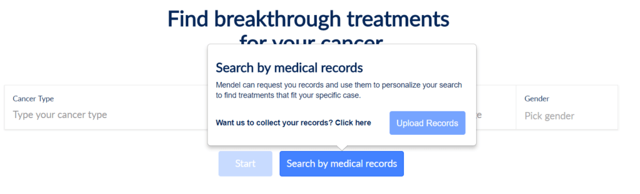
Mendel was developing machine learning algorithms to extract information from digital records and to match patients with ongoing trials that best suited their needs. The startup charged patients on a subscription basis, starting at $99 for the first 3 months to process all data from medical records.
But Mendel.ai has since gone quiet. The company has not announced any further expansion plans, nor raised additional funding rounds. Moreover, the information on its website and options to upload medical records are no longer available (the image to the right was as of 7/22/2018).
Other startups, like Antidote.me, are using machine learning to simplify the jargon in the “inclusion/exclusion” criteria listed in trials on ClinicalTrials.Gov.
On the B2B side, startups are now using deep learning and natural language processing to automate clinical trial matching by directly partnering with health institutions. For example, Deep 6 AI works with clients like Cedars-Sinai Medical Center and TD2, an oncology CRO. (CROs, or Contract Research Organizations, are contracted out by pharma or life sciences companies to conduct parts or all aspects of a clinical trial.)

Acquisitions as a strategy to get patient data
Flatiron Health has tackled the interoperability problem by acquiring an oncology-focused EMR company Altos Solutions in 2014. At the time, Flatiron was selling its cloud analytics platform to healthcare and life science companies, and Altos’ EMR was being used by oncology institutions like Florida Cancer Specialists. The deal gave Flatiron direct access to raw patient data, instead of relying solely on access to third party EMRs.
Today, over 2,500 clinicians use Flatiron’s OncoEMR, and over 2 million active patient records are reportedly available for research. In one of the largest M&A deals in artificial intelligence, Roche Holding acquired Flatiron for $1.9B in February 2018.
This, along with Roche’s other recent data moves like its acquisitions of Foundation Medicine and Viewics, underscores Roche’s interest in repositioning itself as a pharma company driven by machine learning with a strong focus on data.

CHALLENGES WITH ENROLLMENT
Enrollment procedures do not end when a patient chooses what looks like an appropriate clinical trial. Instead, the patient must visit a participating site to see if he or she will be eligible for the trial, usually after a preliminary phone screen with a study investigator from the clinical research team. Trials list inclusion and exclusion criteria that each patient must meet to be eligible for a study. These terms are often riddled with medical jargon, as can be seen in the below screenshot of eligibility criteria from a Phase II trial currently recruiting breast cancer patients. 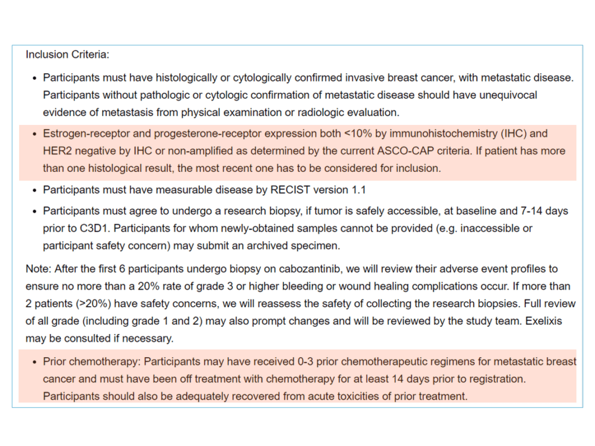
(According to ClinicalTrials.Gov, this study began in November 2017 and is expected to end in May 2025, highlighting the time and cost involved in each phase of the trial.)
In the above example, a patient must go through evaluations, like laboratory and imaging tests, to make sure she meets all the inclusion and exclusion criteria.
Depending on their availability and how far they live from a trial site, some patients may be able to complete these procedures in less than a week. But for others juggling jobs, parents, or long commutes, the process could take multiple visits.
As a part of confirming eligibility, site investigators collect patients’ medical records from other physicians’ offices. As previously mentioned, these faxed or e-mailed copies add an additional layer of complexity in using AI to extract information.
If eligible, the patient signs a consent form agreeing to the terms of the clinical trial. This includes awareness of potential side effects, willingness to provide biological samples that contain genetic information, and paying costs not included within the study budget.
Some solutions using AI to extract information from patient medical records can help simplify the enrollment process by automatically verifying some of the inclusion and exclusion criteria.
A more promising solution comes from the use of patient-generated data.
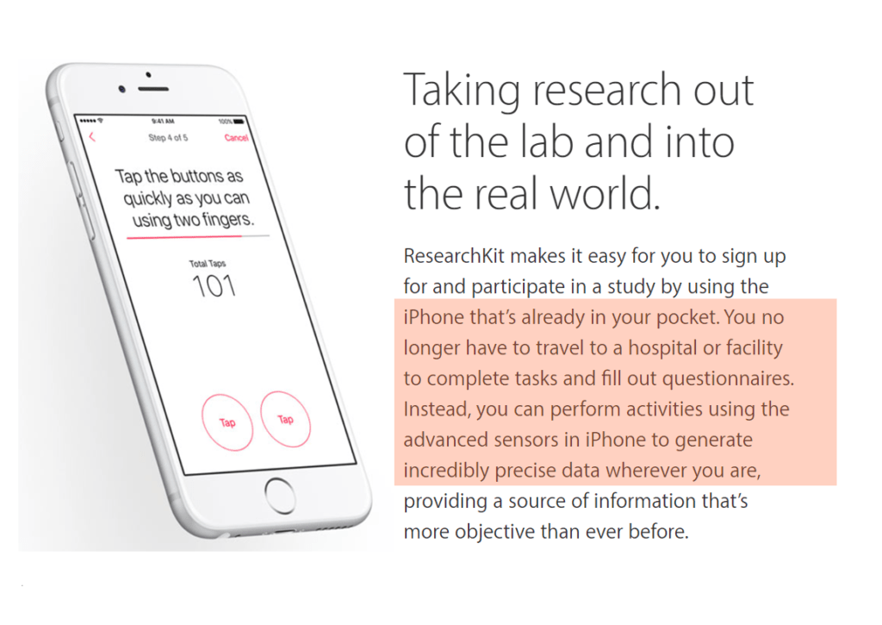
Because of the amount of data being generated in real time, AI is inseparable from patient-generated data.
One company exploring this application is Apple, which is gradually building a clinical study ecosystem around the iPhone and Apple Watch. By continuously monitoring patients in the comfort of their homes, the company can generate a treasure trove of previously unavailable health data. Apple is already partnering with health institutions and medical researchers to easily identify the right pool of patients for their study. (More on this below.)

MEDICATION ADHERENCE
Once a patient enrolls in a study, he or she receives the experimental study drug.
Patients go home with the first course of the medication (for example, a 30-day pill bottle with instructions on dosage) and a patient diary to fill out daily. Many clinical studies still use paper diaries instead of an electronic system.
Patients are expected to note when they took the study drug, what other medications were taken on those days, and any adverse reactions (including headache, stomach ache, muscle aches).
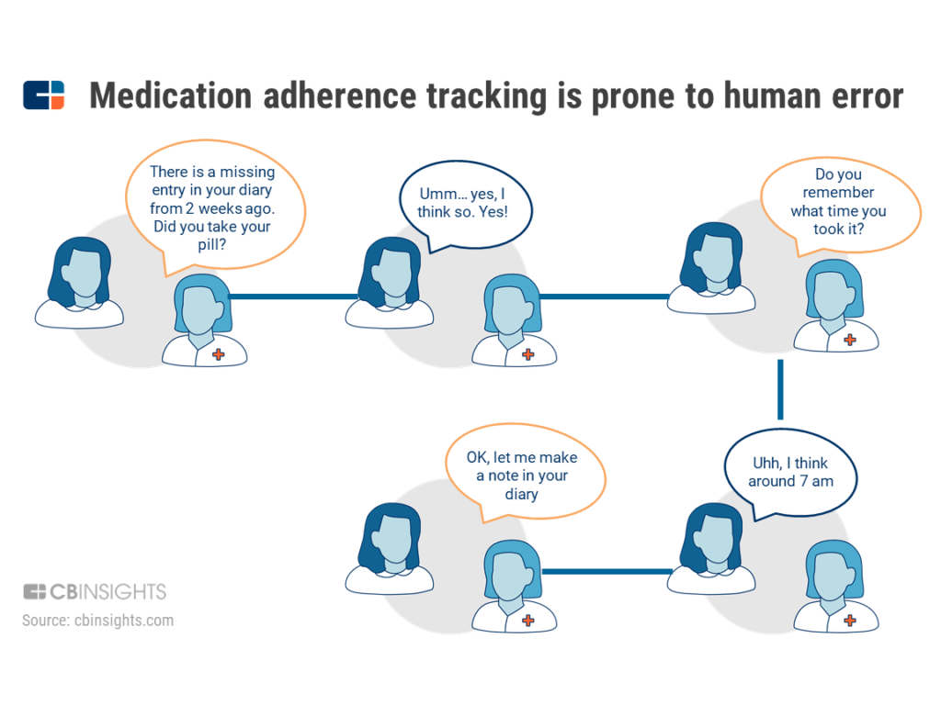
Relying on unverifiable sources (like patients’ memories and paper journals) is plagued with inefficiencies:
Reliance on patient memory: When a patient comes in for regular check-ups, the study investigator checks their pill bottle to make sure there are no pills left and reviews the patient’s diaries for any blanks or inconsistencies. If there is missing information in the diary entries, the investigator relies on the patient’s memory of events. This makes the process prone to human error.
Outdated recording system: Paper documents that could get lost or miss information is an outdated and unreliable way to record key data points for a trial.
Risk of drop out: Frequent travel to a clinical study site for regular check-ins is a strain on patients’ time and money, especially for patients traveling out-of-state (given airfare, hotel accommodations, time taken off work, etc.). This heightens the risk of drop out.
Additional payments: Although out-of-pocket costs are included in the consent document that the patient signs, many patients do not understand that there may be extra fees. For instance, additional MRI and lab tests during follow-up visits may not be included in the trial — and health insurers may not cover such tests, since they’re for “research” purposes and not out of “medical necessity.”

How AI can help medication and protocol adherence
Non-adherence — when a patient takes a medication other than the way they are told to — can have adverse effects on a patient’s health, incur costs if a study has to recruit new patients, and interfere with the accuracy of study outcomes. Clinical study sponsors are desperate to change this, and investing in technology to do so.
In addition to using mobile tech to send patients reminders to take their medication, pharmaceutical companies Pfizer and Novartis have been investing in IoT and “ingestible sensors” to track drug intake. In Q1’17, Merck Ventures participated in a $14.5M Series B to Medisafe, which develops wireless pill bottles.
AI startups are going one step further by providing visual confirmation.
New York-based mobile SaaS platform AiCure uses image and facial recognition algorithms to track adherence. Patients use their phones to take a video of themselves swallowing a pill, and AiCure confirms that the right person took the right pill.
After a series of grants from the National Institute of Health and the National Institute of Drug Abuse, among others, AiCure went on to raise over $27M in equity funding.
Another startup in this category, Khosla Ventures-backed Catalia Health, is developing a healthcare companion and coach using AI. Catalia hopes to enforce behavioral changes in patients by asking specific questions, setting reminders, and tailoring conversations to each patient. One of the company’s goals is understanding why patients may have missed a dose. Catalia’s robot-like assistant is essentially a tablet with a touchscreen, but the startup is reportedly working on voice activation as well.
Notably, an AI assistant’s ability to successfully enforce lifestyle changes largely depends on patients’ willingness to interact with it on a daily basis — something that could be monitored using AI-IoT technology.

AI-IoT offers continuous daily feedback
One emerging trend is fusing biosensors with AI. To do so, some startups are developing their own monitoring devices and sensors, then adding a layer of machine learning to interpret the data. Others are only developing the AI software, and integrating with third-party at-home monitoring devices.
Israel-based ContinUse Biometrics is developing its own sensing technology. The startup monitors 20+ bio-parameters — including heart rate, glucose levels, and blood pressure, which are some of the standard biometrics measured during drug trials — and uses AI to spot abnormal behavior. It raised a $20M Series B in Q1’18. Biofourmis is developing an AI analytics engine that pulls data from FDA-approved home monitoring devices and predicts health outcomes for patients.
AI-IoT in clinical trials holds the potential for real-time, continuous monitoring of physiological and behavioral changes in patients, potentially reducing the cost, frequency, and difficulty of on-site check-ups.

How Apple is disrupting clinical trials
The biggest barriers to entry for smaller startups streamlining clinical trials are that the technologies are relatively new and the industry is slow to adapt.
Tech giants like Apple, however, have seen success in bringing on partners for their healthcare-focused initiatives. Apple is already addressing some of the bottlenecks in information flow in healthcare, allowing researchers to build AI applications using its APIs. In particular, Apple is building a clinical research ecosystem around two of its devices: the iPhone and the Apple Watch. Data is at the core of AI applications. Through these products, Apple can provide medical researchers with two streams of patient health data that were not easily accessible until now.

APPLE’S ALTERNATE STREAM OF BIG DATA
Since 2015, Apple has launched two open source frameworks — ResearchKit and CareKit — to help clinical trials recruit patients and monitor their health remotely. 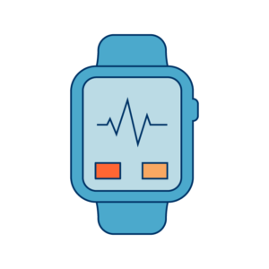
The frameworks allow researchers and developers to create medical apps to monitor people’s daily lives.
For example, researchers at Duke University developed an Autism & Beyond app that uses the iPhone’s front camera and facial recognition algorithms to screen children for autism.
Similarly, nearly 10,000 people used the mPower app, which uses exercises like finger tapping and gait analysis to study patients with Parkinson’s disease who have consented to share their data with the broader research community. Other variations of the app — like the HopkinsPD for Android users — use machine learning to process this data collected from smartphones to create a severity score for patients.

DISRUPTING EHR SHARING
In January of this year, Apple announced that iPhone users will now have access to all their electronic health records from participating institutions on their iPhone’s Health app.
Called the “Health Records” API, the feature is an extension of what AI healthcare startup Gliimpse was working on before it was acquired by Apple in 2016.
Gliimpse’s “core technology turns medical documents into data, easily allowing search and filtering graphs and dashboards that matter most,” according to information on its now-shut-down website. This aligns with Apple’s development of its Health Records feature — an easy-to-use interface for users to find all the information they need on allergies, conditions, immunizations, lab results, medications, procedures, and vitals.
Apple is also working with popular EHR vendors like Cerner and Epic to solve problems of interoperability. One potential end goal of these partnerships could be a two-way data flow, where EHR vendors are incentivized to integrate patient-generated data into Apple software.
“More than 500 doctors and medical researchers have used Apple’s ResearchKit and CareKit software tools for clinical studies involving 3 million participants on conditions ranging from autism and Parkinson’s disease to post-surgical at-home rehabilitation and physical therapy.” — Apple
In June, Apple rolled out a Health Records API for developers. Users can choose to share their data with third-party applications and medical researchers opening up new possibilities for disease management and lifestyle monitoring.

WHAT DOES THIS DATA MEAN FOR CLINICAL STUDIES?
Apple is now at the center of a new healthcare data ecosystem, offering daily data previously unavailable while also gathering difficult-to-consolidate EHR information.
The possibilities are seemingly endless when it comes to using AI and machine learning for early diagnosis, driving decisions in drug design, enrolling the right pool of patients for studies, and remotely monitoring patients’ progress throughout the study.
One potential competitor for Apple in this space is Google. Google’s Project Baseline, which aims to enroll 10,000 patients and monitor their daily lives over the course of 5 years, could ultimately benefit clinical trials.
Many trials have an experimental group (patients who get the study drug) and a control group (patients who get a placebo drug). The point of a control group is to establish a baseline to compare to the experimental group’s symptoms. Often patients are unaware of which drug they are taking.
Patient-generated data — like the data Project Baseline is gathering — could eliminate the need for a control group, providing the data required from the control and ultimately reducing recruitment bottlenecks. However, the project is still in its early stages, and these benefits may not be seen for several years.

Why AI alone isn’t the magic bullet
The healthcare industry leads in AI adoption, experimenting with applications ranging from machine-assisted diagnostics to extracting information from electronic health records.
In particular, using AI software to design new drugs has gained momentum, with pharma giant Merck partnering with startup Atomwise and GlaxoSmithKline partnering with Insilico Medicine, among others.
But AI adoption in the actual clinical trial process is still in its early stages.
Compared to other areas of healthcare, fewer startups are directly targeting clients in the clinical trials space. And in many aspects of clinical trials, there’s a need for digitization that precedes the need for AI.
As discussed above, many trials still rely on paper diaries for data. These diaries are stored digitally, often in difficult-to-search formats, while handwritten clinical notes pose unique challenges for natural language processing algorithms to extract information.
One of the biggest hurdles in clinical trials will be overcoming inertia to overhaul current processes that no longer work.
Another challenge will be understanding precisely where AI can help and what its current limitations are. Researchers will have to center the conversation around achievable short-term goals, rather than a hyperbolic future state where AI makes all problems disappear.
For now, generating new sources of data and putting data in the hands of patients — as Apple is doing — is proving to be revolutionary for clinical studies, as are new AI applications like generating a severity score for Parkinson’s patients.
Ultimately, the goal of artificial intelligence applications in clinical trials will be to close the gap between what patients have access to right now and what they need in the long-term to live healthier, more informed lives.

