I had a little trouble getting the exact instructions to work in STATA so I modified another dataset from a BIOSTAT215 also used for mediation analysis.
This data was used to assess the effects of a medication on bone mineral density in vertebral fractures.
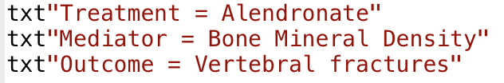
Some minor variable adjustments and creation of my mediator
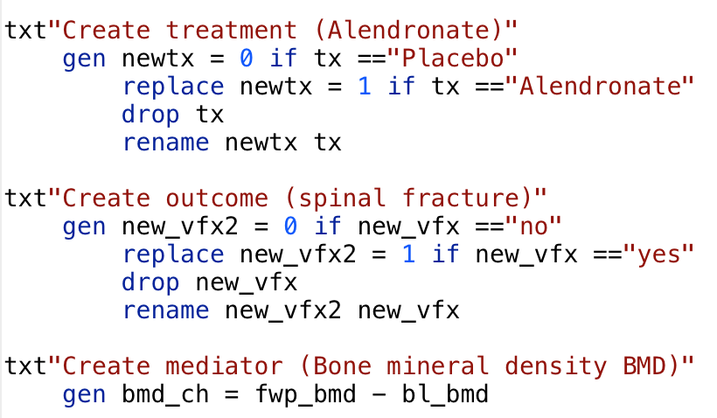

To reach 10,000 I doubled the dataset then randomly sampled 10,0000
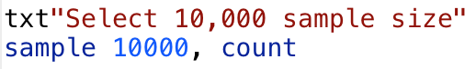

The Baron and Kenny Approach
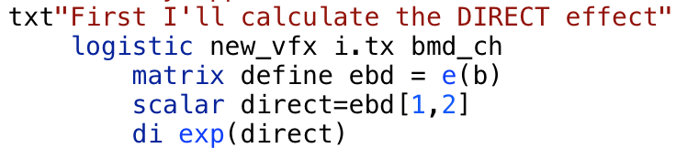
This came out to 63%
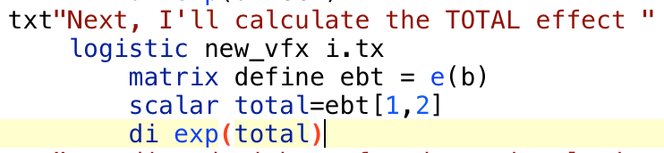
This came out to 50%
This came out to 32%

The calculate my Direct Effects I took advantage of Stata’s “Medeff” command.
