Exposure: minutes of daily moderate intensity cardio exercise
Effect Modifier: male
Outcome: V02 max (continuous measure of endurance)

Hypotheses: Increasing average minutes of moderate intensity (3.0-5.9 mets/hour) cardio exercise per day will increase overall endurance, measured by V02 max. This effect will be stronger in males

set seed 5005
set obs 1000
gen cardio = rnormal()
gen male = runiform() < 0.5
gen v02_e = rnormal()

gen v02 = 28.5 + 0.17*cardio + 6.5*male + 0.5*cardio*male + v02_e

Exposure -Outcome
Cardio Lower CI Upper CI
.2905877 -.3155514 .8967267
.2232268 -.4199315 .8663851
-.0857356 -.7619181 .5904469
.0561294 -.5948058 .7070646
.3098059 -.4785907 1.098202
.3829355 -.3344359 1.100307
.6378867 -.0714399 1.347213
-.099153 -.7703601 .572054
.482359 -.1574671 1.122185
.9696826 .2352869 1.704078

Exposure -Outcome Among Males
Cardio Lower CI Upper CI
.651363 .3760257 .9267003
.718727 .3805133 1.056941
.8642359 .5848897 1.143582
.6551431 .3933958 .9168904
.6852307 .3563294 1.014132
1.069085 .788776 1.349395
.6922405 .3945702 .9899108
.5322732 .2560465 .8084999
.7111378 .4491329 .9731427
.8473261 .4732507 1.221402

Exposure-Outcome among Females
Cardio Lower CI Upper CI
.0261136 -.1901083 .2423355
.2513107 .0087348 .4938867
.0448896 -.3217263 .4115055
.421228 .1713544 .6711015
.1373018 -.2903511 .5649547
.1891635 -.0869881 .4653151
.416777 .0896402 .7439138
.2596947 -.0149209 .5343103
.2527611 -.0513112 .5568334
-.0411383 -.4038376 .321561

clear
set seed 5005
set obs 1000
gen cardio = rnormal()
gen male = runiform() < 0.5
gen v02_e = rnormal()

gen v02 = 0*cardio + 0*male + 0*cardio*male + v02_e

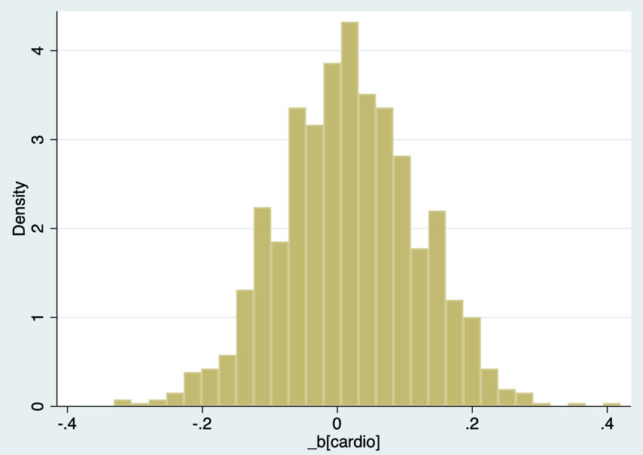

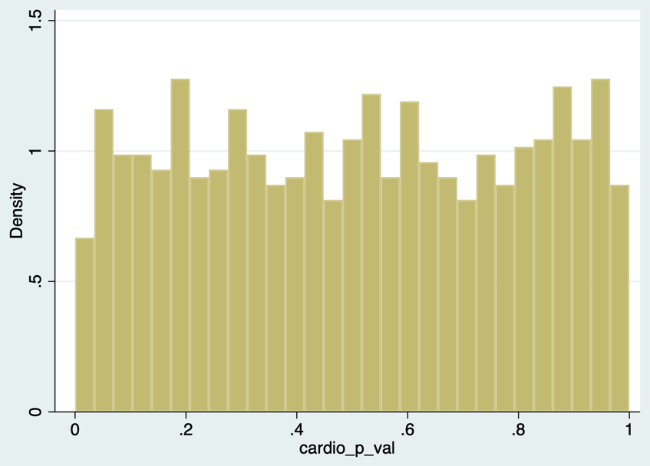

Power
*n=100, μ₀=.02, μ₁=.12, SD=1, α=.05
clear all
set seed 7997
program define simpow
clear
set obs 100
gen x = runiform() < 0.5
gen y = rnormal(0.02, 1) if x==0
replace y = rnormal(0.12, 1) if x==1
regress y x
lincom x
end

simulate pvalue = r(p), reps(1000): simpow

gen plessalpha = pvalue<0.05

tab plessalpha // 71/1000 = 0.071

power twomeans .02 .12 , n(100) a(.05) sd(1)

Stata power = 0.0785
Simulated = 0.071

*n=100,μ₀=.02, μ₁=.12, SD=2, α=.05
clear all
set seed 7997
program define simpow
clear
set obs 100
gen x = runiform() < 0.5
gen y = rnormal(0.02, 2) if x==0
replace y = rnormal(0.12, 2) if x==1
regress y x
lincom x
end

simulate pvalue = r(p), reps(1000): simpow

gen plessalpha = pvalue<0.05

tab plessalpha // 56/1000 = 0.056
power twomeans .02 .12 , n(100) a(.05) sd(2)

Stata power = 0.0570
Simulated = 0.056

*n=500, μ₀=.3, μ₁=.3, SD=1, α=.05
clear all
set seed 7997
program define simpow
clear
set obs 100
gen x = runiform() < 0.5
gen y = rnormal(0.3, 1) if x==0
replace y = rnormal(0.3, 1) if x==1
regress y x
lincom x
end

simulate pvalue = r(p), reps(1000): simpow

gen plessalpha = pvalue<0.05

tab plessalpha // 54/1000 = 0.054
power twomeans .3 .300001 , n(100) a(.05) sd(1)

Unable to estimate unless you set one of the means to something slightly different (0.300001). Then, Stata power = 0.0500
Simulated = 0.054

