1) Give an example of a research question for investigating racial/ethnic health disparities where: [1] SES is a confounder; [2] SES is an effect modifier; [3] SES is a mediator. Briefly discuss the interpretations/implications of each approach as it relates to understanding health disparities by race/ethnicity.
- Does second-hand smoke exposure in children worsen cancer outcomes?
  - In this study, SES is an independent causal factor for both second-hand smoke exposure and in worse cancer outcomes. Thus, it is a confounder.

- Do health educational campaigns advocating HPV vaccination increase vaccination rates?
  - Studies assessing the efficacy of campaigns that advocate for HPV vaccinations should account for SES as an effect modifier. While the campaigns may be effectively reaching/educating their intended audiences, SES can affect whether patients can access HPV vaccines.

- What is the impact of race in breast cancer patients?
  - In this study, we are asking whether there are disparities in outcome based on race. In this study, SES would act as a mediator:
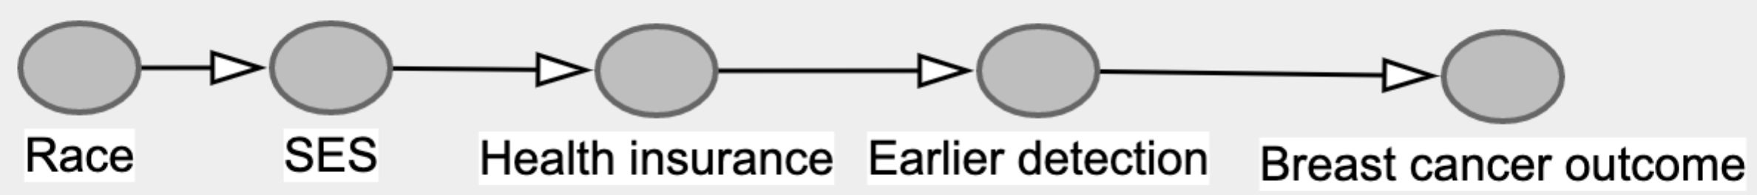
2) Describe a potential effect modifier, mediator, or contextual variable (for definition of contextual variable, see Diez-Roux reading) for an association of interest to you and relevant to health disparities. For example, for investigating the association between education and hypertension, I might be interested in evaluating whether the association between years of education and hypertension is different for Black men than for White men. Describe how you would study whether this relationship exists.
I would be curious to see whether the relationship between type of health insurance (private vs public vs uninsured) and oropharyngeal cancer outcomes differs by race. Studies investigating disparities by race in head and neck cancer outcomes have noted that black patients are more likely to present with more advanced disease and are less likely to receive surgery as part of their treatment plan than white patients. I am interested in seeing whether health insurance mediates this relation. Using Barron-Kenny analysis, I would decompose the total effect of race on outcome and test whether 4 conditions are met:
- Racial/ethnic group is associated with worse oropharyngeal cancer outcomes
- Racial/ethnic group is associated with a set of potential mediating factors
- A set of potential mediating factors are associated with worse oropharyngeal cancer outcomes
- Including both racial/ethnic group and the set of mediating factors in a model changes the association between oropharyngeal cancer outcomes and racial/ethnic group observed in condition 1.

I would then measure the unadjusted association between racial/ethnic group and oropharyngeal cancer outcomes using logistic regression models and chi-square test to measure the association between racial/ethnic group and each set of potential mediating factors.
