Lab 5-1 – Not to be handed in – summarizing more of the hypothesis testing concepts

Using the class data file from 2016-2017 (Class2016_2017.dta)

- Compare the ttests for the mean duration (in seconds) that it took to complete the survey in the 2 years with the non-parametric equivalent Wilcoxon rank sum test. Why won’t our data perform the non-parametric tests in its current form?

Null Hypothesis: H₀: μ₂-μ₁ =0 -> μ₂=μ₁
There is no difference in the amount of time it took to complete the survey between the 2016 cohort and the 2017 cohort.

Alternative Hypothesis: H_{A}: μ₁-μ₂ ≠0 -> μ₂ ≠μ₁
There is a difference in the amount of time it took to complete the survey between the 2016 cohort and the 2017 cohort.

. ttest Duration17 == Duration16, unpaired

Two-sample t test with equal variances
------------------------------------------------------------------------------
Variable | Obs Mean Std. Err. Std. Dev. [95% Conf. Interval]
---------+--------------------------------------------------------------------
Durat~17 | 49 96.55102 13.90976 97.3683 68.58358 124.5185
Durat~16 | 55 104.7636 27.95902 207.3497 48.70917 160.8181
---------+--------------------------------------------------------------------
combined | 104 100.8942 16.1053 164.2425 68.95317 132.8353
---------+--------------------------------------------------------------------
diff | -8.212616 32.41191 -72.50149 56.07626
------------------------------------------------------------------------------
diff = mean(Duration17) - mean(Duration16) t = -0.2534
Ho: diff = 0 degrees of freedom = 102

Ha: diff < 0 Ha: diff != 0 Ha: diff > 0
Pr(T < t) = 0.4002 Pr(|T| > |t|) = 0.8005 Pr(T > t) = 0.5998

. ttest Duration17 == Duration16, unpaired unequal

Two-sample t test with unequal variances
------------------------------------------------------------------------------
Variable | Obs Mean Std. Err. Std. Dev. [95% Conf. Interval]
---------+--------------------------------------------------------------------
Durat~17 | 49 96.55102 13.90976 97.3683 68.58358 124.5185
Durat~16 | 55 104.7636 27.95902 207.3497 48.70917 160.8181
---------+--------------------------------------------------------------------
combined | 104 100.8942 16.1053 164.2425 68.95317 132.8353
---------+--------------------------------------------------------------------
diff | -8.212616 31.22801 -70.37507 53.94984
------------------------------------------------------------------------------
diff = mean(Duration17) - mean(Duration16) t = -0.2630
Ho: diff = 0 Satterthwaite's degrees of freedom = 78.6208

Ha: diff < 0 Ha: diff != 0 Ha: diff > 0
Pr(T < t) = 0.3966 Pr(|T| > |t|) = 0.7932 Pr(T > t) = 0.6034

Assuming equal variance in the two populations gives a pooled estimate of P=0.8005 whereas assuming unequal variance in the two populations gives a pooled estimate of P=0.7932. As we can see, both t-tests yield the same answer – that the mean time it took for students to complete the survey in 2017 was 8.21 seconds less than the mean time it took students in 2016 to complete the survey. With each test we see different calculations for the degrees of freedom resulting in the differences in unrounded estimations of both the one and 2-sided p-values. Both tests however lead us to fail to reject the null hypothesis given a standard alpha of 0.05.

We cannot run a non-parametric Wilcoxon rank sum test on the data because the duration is not a paied variable across years. The signrank command in STATA tests the equality of matched pairs of observations where the null hypothesis is that both distributions of the variable are the same. We can see that trying to perform this test with the data as is returns a wrong result:

. signrank Duration17=Duration16

Wilcoxon signed-rank test

sign | obs sum ranks expected
-------------+---------------------------------
positive | 26 615.5 612.5
negative | 23 609.5 612.5
zero | 0 0 0
-------------+---------------------------------
all | 49 1225 1225

unadjusted variance 10106.25
adjustment for ties -1.13
adjustment for zeros 0.00
----------
adjusted variance 10105.13

Ho: Duration17 = Duration16
z = 0.030
Prob > |z| = 0.9762

To run this test in independent, non-paired data we would need to create a single duration variable separated by a group variable.

I have created a new dataset with a Group variable (0 = 2016, 1 = 2017 (Class2016_2017Grouped.dta)).

Now use the non-parametric tests Ranksum (which compares the mean values of the ranks of the durations) and Median (comparing the median duration).

. ranksum Duration, by(Group)

Two-sample Wilcoxon rank-sum (Mann-Whitney) test

Group | obs rank sum expected
-------------+---------------------------------
0 | 55 2754.5 2887.5
1 | 49 2705.5 2572.5
-------------+---------------------------------
combined | 104 5460 5460

unadjusted variance 23581.25
adjustment for ties -575.00
----------
adjusted variance 23006.25

Ho: Duration(Group==0) = Duration(Group==1)
z = -0.877
Prob > |z| = 0.3806

. median Duration, by(Group)

Median test

Greater |
than the | Group
median | 0 1 | Total
-----------+----------------------+----------
no | 26 35 | 61
yes | 29 14 | 43
-----------+----------------------+----------
Total | 55 49 | 104

Pearson chi2(1) = 6.2350 Pr = 0.013

Continuity corrected:
Pearson chi2(1) = 5.2787 Pr = 0.022

Are there differences in the test results? Create histograms of duration and see why there might be differences.

From the tests above we see that there are differences. Ranksum test the hypothesis that two independent samples are from populations with the same distribution. With a P-value of 0.3806 we fail to reject the null hypothesis.

Using the median test, we reject the null hypothesis that any “K” samples drawn from these populations have the same median.

. hist Duration, by(Group) percent ytitle(Percent of Class) xtitle(Duration of
> Survey Completion Seconds) bin(20) by(, title(Survey Completeion in 2016 and
> 2017))
. graph box Duration, by(Group)
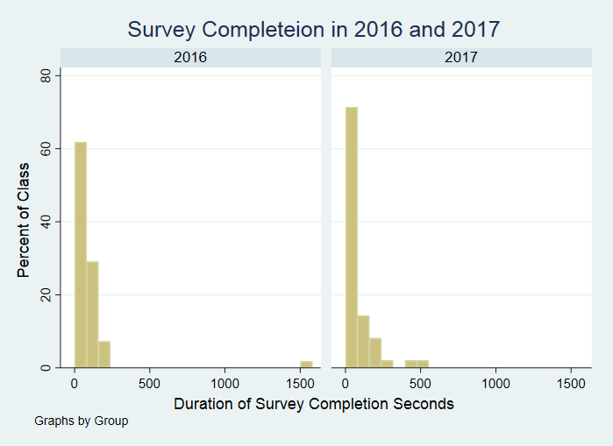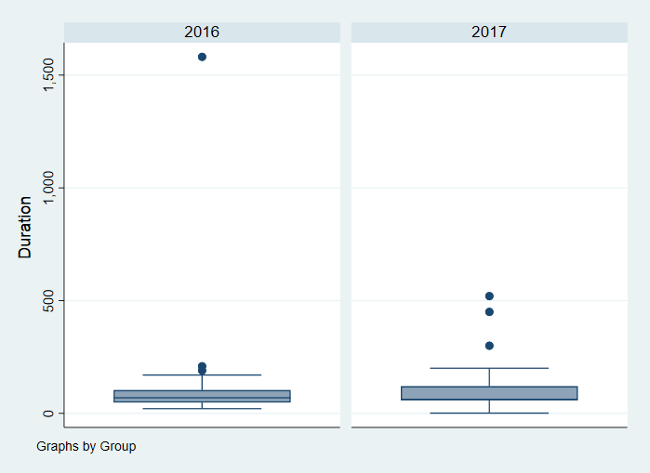

We see from both histograms and boxplots that there are extreme outlier values in both 2016 and 2017. If we were to remove the outlier we may expect a much different result in our analysis.

- Create a new variable that tabulates groups of apple devices where less than 1 device = 1, 2 devices = 2, 3 devices = 3, 4 devices = 4, and greater than 4 devices = 5.

. gen apple=.
(104 missing values generated)

. replace apple=1 if apple_n<2
(15 real changes made)

. replace apple=2 if apple_n==2
(18 real changes made)

. replace apple=3 if apple_n==3
(40 real changes made)

. replace apple=4 if apple_n==4
(19 real changes made)

. replace apple=5 if apple_n>4
(12 real changes made)

- Test whether there is a difference in duration by the grouped number of apple devices. Use one-way anova and the kruskal-wallis non-parametric test. Are the results comparable? Is there a difference? Why is there a difference?

Null Hypothesis: No difference in groups
Alternative Hypothesis: At least one of the means is different.

. oneway Duration apple

Analysis of Variance
Source SS df MS F Prob > F
------------------------------------------------------------------------
Between groups 98882.021 4 24720.5053 0.91 0.4594
Within groups 2679603.82 99 27066.7052
------------------------------------------------------------------------
Total 2778485.84 103 26975.5906

Bartlett's test for equal variances: chi2(4) = 128.4763 Prob>chi2 = 0.000

Using the data on apple devices grouped above, a one-way ANOVA with p=0.46 we fail to reject the null hypothesis (given a standard alpha of 0.05) that there is no difference in the amount of time it takes to complete the survey among students depending on the number of Apple devices they have. By failing to reject the null hypothesis, we suspect that there may be no difference in the groups.

One-way ANOVA tests may not appropriate in some instances if the data violates certain assumptions of ANOVA testing: (1) the dependent variable must be continuous, (2) the independent variable consists of two or more categorical, independent groups, (3) there is independence of observations, (4) there should be no significant outliers, (5) the dependent variable should be approx. normally distributed for each category, (5) there is homogeneity of variances.

We can check some of these assumptions using histograms and boxplots.
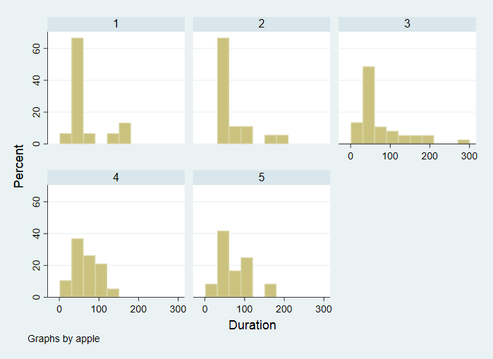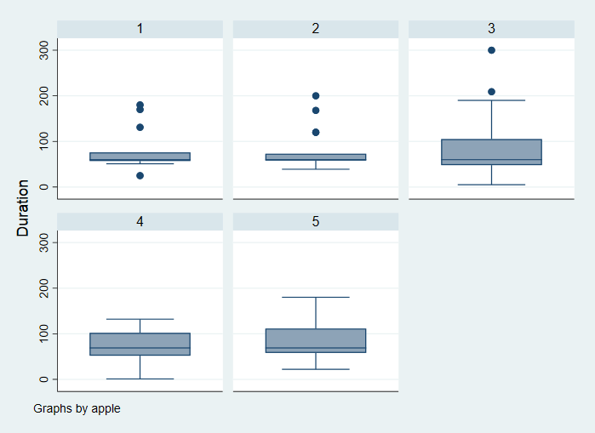
*outliers excluded for better visualization.

Unfortunately, we know there are violations to some of these assumptions. (1) Survey duration does not look to be normally distributed for each Apple device group, and (2) The data set is known to have significant outliers, which subsequently fails the assumption of homogeneity of variances.

Because of this, we cannot conclude any firm results with the ANOVA test. However, we can run a rank test which is less sensitive to these assumptions.

. kwallis Duration, by(apple)

Kruskal-Wallis equality-of-populations rank test

+------------------------+
| apple | Obs | Rank Sum |
|-------+-----+----------|
| 1 | 15 | 755.00 |
| 2 | 18 | 909.50 |
| 3 | 40 | 2143.50 |
| 4 | 19 | 972.50 |
| 5 | 12 | 679.50 |
+------------------------+

chi-squared = 0.467 with 4 d.f.
probability = 0.9766

chi-squared with ties = 0.478 with 4 d.f.
probability = 0.9756

With a P value = 0.9766, which is greater than an alpha of 0.05 we fail to reject the null hypothesis. Though this conclusion is the same as our original ANOVA, the rank test is more appropriate to run since there is no assumption of normality, and ranks are less sensitive to outliers and to measurement error.

- Is this difference consistent over Groups? Make sure you examine the actual duration by group and by apple device group. Remove the outlier in the Duration variable. Is the result the same? Is the result the same for parametric and non-parametric tests? The Kruskal-Wallis test does not allow the ‘by’ statement but we can do a comparison of medians test:

. by Group, sort: tabstat Duration, by(apple) statistic(n mean sd min p25 p50 p75 max)

-------------------------------------------------------------------------------------------------------------------
-> Group = 2016

Summary for variables: Duration
by categories of: apple

apple | N mean sd min p25 p50 p75 max
---------+--------------------------------------------------------------------------------
1 | 7 80.85714 51.12543 25 51 57 131 170
2 | 7 70 44.87761 39 39 58 73 168
3 | 22 148.6818 324.3329 21 42 67 126 1581
4 | 13 79.69231 27.18267 45 56 79 102 132
5 | 6 66.5 28.83574 22 53 67 87 103
---------+--------------------------------------------------------------------------------
Total | 55 104.7636 207.3497 21 48 69 103 1581
------------------------------------------------------------------------------------------

-------------------------------------------------------------------------------------------------------------------
-> Group = 2017

Summary for variables: Duration
by categories of: apple

apple | N mean sd min p25 p50 p75 max
---------+--------------------------------------------------------------------------------
1 | 8 75 42.42641 60 60 60 60 180
2 | 11 82.72727 46.0632 50 60 60 120 200
3 | 18 128.6111 146.0842 5 60 60 120 520
4 | 6 51 43.86342 1 5 60 60 120
5 | 6 100 48.98979 60 60 90 120 180
---------+--------------------------------------------------------------------------------
Total | 49 96.55102 97.3683 1 60 60 120 520
------------------------------------------------------------------------------------------

. by Group, sort : median Duration, by(apple) medianties(below)

-------------------------------------------------------------------------------
-> Group = 2016

Median test

Greater |
than the | apple
median | 1 2 3 4 5 | Total
-----------+-------------------------------------------------------+----------
no | 4 5 11 5 3 | 28
yes | 3 2 11 8 3 | 27
-----------+-------------------------------------------------------+----------
Total | 7 7 22 13 6 | 55

Pearson chi2(4) = 2.1034 Pr = 0.717

-------------------------------------------------------------------------------
-> Group = 2017

Median test

Greater |
than the | apple
median | 1 2 3 4 5 | Total
-----------+-------------------------------------------------------+----------
no | 7 8 12 5 3 | 35
yes | 1 3 6 1 3 | 14
-----------+-------------------------------------------------------+----------
Total | 8 11 18 6 6 | 49

Pearson chi2(4) = 2.9883 Pr = 0.560

For both years, we can see from the tabstat command that the mean duration within each Apple device group are typically much larger than the median suggesting to us that the data is skewed so the non-parametric test is likely the better option with the raw data (including outliers).

Duration within the 75% percentile looks to be between 60-130 seconds. Similarly, most maximum values across both years look to be between 100-200 seconds. To examine outliers we can use the list command to see how extreme values within this data look:

. list if Duration>400

+-----------------------------------------------------------------------------------------------------+
37. | Duration | gender | height | cash | coffee_y | coffe~uy | apple_~y | apple_n | AnyChi~n | HowMan~n |
| 1581 | Female | 65.6 | 20 | 1 | 1 | 1 | 3 | 0 | 0 |
|-----------------------------------------------------------------------------------------------------|
| Group | apple |
| 2016 | 3 |
+-----------------------------------------------------------------------------------------------------+

+-----------------------------------------------------------------------------------------------------+
58. | Duration | gender | height | cash | coffee_y | coffe~uy | apple_~y | apple_n | AnyChi~n | HowMan~n |
| 520 | Male | 62 | 27 | 3 | 1 | 1 | 3 | 0 | 0 |
|-----------------------------------------------------------------------------------------------------|
| Group | apple |
| 2017 | 3 |
+-----------------------------------------------------------------------------------------------------+

+-----------------------------------------------------------------------------------------------------+
59. | Duration | gender | height | cash | coffee_y | coffe~uy | apple_~y | apple_n | AnyChi~n | HowMan~n |
| 450 | Male | 60 | 46.05 | 4 | 4 | 1 | 3 | 0 | 0 |
|-----------------------------------------------------------------------------------------------------|
| Group | apple |
| 2017 | 3 |
+-----------------------------------------------------------------------------------------------------+

Typically, determining outliers takes a substantial amount of background knowledge in your field. In examining your data, you should be considering: (1) what values are actually biologically plausible, (2) what values should be expected based on prior research done on the topic, (3) are there other variable irregularities in that persons’ data (See list command above), (4) could this have been a computational error, etc.

The idea behind this lab is to illustrate how statistical tests can quickly change looking depending on your data and how you manipulate it. While most of you will likely only exclude the person with survey duration of 1581 seconds, I will exclude the largest three values to illustrate how ANOVA and ranksum tests may or may not change given which values in your data you choose to exclude:

. oneway Duration apple if Duration<400

Analysis of Variance
Source SS df MS F Prob > F
------------------------------------------------------------------------
Between groups 1923.75707 4 480.939269 0.19 0.9411
Within groups 238275.688 96 2482.03842
------------------------------------------------------------------------
Total 240199.446 100 2401.99446

Bartlett's test for equal variances: chi2(4) = 8.1256 Prob>chi2 = 0.087

. kwallis Duration if Duration<400, by(apple)

Kruskal-Wallis equality-of-populations rank test

+------------------------+
| apple | Obs | Rank Sum |
|-------+-----+----------|
| 1 | 15 | 755.00 |
| 2 | 18 | 909.50 |
| 3 | 37 | 1834.50 |
| 4 | 19 | 972.50 |
| 5 | 12 | 679.50 |
+------------------------+

chi-squared = 0.542 with 4 d.f.
probability = 0.9693

chi-squared with ties = 0.557 with 4 d.f.
probability = 0.9677

Are the non-parametric and parametric tests now consistent?

Though our conclusions from both tests remain the same, we can see from the outputs above that the ANOVA test with the trimmed data now has a more consistent p-value with that of the original Kruskal-Wallis rank test. (Trimmed ANOVA: p=0.9411, Original Kwallis: p=0.9756). Additionally, we can confirm that the rank test is less sensitive to the inclusion or exclusion of outliers by comparing the lack of change in the p-values from the raw (0.9756) and trimmed data (p=0.9677).

We should note however, that dropping 3 values from a relatively small data set significantly lowered the F-statistic in the ANOVA test – 0.91 to 0.19.

